PROTON e.MAS — CRM Feature Guide
Operator Handbook — v2, August 2026

Table of Contents
Right-click here and choose “Update Field” (or press F9) to generate the table of contents.
(This table of contents is a live Word field. If it appears empty or out of date, right-click it and choose “Update Field”, or select the whole document and press F9.)

Introduction

What is Proton e.MAS CRM

What it is
Proton e.MAS CRM is Proton's unified customer support platform for the e.MAS electric-vehicle business. It brings every customer conversation — WhatsApp, email, and phone/IVR calls — into a single inbox, adds an AI assistant that can draft or send replies, and layers on automotive support tools such as roadside-assistance (RSA) incident logging, a vehicle/service lookup (Customer 360), case tracking, and reporting built around dealer and PIC (person-in-charge) escalation.
Every agent and administrator uses the same platform through a web browser; there is nothing to install.

Where to find it
The platform is reached at your organization's CRM web address, provided by your administrator. Bookmark it — you'll come back to it every shift.

How to use it
1. Open a web browser and go to your organization's CRM address.
2. Sign in with the account your administrator created for you (see Logging in below).
3. After signing in you land on the Conversations view — the default screen showing every conversation across the inboxes you have access to.
4. Use the sidebar on the left to move between Conversations, Contacts, Knowledge, Cases, RSA, Reports, and (for administrators) Administration.
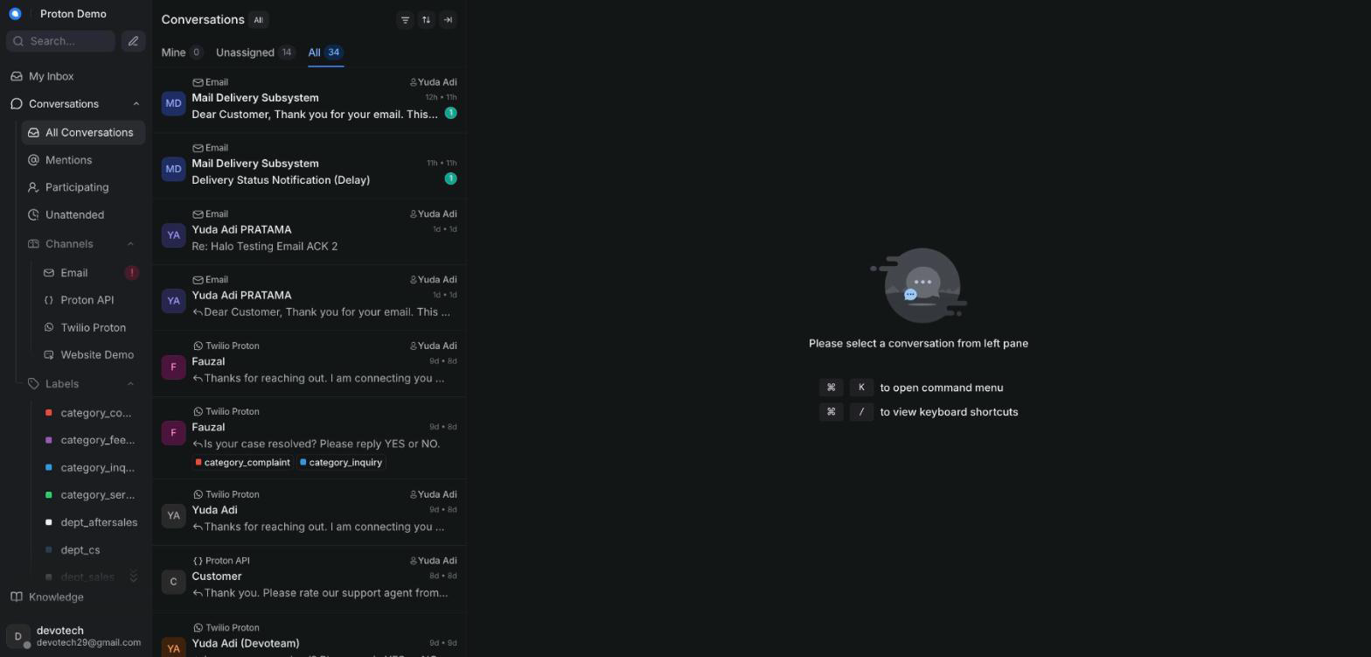
Landing view after logging in to Proton e.MAS CRM

Example scenario
At the start of a shift, an agent at a Proton e.MAS dealership opens the CRM in their browser and lands directly on the Conversations view, where overnight WhatsApp inquiries about test drives and service bookings are already waiting.

Integrations & automation
The CRM is the single front door for WhatsApp, email, and phone/IVR conversations, the Gemini-powered AI assistant, the vehicle/service data lookup (DMS/TSP), and Proton's reporting — every chapter in this guide covers one part of that single platform.

Logging in

What it is
The sign-in screen that authenticates you as an agent or administrator before you can see any conversations or customer data.

Where to find it
Your CRM web address opens directly to the login screen if you are not already signed in.

How to use it
1. Go to your organization's CRM address.
2. Enter the email address and password your administrator set up for you.
3. Click the sign-in button.
4. If you forget your password, use the "Forgot password?" link to request a reset email.
5. Once signed in, you stay logged in on that browser until you sign out or your session expires.
Screenshot: The Proton e.MAS CRM login screen

Example scenario
A newly hired agent receives a welcome email with their login details, opens the CRM address on their laptop, signs in for the first time, and is prompted to set a new password before reaching the dashboard.

Integrations & automation
Signing in does not touch any other system by itself — it simply opens the session you use for every other feature in this guide.

Screen layout

What it is
The main working screen you see after logging in: a navigation sidebar on the left, the conversation list in the middle-left column, the open conversation with its reply box in the center, and a contact side panel on the right.

Where to find it
This layout is what you see any time you are inside the Conversations area of the CRM.

How to use it
1. Use the sidebar on the far left to switch between Conversations, Contacts, Knowledge, Cases, RSA, Reports, Campaigns/Help Center, and (for administrators) Administration and other admin-only pages.
2. Use the conversation list to browse and filter the conversations in your inboxes — see the Conversations chapter for the filters available.
3. Click a conversation to open it in the main conversation pane, where the message thread and reply box live.
4. Check the contact side panel on the right for the customer's details and history alongside the conversation you're reading.
5. Look for AI-assist buttons (Ask Copilot, Suggest reply, Summarize) above the reply box when you need help drafting a response.
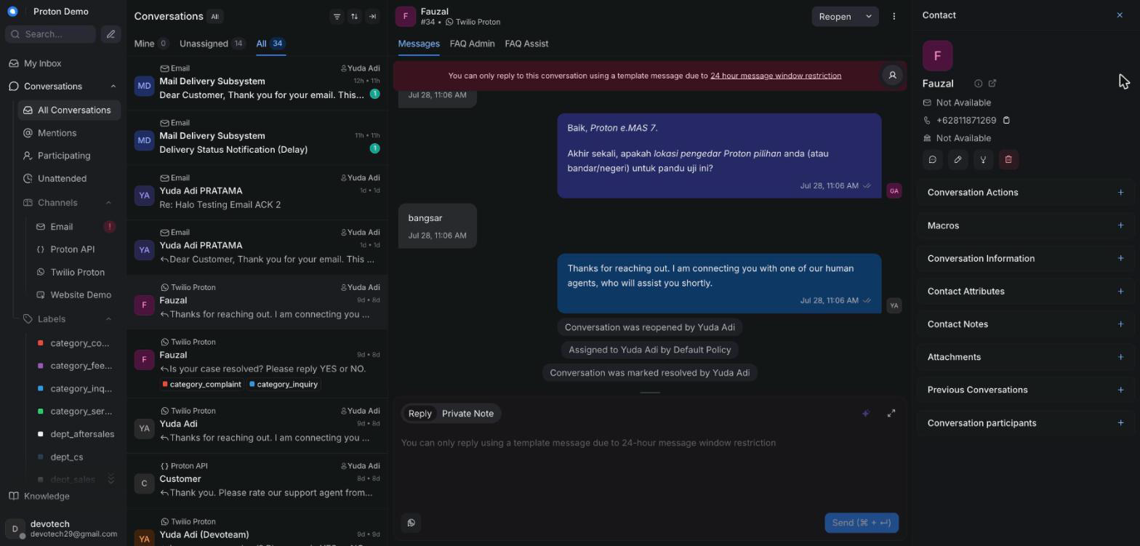
Main dashboard layout: sidebar, conversation list, reply box, contact panel

Example scenario
An agent handling a service-booking question keeps the contact panel open to check the customer's vehicle model while typing a reply in the main conversation pane, without leaving the conversation.

Integrations & automation
The sidebar is where Proton's added modules — Knowledge, Cases, RSA, the extra Reports pages, and (for administrators) Integrations, Escalation Routing, SLA Policies, Audit Log, and Roles & Permissions — sit alongside the standard Conversations and Contacts views, so everything is reachable from one place.

Roles: agent vs administrator

What it is
Every account has a base role — Agent or Administrator — that controls what you can see and do. Administrators can additionally be granted specific permissions (for example, managing escalation routing, SLA policies, integrations, or viewing the audit log), so two administrators may not see exactly the same admin pages unless they've been granted the same permissions.

Where to find it
Your role is set by an administrator when your account is created, under Administration → Agents. Fine-grained permissions are managed under Administration → Roles & Permissions.

How to use it
1. As an agent, you see Conversations, Contacts, and Knowledge (read access) — the day-to-day support tools.
2. As an administrator, you additionally see Cases, the RSA Incident Log, Customer 360, Reports, and Administration together with any admin-only pages your permissions grant, such as Integrations, Escalation Routing, SLA Policies, Audit Log, and Roles & Permissions.
3. If you believe you're missing access you should have, ask an administrator to check your role and permissions under Administration → Roles & Permissions.
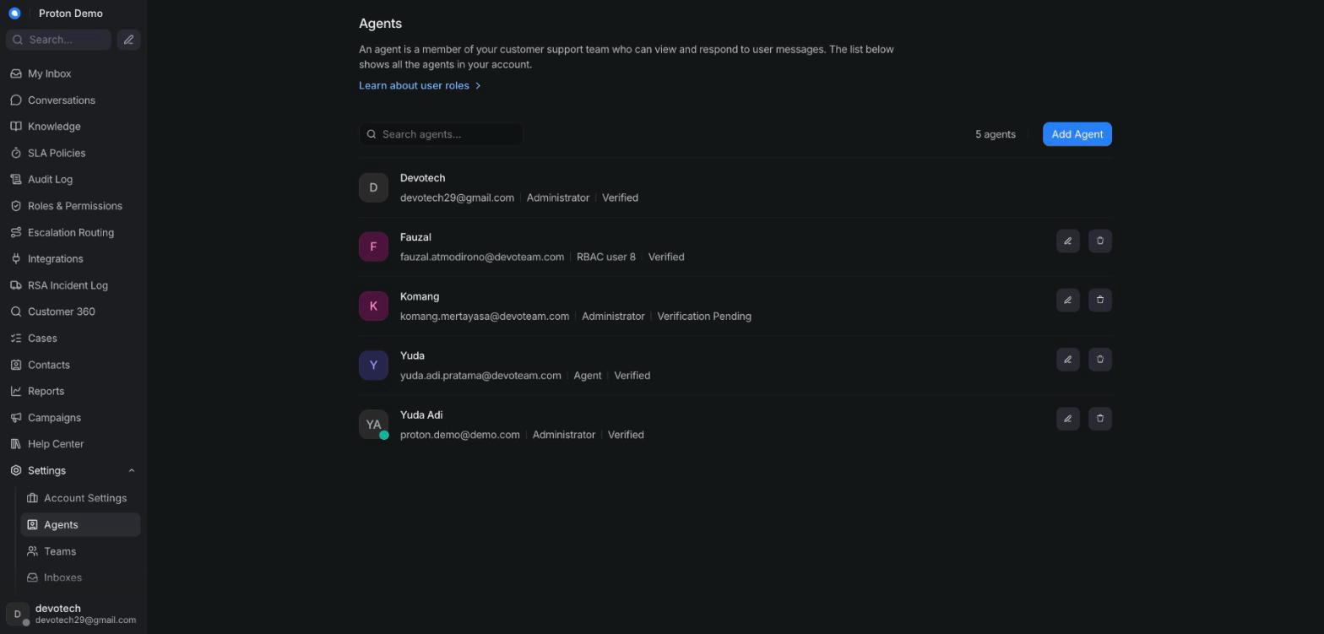
Sidebar differences between an agent and an administrator account

Example scenario
A support supervisor is given the Administrator role plus the escalation-routing permission, so they can update which dealer receives escalation emails without also being handed full account-wide administrator access to every setting.

Integrations & automation
Roles and permissions gate every admin-only page covered in the Administration chapter — what you see there depends directly on what's set up here.

Language (English / Indonesian)

What it is
A setting that switches the CRM's interface text between English and Indonesian. It changes labels and menus, not the language customers write to you in.

Where to find it
Your profile settings menu, usually reached from your avatar/name in the top corner of the screen.

How to use it
1. Open your profile settings from your avatar or name.
2. Find the interface language option.
3. Choose English or Indonesian (Bahasa Indonesia).
4. The interface labels update immediately (or after a page refresh).
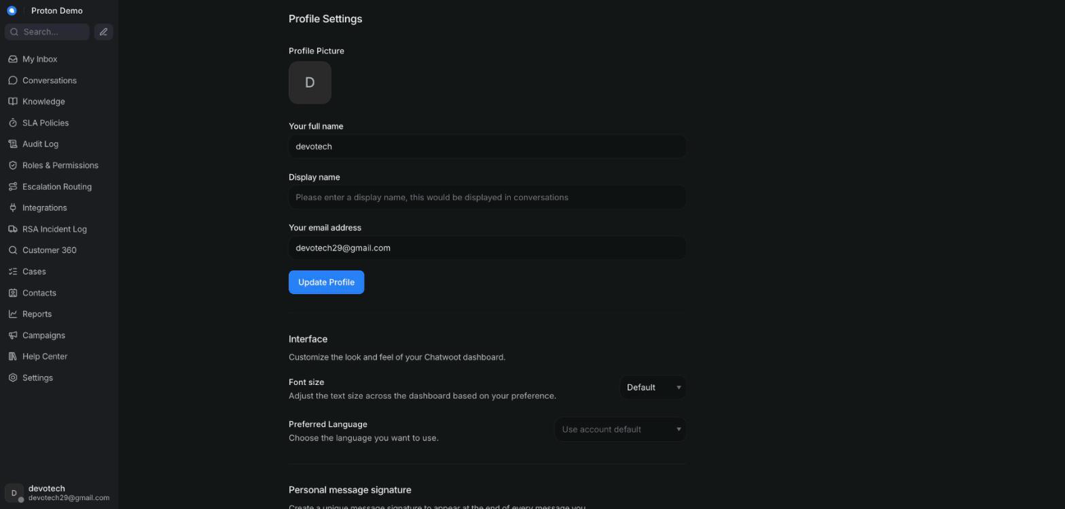
Switching the interface language between English and Indonesian

Example scenario
An agent who is more comfortable working in Bahasa Indonesia switches their interface language, while the AI assistant continues to reply to each customer in whatever language that customer writes in.

Integrations & automation
The interface language is a personal preference only — it doesn't change which language the AI assistant uses when replying to a customer.

Conversations

Conversation inbox & views

What it is
The conversation list is where every incoming conversation lands — WhatsApp, email, and phone/IVR alike — filterable by who it's assigned to and by its status. By default the CRM shows every conversation across all statuses, so nothing is hidden behind a narrower filter unless you choose one.

Where to find it
The left-hand column of the Conversations view, always visible once you're signed in.

How to use it
1. Use the assignee tabs to switch between Mine, Unassigned, and All conversations.
2. Use the status filter to narrow the list to Open, Pending, Snoozed, or Resolved conversations, or leave it on All to see everything regardless of status.
3. Click an inbox name in the sidebar to scope the list to a single channel (for example, just WhatsApp).
4. Click any conversation in the list to open its full thread.
5. Use the sort option to reorder the list, for example by most recent activity.
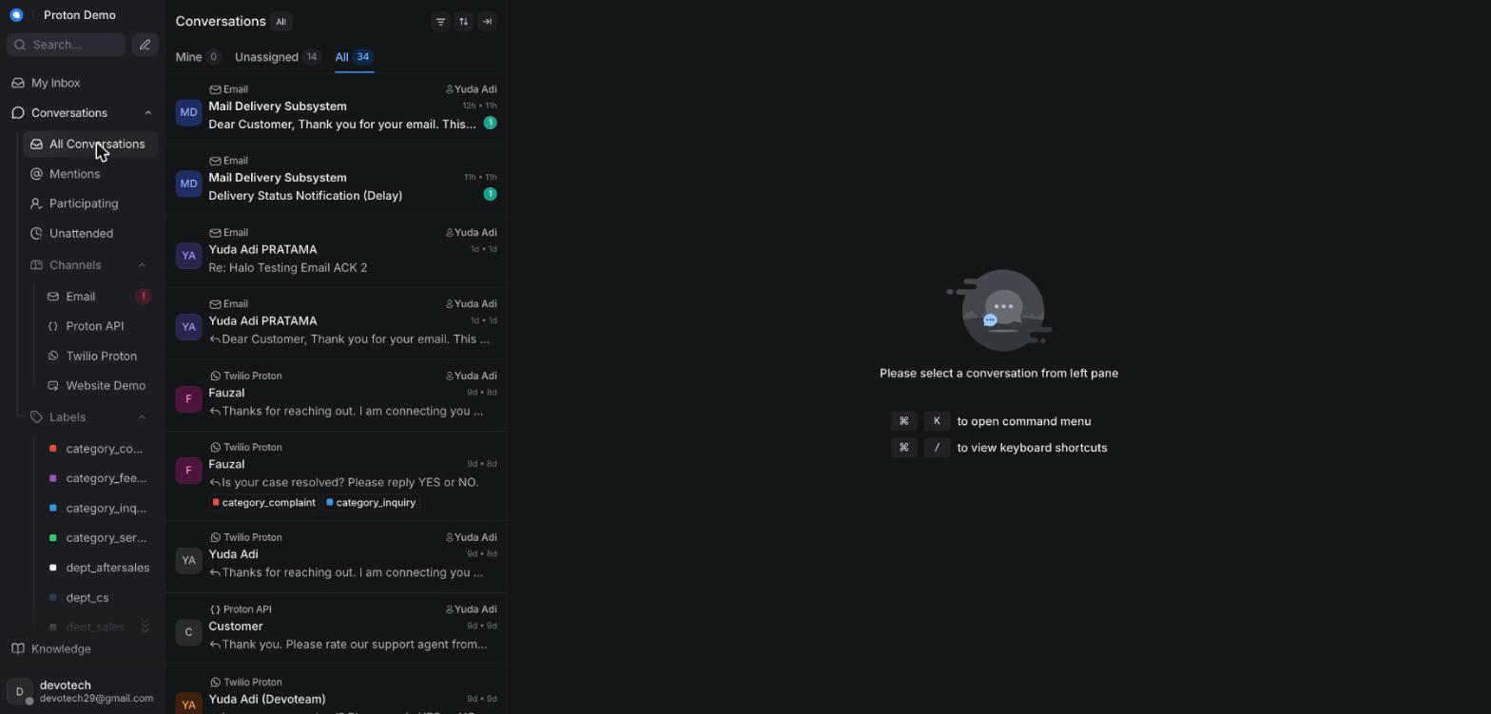
Conversation list showing the default "All" tab and "All" status filter

Example scenario
At the start of a shift, an agent opens the Conversations view and — since it defaults to "All" agents and "All" statuses — immediately sees a pending WhatsApp inquiry about a test drive that came in overnight, without having to change any filter first.

Integrations & automation
New conversations can arrive automatically from the AI assistant handling WhatsApp or phone/IVR contact before a human ever sees them (see the AI assistant behaviour chapter); this list is also where assignment, labels, and priorities (below) become visible at a glance.

Assignment & teams

What it is
Assignment determines which agent — or which team — owns a conversation. An unassigned conversation is visible to the whole team until someone picks it up or it's assigned.

Where to find it
The assignee and team controls in the conversation's action panel, next to an open conversation.

How to use it
1. Open the conversation you want to assign.
2. Click the assignee control and choose an agent, or click the team control and choose a team.
3. To reassign, repeat the same steps and pick a different agent or team.
4. To unassign, clear the assignee field.
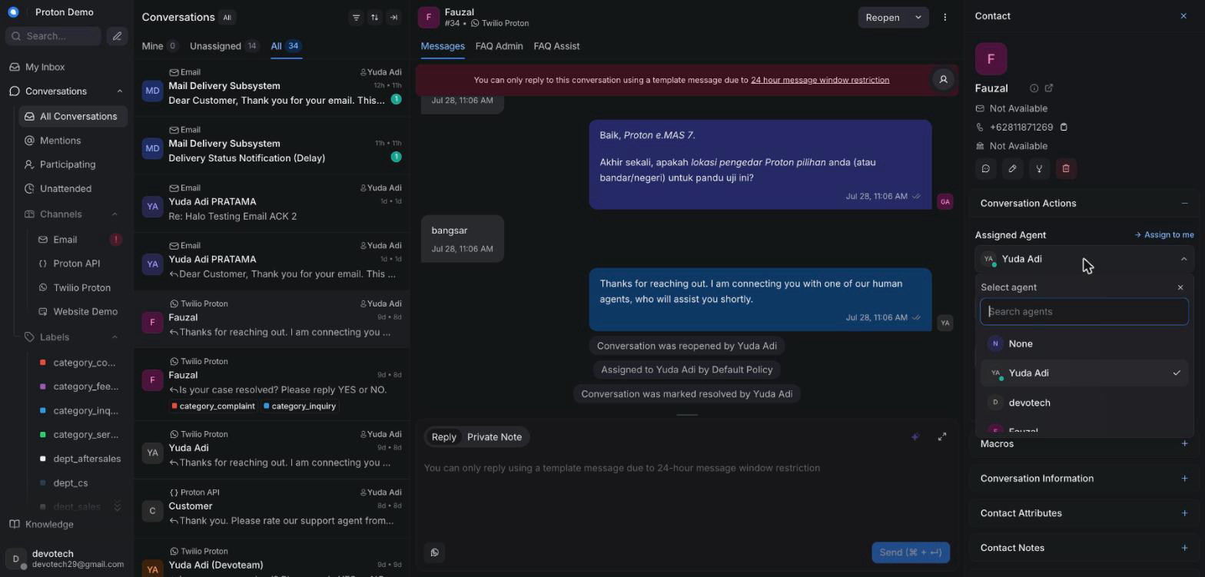
Assigning a conversation to an agent or team

Example scenario
A WhatsApp inquiry about booking a test drive for the Proton e.MAS 7 comes in; the on-duty agent assigns it to the "Sales — Jakarta" team so any available team member can respond, rather than keeping it for themselves.

Integrations & automation
When the AI assistant hands a conversation off to a human, it can trigger an automatic agent assignment as part of that handoff (see the AI assistant behaviour chapter). Administrators can also set which channels each agent handles first, to steer that automatic assignment — see the Administration chapter's Inboxes section.

Labels

What it is
Labels are tags you attach to a conversation to categorize it. Alongside general-purpose labels, Proton uses two special ones: an escalate label that flags a conversation for the escalation email workflow, and dealer-specific labels (for example, one per dealer outlet) used for turnaround-time reporting. A dealer label now routes to a dealer group — every member of that group is forwarded the case, not just one address (see the Administration chapter's Escalation Routing section).

Where to find it
The label control on an open conversation, and a Labels view in the sidebar listing conversations by label.

How to use it
1. Open the conversation you want to label.
2. Click the label control and pick one or more existing labels.
3. Apply the department label first (for example dept_sales), then the dealer label if one is involved, and apply escalate last. The escalation handler reads whichever labels are already on the conversation at the moment escalate is applied — applying it first means the department/dealer leg doesn't fire for that trigger.
4. Apply the relevant dealer label so the conversation counts toward that dealer's turnaround reporting, even outside an email escalation.
5. Remove a label the same way, by deselecting it.
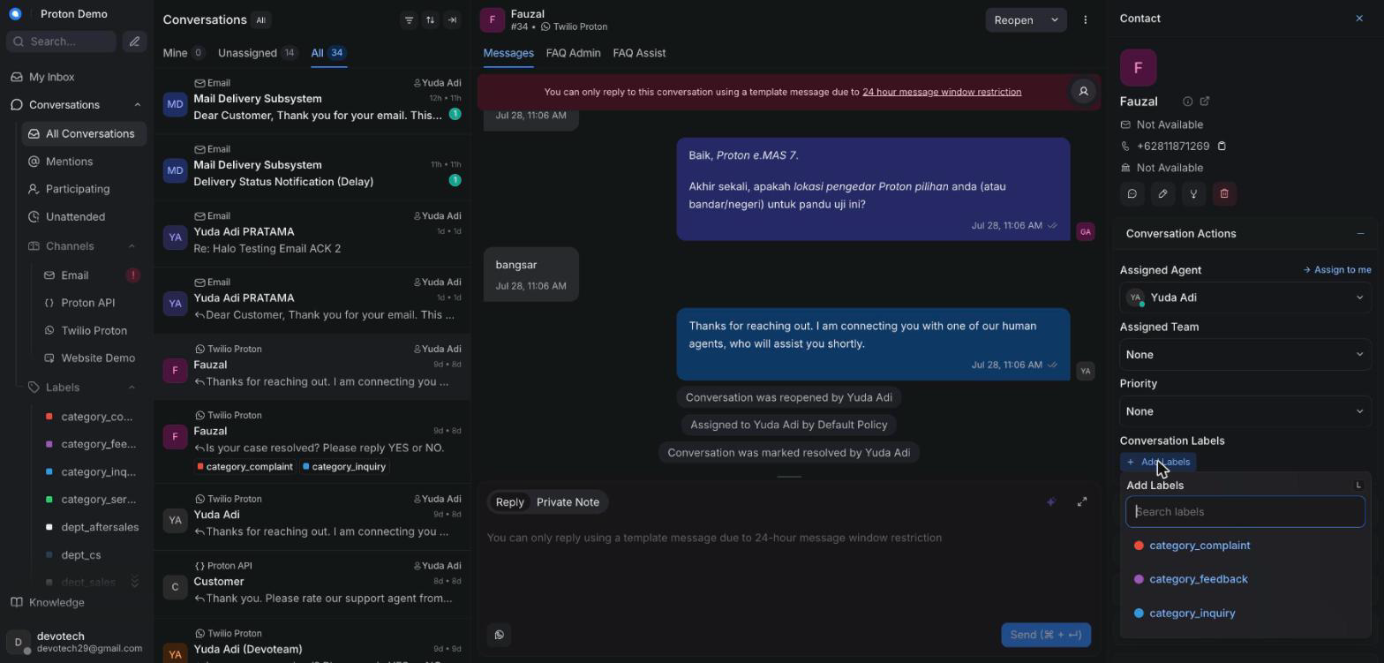
Applying a label to a conversation

Example scenario
A customer's warranty complaint escalates over email; the agent adds the department label, then the dealer's label, then escalate — in that order — which together kick off the automated escalation email to everyone on that dealer group and start the clock for turnaround reporting. See Escalation replies, below, for what happens once the dealer answers.

Integrations & automation
The escalate label triggers the two-thread escalation email described in the AI assistant behaviour chapter; dealer labels feed the dealer turnaround figures shown in the Reports chapter. The email this sends now carries a hidden reference back to this conversation, which is what makes Escalation replies (below) possible.

Escalation replies

What it is
When a dealer or PIC replies to an escalation email, their reply doesn't start a fresh conversation you have to go hunting for — it's linked back onto the original conversation automatically, as a private note starting Reply from <name> <email>:. If a customer instead replies to their own acknowledgement email, that reply rejoins their case too, but as an ordinary incoming message that reopens the conversation, not a private note — it looks exactly like a new message the customer sent.

Where to find it
The reply lands as a new message on the original escalated conversation — not on any new conversation that may briefly appear elsewhere in the inbox. A throwaway conversation is created behind the scenes to receive the raw email, but it's automatically labelled and resolved, so it shouldn't show up in your queue as something to work.

How to use it
1. Watch a conversation you've already escalated for a new private note starting Reply from . That's the dealer or PIC's reply, with any quoted trail and signature stripped out.
2. Directly beneath it, look for a second private note titled exactly Suggested customer reply (draft — review before sending):. This is an AI-drafted reply based on what the dealer said — read it, edit it to sound right, and send it as your own reply. It never goes to the customer on its own.
3. The conversation also picks up an escalation_replied label, so you can spot which escalated cases already have an answer waiting for review just by scanning labels in the conversation list.
4. If the reply instead comes from the customer replying to their own acknowledgement email, you'll see it as a normal incoming message and the conversation reopens by itself — reply to it the same way you would any other reopened case.
5. A second reply from the same dealer/PIC address after the first one's already linked in doesn't post another note — check the dealer's own mailbox directly if they say they've replied twice.
Screenshot: A dealer's reply linked back onto the case as a private note, with the AI-drafted customer reply beneath it

Example scenario
An agent escalates a charging-fault complaint to a dealer on Monday. On Wednesday the dealer emails back confirming the part has been ordered. Within a couple of minutes the agent sees a Reply from private note on the original conversation with the dealer's update, and a second note with a drafted customer-facing reply already summarizing it — the agent tidies the wording and sends it straight to the customer without re-typing anything.

Integrations & automation
This is the other half of the escalate label workflow described in Labels, above, and in the AI Assistant Behaviour chapter's Escalation labels & the escalation email section. Only senders in the Escalation Routing directory (Administration chapter) — or the conversation's own customer — are trusted to link a reply back onto a case this way.

SLA breach alerts

What it is
If a conversation on the Email inbox goes past its response or resolution target without action, the CRM posts a private note on that conversation flagging the breach, and separately emails the department's PIC group (resolved from the conversation's own department label) so the breach doesn't rely on someone happening to notice the note.

Where to find it
The private note appears directly in the conversation's timeline, marked private the same way any other internal note is. The matching email goes to whichever PIC group is configured for that conversation's department under Escalation Routing (see the Administration chapter).

How to use it
1. Watch for a private note starting ⚠️ SLA breach on a conversation — it names which target was missed (first response or resolution) and the case number.
2. Treat it as a prompt to act on the conversation now, not just a record — the department's PIC group has already been emailed the same breach, so a customer-facing follow-up may already be expected.
3. Respond to or resolve the conversation as normal; a second scan doesn't re-alert for the same breach once it's been recorded, so you won't see the note repeat on its own.
4. If a breach note appears but you believe the response/resolution target is wrong for this inbox, check — or ask an administrator to check — the thresholds under SLA Policies (see the Administration chapter).
Screenshot: An SLA breach private note on a conversation

Example scenario
An email case sits unassigned past its response window overnight. The next morning, the agent opens the conversation and finds a private note flagging the breach, already an hour old — the department's PIC group also got an email at the same moment, so the agent replies immediately rather than treating it as a routine pickup.

Integrations & automation
SLA breach alerts read the same response/resolution targets set on the SLA Policies admin page (see the Administration chapter), including the Tier-2 re-alert and warning thresholds described there. Today this only scans the Email inbox.

Priorities

What it is
A priority flag (for example Urgent, High, Medium, Low, or none) you can set on a conversation to indicate how urgently it needs attention. It shows as a badge in the conversation list so high-priority conversations stand out.

Where to find it
The priority control in the conversation's action panel.

How to use it
1. Open the conversation you want to flag.
2. Click the priority control.
3. Choose the priority level that matches how urgently it needs handling.
4. Change it at any point as the situation develops.
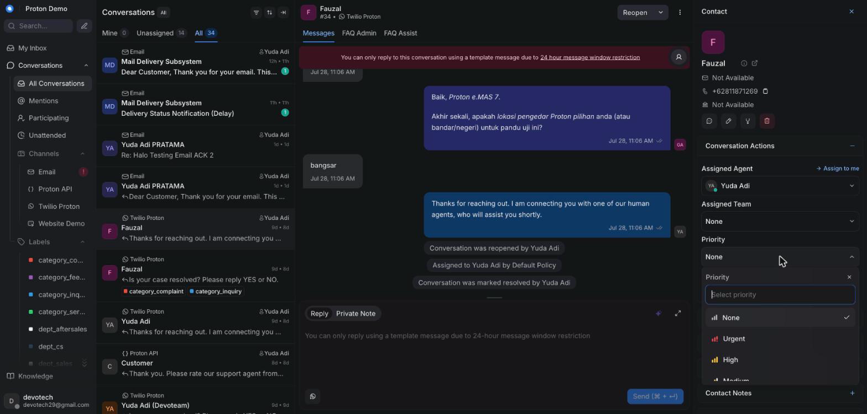
Setting a conversation's priority

Example scenario
A call reporting a vehicle breakdown on the highway is marked Urgent so it surfaces at the top of the queue and gets picked up immediately for roadside-assistance follow-up.

Integrations & automation
A conversation's priority flag is separate from, but complements, the per-agent channel handling order administrators can configure in Administration → Inboxes, which decides which agent gets auto-assigned first for a given channel.

Private notes

What it is
Internal messages attached to a conversation that only agents and administrators can see — never the customer. Used for handoff context, questions to a teammate, or reviewing an AI-drafted reply before sending it.

Where to find it
The reply box's note mode, toggled from the main "reply" mode.

How to use it
1. Open the conversation and click into the reply box.
2. Switch the reply box to its private "Note" mode.
3. Type your note — mention a teammate with @ if you need their input (see Mentions below).
4. Send the note; it posts as private and is visually distinct from a customer-facing reply.
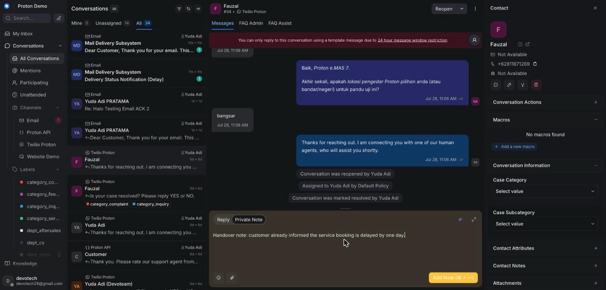
Adding a private note visible only to agents

Example scenario
An agent handing off their shift leaves a private note summarizing that the customer has already been told their service booking is delayed by a day, so the next agent doesn't repeat the same message.

Integrations & automation
Private notes are exactly how an AI-drafted reply arrives when the AI assistant is running in suggest mode (see AI auto-draft below), and where Ask Copilot answers land when inserted into the conversation.

Canned responses

What it is
Pre-written reply snippets for common questions, so agents don't retype the same answer over and over.

Where to find it
A shortcut inside the reply box, typically triggered by typing a character like "/" or clicking a canned-response icon.

How to use it
1. Click into the reply box.
2. Trigger the canned-response search (for example, typing "/").
3. Search by the short code or keyword for the response you need.
4. Select it — it's inserted into the reply box.
5. Edit if needed, then send as normal.
Screenshot: Inserting a canned response into a reply

Example scenario
For a frequently asked question about e.MAS charging cable compatibility, an agent inserts the matching canned response instead of retyping the same answer for the tenth time that day.

Integrations & automation
Canned responses are created and maintained by administrators (see the Administration chapter), which keeps the wording consistent across the whole team.

Macros

What it is
A macro bundles a sequence of actions — for example, adding a label, assigning a team, sending a reply, and marking the conversation resolved — so an agent can run all of them in a single click instead of doing each step by hand.

Where to find it
The macro option in the conversation's action menu, inside an open conversation.

How to use it
1. Open the conversation you want to act on.
2. Open the macro menu from the conversation's action area.
3. Pick the macro you want to run from the list.
4. Confirm — its steps run automatically in order (for example: apply a label, send a reply, then resolve).
5. Check the conversation afterward to confirm every step applied as expected.
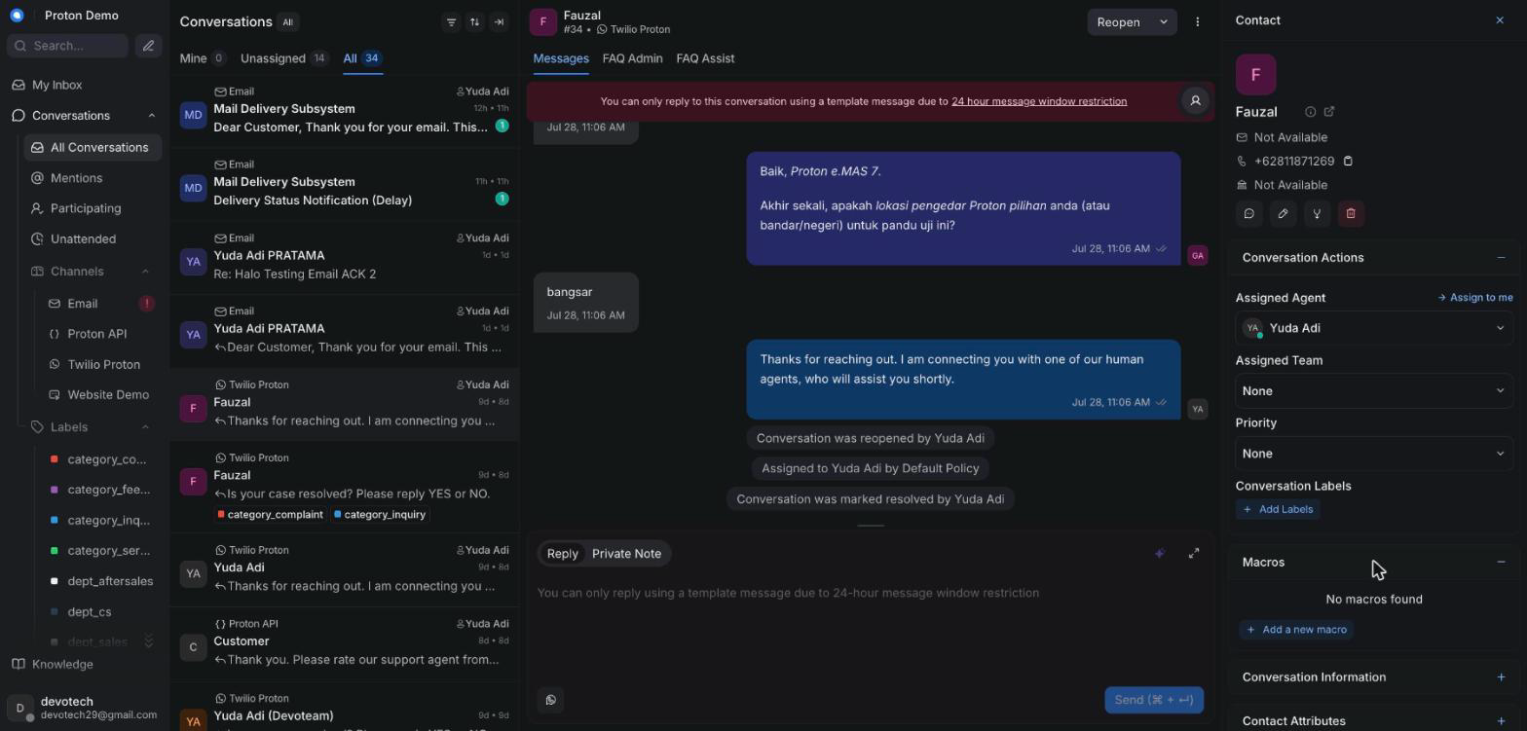
Running a macro from an open conversation

Example scenario
An agent closes out a routine "test drive confirmed" conversation by running a single macro that adds a confirmed label, sends the standard confirmation message, and marks the conversation resolved.

Integrations & automation
Agents can only run macros that already exist — building or editing what a macro does is administrator work, covered in the Administration chapter.

Mentions

What it is
Typing @ followed by a teammate's name inside a private note to notify them directly — useful for handoffs or asking for a second opinion.

Where to find it
Inside the private-note editor in the reply box.

How to use it
1. Switch the reply box to note mode.
2. Type @ followed by the teammate's name.
3. Select them from the suggestion list that appears.
4. Finish writing your note and send it — the mentioned teammate is notified.
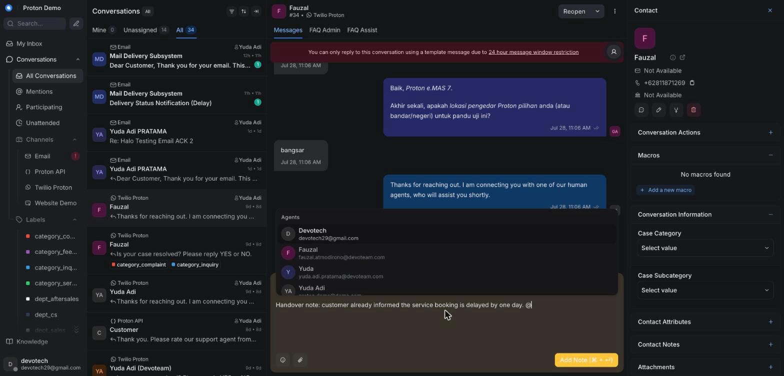
Mentioning a teammate in a private note

Example scenario
Unsure how to answer a question about an extended warranty case, an agent mentions their team lead in a private note to ask for guidance before replying to the customer.

Integrations & automation
Mentions only work inside private notes, so a mentioned teammate is notified without the customer ever seeing it.

Ask Copilot panel

What it is
A chat panel next to the conversation where an agent can ask an AI assistant questions about the customer or the topic at hand, and get answers grounded in the knowledge base. Each answer is followed by a "Looked at" line naming which knowledge tools it consulted, and — when sources are available — a "Sources" line with each source title, shown as a clickable link where one exists or as plain text otherwise.

Where to find it
Opened from a Copilot button above the reply box, on the right side of the conversation.

How to use it
1. Open the conversation you need help with.
2. Click the Copilot button above the reply box.
3. Type your question in the panel's chat box and send it.
4. Read the answer, along with the "Looked at" line noting which knowledge tools (for example, a knowledge-base search) it used to answer, and the "Sources" line underneath when it has one — click a source to open it, or read its title if it isn't linked.
5. Click "Insert into reply" on any answer you'd like to drop straight into your draft.
6. Reset the panel to start a fresh question thread, or close it when you're done.
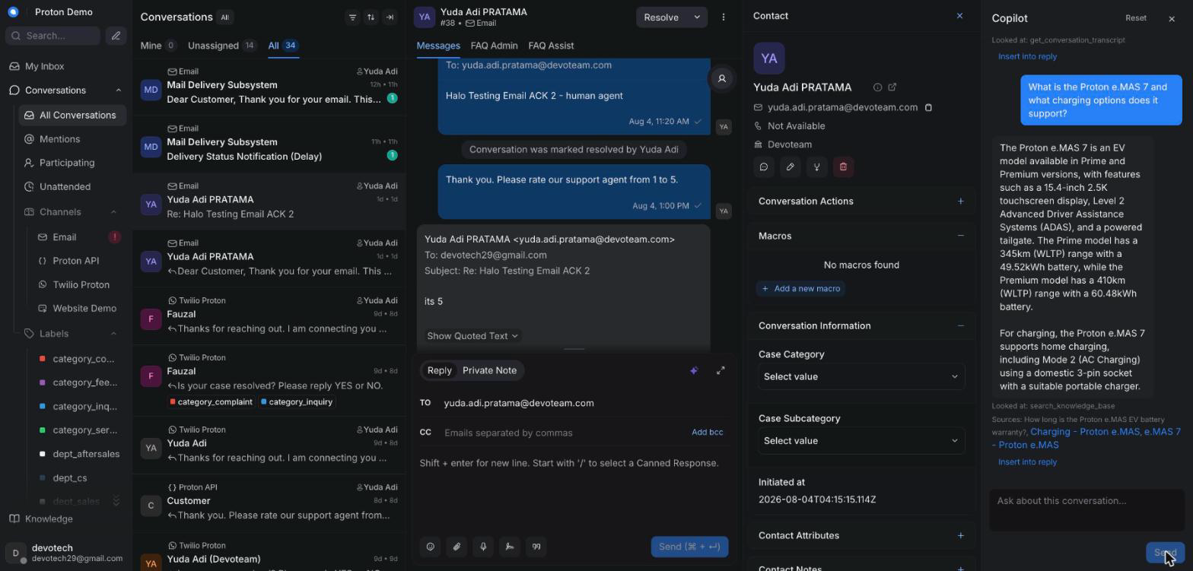
Asking the Copilot panel a question and seeing its "Looked at" line

Example scenario
While handling a report of a charging error code on an e.MAS 5, an agent asks Copilot what the error code means and how it's usually resolved, then inserts the grounded answer straight into their reply.

Integrations & automation
Copilot draws on the same knowledge base and per-inbox assistant configuration covered in the Knowledge chapter and the AI assistant behaviour chapter; it's a feature an administrator can turn on or off per tenant.

Suggest-a-reply

What it is
A one-click AI-drafted reply for the conversation you're currently in, based on the conversation so far and the knowledge base, placed directly in the reply box for you to review before sending — with a "Sources" line showing what it was grounded in.

Where to find it
A "Suggest reply" action above the reply box.

How to use it
1. Open the conversation.
2. Click "Suggest reply" above the reply box.
3. Wait a moment for the draft to appear in the reply box.
4. Check the Sources line underneath the draft for the knowledge-base articles it drew on.
5. Edit the draft if needed, then send it like any other reply.
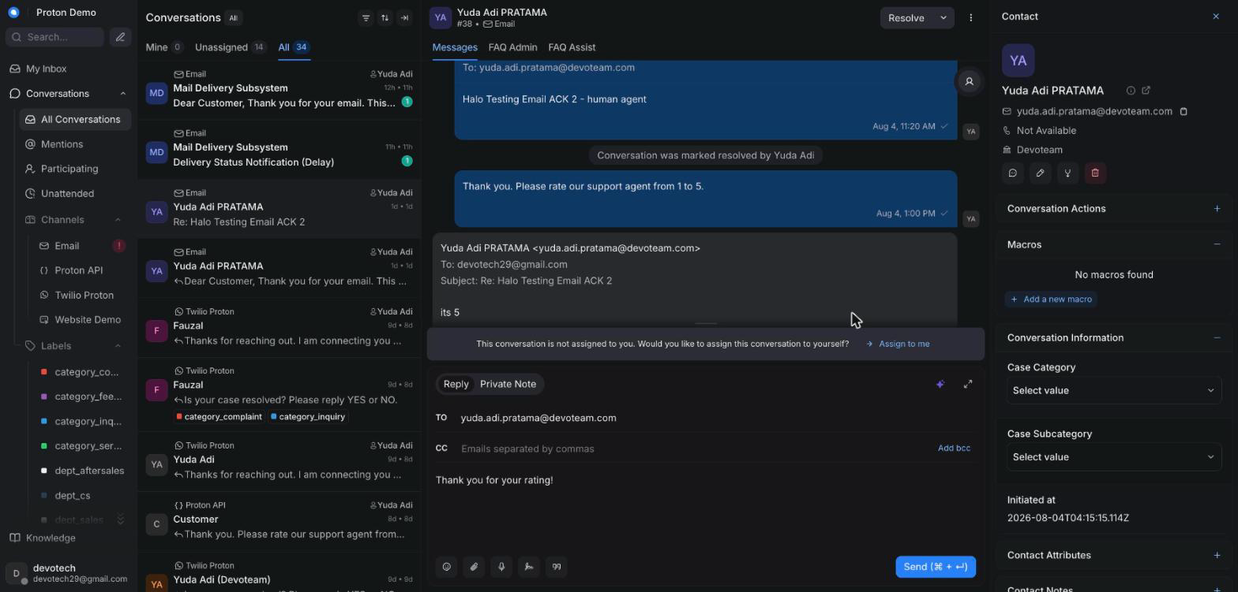
A suggested reply drafted in the reply box with its source citations

Example scenario
A customer asks about the cancellation policy for a service booking; the agent clicks Suggest reply, receives a draft citing the relevant FAQ article, adjusts the tone slightly, and sends it.

Integrations & automation
Suggest-a-reply draws on the same knowledge base as Ask Copilot and the AI auto-draft behaviour described below; its source citations link back to content covered in the Knowledge chapter.

Summarize conversation

What it is
Generates a short summary of the conversation so far — useful for a quick catch-up or for handing a conversation off to another agent.

Where to find it
A "Summarize" action above the reply box.

How to use it
1. Open the conversation you want to summarize.
2. Click "Summarize" above the reply box.
3. Wait a moment for the summary to be generated.
4. The summary is inserted into the reply box as a draft, switched to private "Note" mode — it is not posted automatically, so review it and click send yourself to add it to the conversation.
5. Read it before handing the conversation to a teammate, or to refresh your own memory of a long-running case.
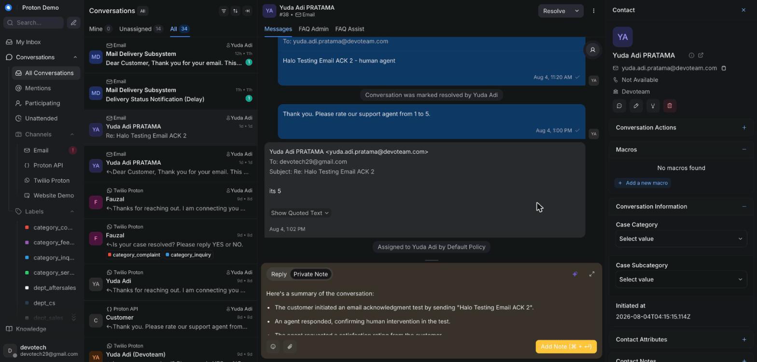
Generating a conversation summary for a quick catch-up or handover

Example scenario
Before going off shift, an agent summarizes a long-running roadside assistance conversation so the next agent can immediately see the vehicle's status and what's already been arranged.

Integrations & automation
The summary is written in English regardless of the conversation's original language, matching Proton's internal reporting standard.

AI auto-draft and suggest-vs-auto mode

What it is
The AI assistant can act on incoming customer messages on its own, without an agent asking it to. It always works in one of two modes, set per inbox by an administrator: suggest mode (the default), where it drafts a reply as a private note and reopens the conversation for a human to review and send; or auto mode, where it sends its reply straight to the customer.

Where to find it
Not something an agent turns on or off — it's configured per inbox by an administrator. Agents simply see its effects appear inside conversations.

How to use it
1. Watch for a private note marked as a suggested reply on a conversation the AI has just handled — that means the inbox is in suggest mode.
2. Read the suggested draft, edit it if needed, then send it yourself as a normal reply. The AI never sends this for you.
3. On an inbox running in auto mode, the AI's reply is sent to the customer directly and the conversation stays in Pending while the AI keeps handling it — it only moves to Open once the AI hands off or an agent steps in.
4. If the AI can't confidently help, it hands the conversation off to a human on its own — reopening it and, if configured, posting a brief acknowledgement to the customer first.
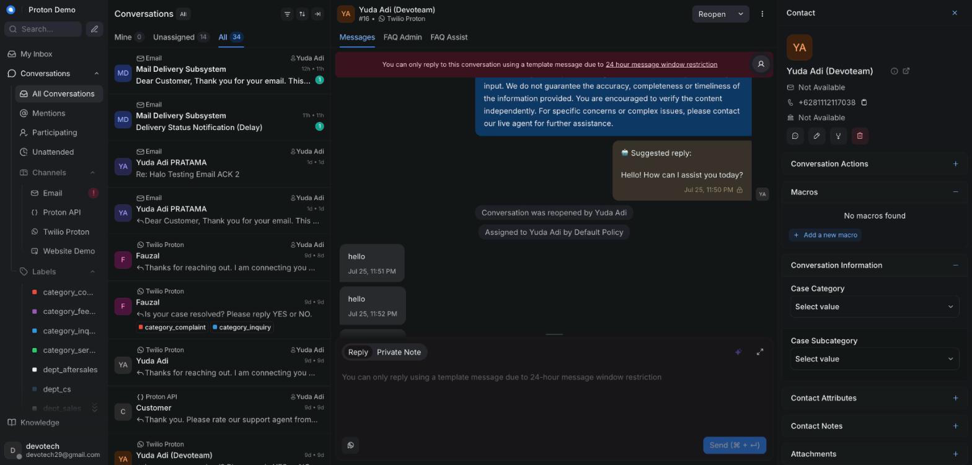
An AI-drafted reply posted as a private note awaiting agent review

Example scenario
On a WhatsApp inbox running suggest mode, a customer asks about the price of an e.MAS X service package; the AI drafts an answer as a private note, the on-duty agent reviews it, adjusts the price wording, and sends it as their own reply.

Integrations & automation
Suggest-vs-auto mode is a per-inbox setting administrators manage; when the AI can't answer, it hands off to a human automatically. See the AI assistant behaviour chapter for the full explanation of when it replies, escalates, or hands off.

Contact side panel

What it is
A panel next to the conversation showing the customer's details, past conversations, and notes, so you don't have to leave the conversation to see who you're talking to.

Where to find it
The right side of an open conversation. It now opens by default, rather than needing to be expanded manually each time.

How to use it
1. Open any conversation — the contact panel opens automatically.
2. Scroll through it to see contact details, conversation history, and any existing notes.
3. Collapse or expand it manually if you want more room for the conversation itself; your choice is remembered for next time.
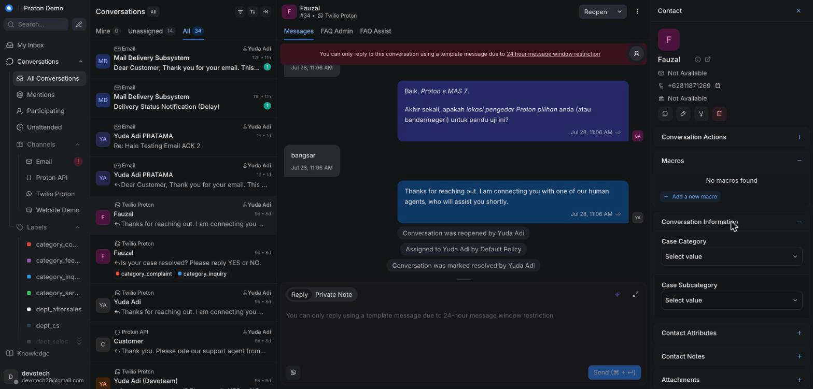
The contact side panel open next to a conversation

Example scenario
While chatting with a returning EV owner about a second service booking, an agent glances at the contact panel to confirm the vehicle model already on file instead of asking the customer to repeat it.

Integrations & automation
The contact panel is the entry point to the fuller contact profile and Customer 360 lookup tools covered in the Contacts chapter.

Resolving, snoozing & transcripts

What it is
The actions that close out a conversation (Resolved), pause it for later (Snoozed), or let you review and export its full message history (transcript).

Where to find it
Action buttons in the conversation header, and a menu option for exporting the transcript.

How to use it
1. Once the customer's issue is fully handled, click Resolve.
2. If you need to come back to a conversation later — for example, waiting on the customer or a dealer — click Snooze and choose when it should reopen.
3. A snoozed conversation reopens automatically at the chosen time, or immediately if the customer replies first.
4. To get a transcript of the conversation, open the conversation's menu and choose the transcript/export option.
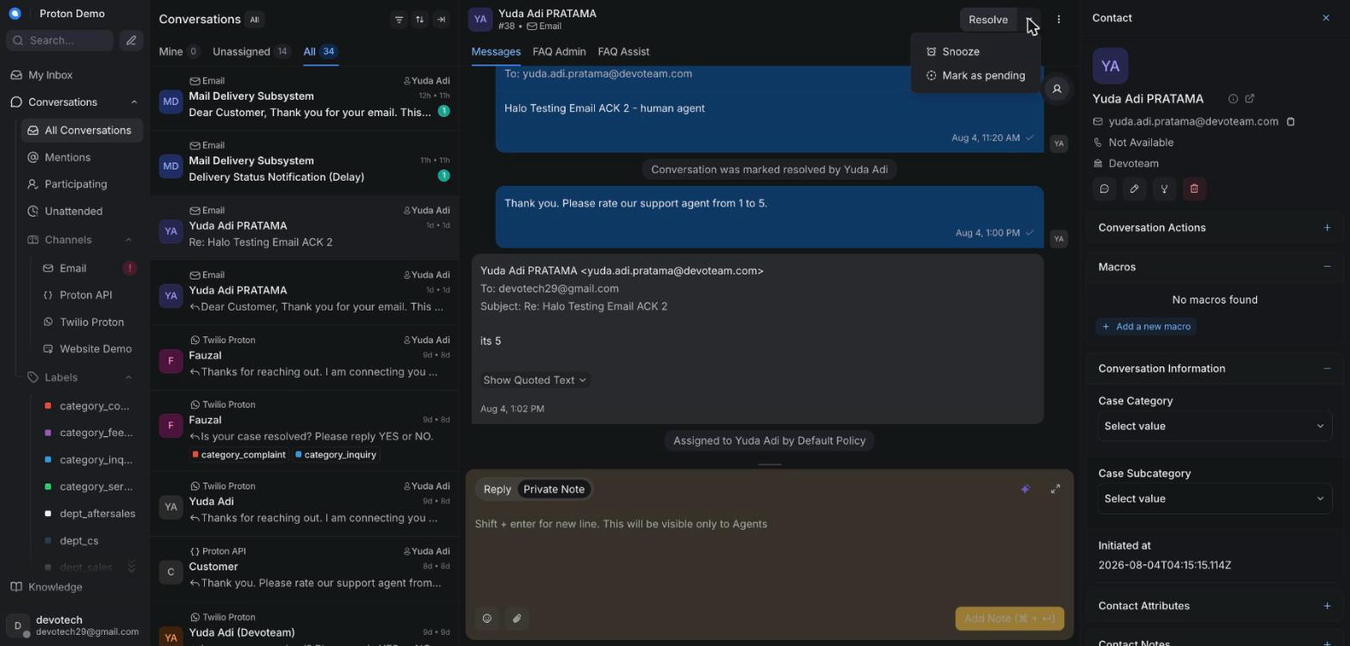
Resolving or snoozing a conversation

Example scenario
A test-drive scheduling conversation is snoozed for two days while the customer checks their calendar; it reopens automatically when they reply, and once the drive is booked the agent marks it Resolved.

Integrations & automation
Conversations can also close automatically due to inactivity timers an administrator sets per inbox — an idle warning is posted first, then an automatic close after a grace period (see the Administration chapter). A conversation resolved this way may also trigger a satisfaction-survey message, covered in the AI assistant behaviour chapter.

Contacts

Contacts list & search

What it is
The Contacts area lists everyone who has ever messaged in — across WhatsApp, email, and phone/IVR — as a single directory of customers, separate from the Conversations view's per-channel threads.

Where to find it
Contacts in the main sidebar.

How to use it
1. Open Contacts from the sidebar to see the full customer list.
2. Use the search box to find a customer by name, phone number, or email address.
3. Use the available filters to narrow the list (for example, by the channel a customer last used).
4. Click a customer's row to open their contact profile.
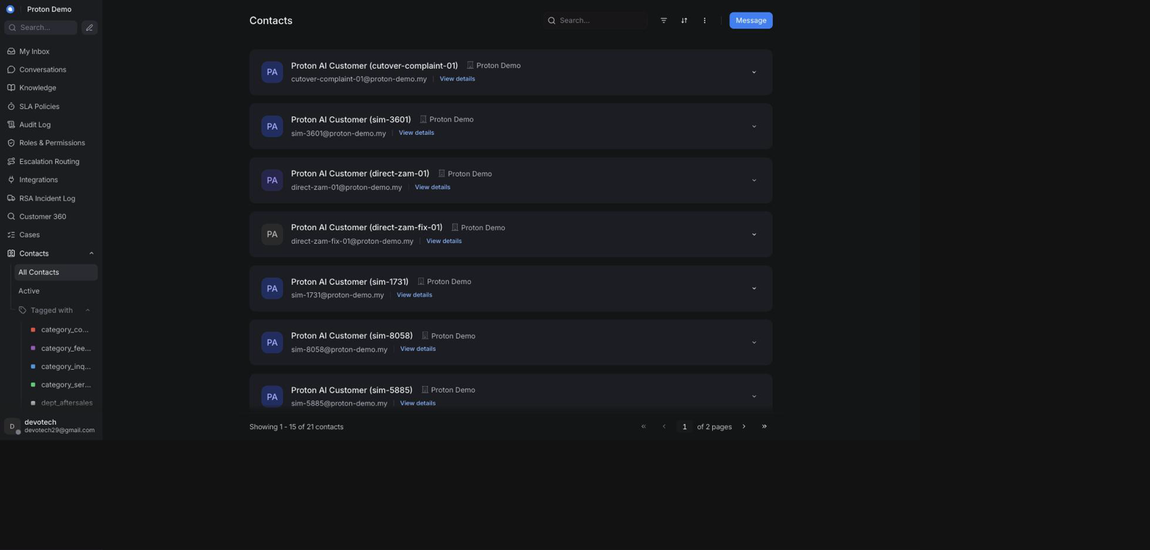
The contacts list with search and filters

Example scenario
An agent taking a phone call for a customer who has previously written in on WhatsApp searches Contacts by the customer's phone number to confirm they're speaking with an existing customer before opening a new conversation.

Integrations & automation
Every contact created through an inbound WhatsApp, email, or phone/IVR message is added here automatically by Chatwoot — there is no separate manual step to add a customer who has already messaged in.

Contact profile & history

What it is
A contact's profile is a single page showing everything the CRM knows about that customer: their basic details and custom attributes (for example, vehicle model), plus every conversation they've ever had across every channel.

Where to find it
Click any customer in the Contacts list, or open the contact side panel from an active conversation and click through to the full profile.

How to use it
1. Open a contact from the Contacts list or from an open conversation's contact panel.
2. Review their contact details and custom attributes at the top of the profile.
3. Scroll the conversation history to see every past conversation with this customer, regardless of channel or status.
4. Click any past conversation in the list to reopen and review it.
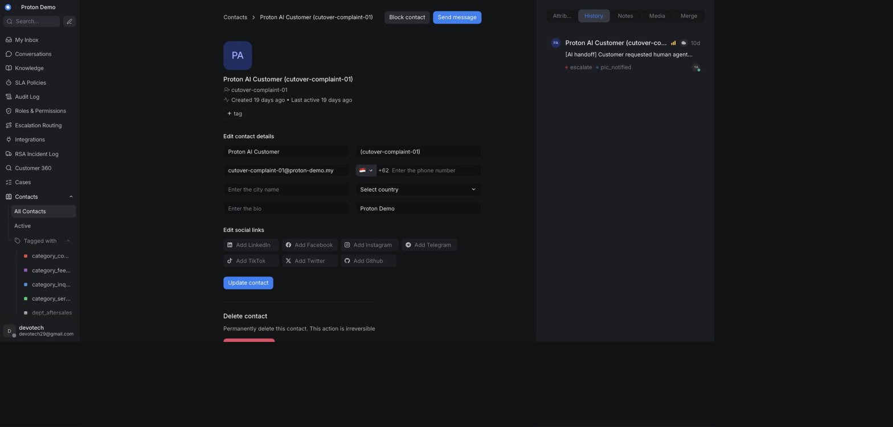
A contact's profile showing their conversation history

Example scenario
Before replying to a new service complaint, an agent opens the customer's profile and sees a previous conversation from three months ago about the same vehicle, giving useful context before responding.

Integrations & automation
Conversation history shown here is what the Customer 360 lookup (below) also draws on when it lists a customer's conversations, so the two views never disagree about which conversations belong to a customer.

Notes & segments

What it is
Notes let staff record customer-level context that isn't tied to a single conversation (for example, a standing delivery preference). Segments are saved contact filters — a named, reusable version of a Contacts search you'd otherwise have to rebuild every time.

Where to find it
Notes live on the contact's profile; segments are created from the Contacts list's filter/search bar and then appear as a saved view in the Contacts sidebar area.

How to use it
1. To add a note, open the contact's profile and use the notes area to record context about that customer.
2. To create a segment, open Contacts, build a filter (for example, by channel or a custom attribute), and save it with a name.
3. Reopen a saved segment at any time from the Contacts sidebar to reapply the same filter without rebuilding it.
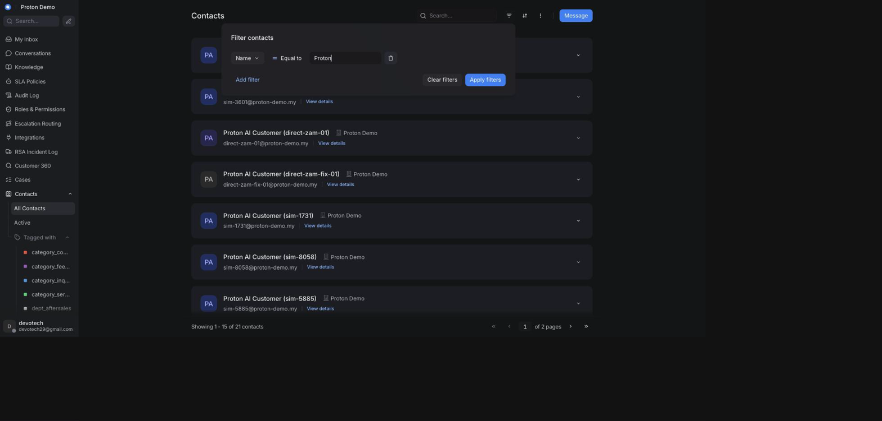
Creating or applying a contact segment

Example scenario
A dealer-relations coordinator saves a segment for customers tagged with a particular dealer's custom attribute, then reopens it weekly instead of re-entering the same filter each time.

Integrations & automation
Notes and segments are contact-level only — they don't feed the AI assistant's replies or any of the reports in the Reports chapter.

Customer 360

What it is
Customer 360 is a single search box that looks a customer up by phone number or vehicle number and brings together, on one page, what the CRM already knows about them: their matching contact record, every conversation they've had across channels, any roadside-assistance (RSA) incidents tied to their vehicle, and — where the DMS/TSP integration is configured (see the Administration chapter's Integrations section) — a vehicle and service-history block. It's read-only: nothing here can be created, edited, or deleted; contact details are still edited from the contact's own profile, and RSA incidents from the RSA Incident Log chapter's page.

Where to find it
Customer 360 in the main sidebar. This page is only visible to administrators who have also been granted the Customer 360 permission (see the Administration chapter's Roles & Permissions section) — an administrator without that permission won't see it in their sidebar.

How to use it
1. Open Customer 360 from the sidebar.
2. Enter a phone number or a vehicle number in the search box (at least two characters).
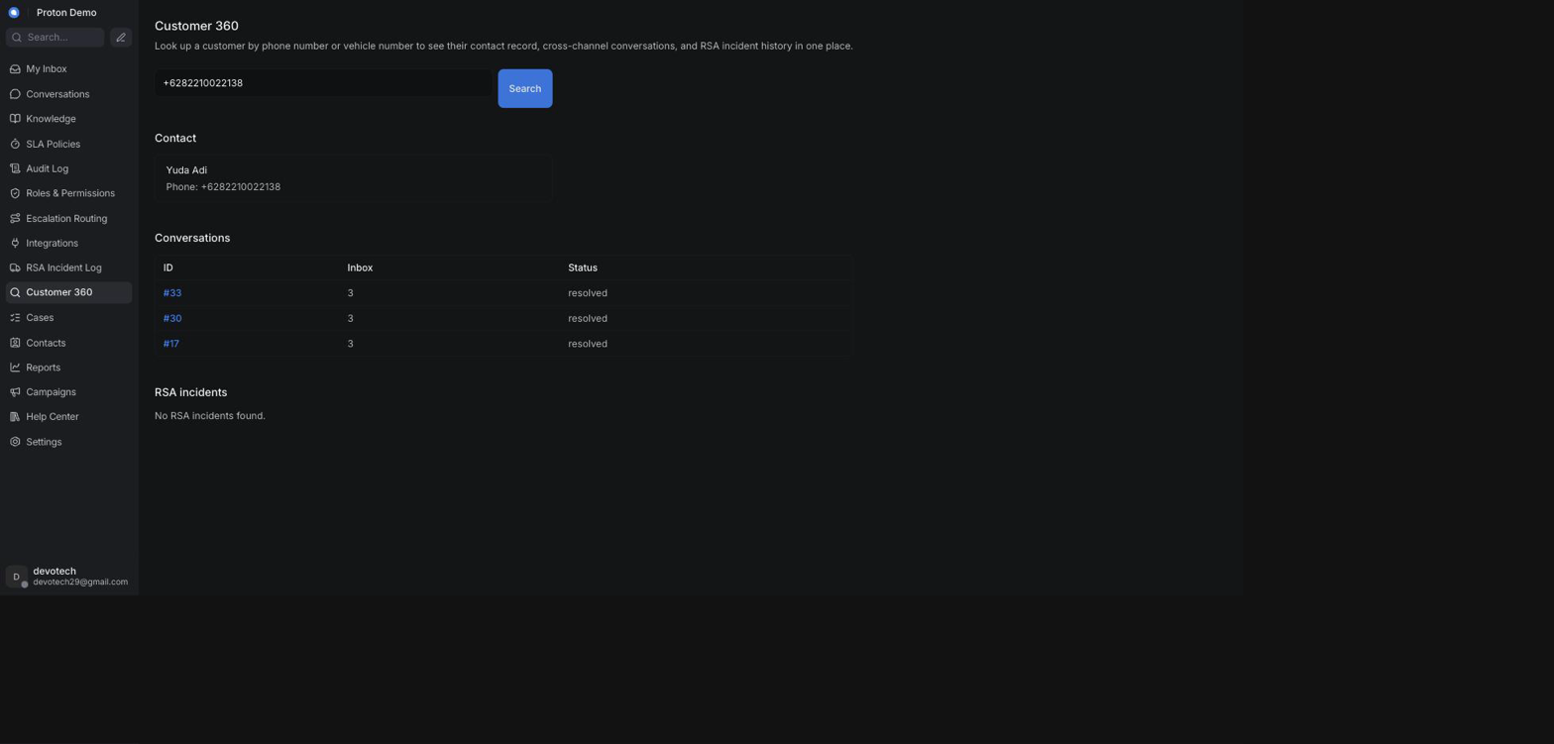
Searching Customer 360 by phone number or vehicle number

3. Click Search.
4. Review the Contact section for the matching customer's name, phone number, and email — searching by phone number looks for an exact match; searching by vehicle number instead matches any conversation whose noted vehicle model contains that value, so the conversations shown can differ slightly between the two search modes for the same customer.
5. Review the Conversations table — every conversation for the matched contact (or matching the vehicle), across any channel or status. Click a conversation's ID to open it.
6. Review the RSA incidents table — any roadside-assistance incidents whose vehicle number matches the search (see the RSA Incident Log chapter).
7. If a DMS / TSP section appears, review the customer's vehicles and service history from the connected dealer-management/telematics system; a "Not connected" notice means the integration couldn't be reached, and a "Mock data" notice means the results shown are demo data rather than a live system.
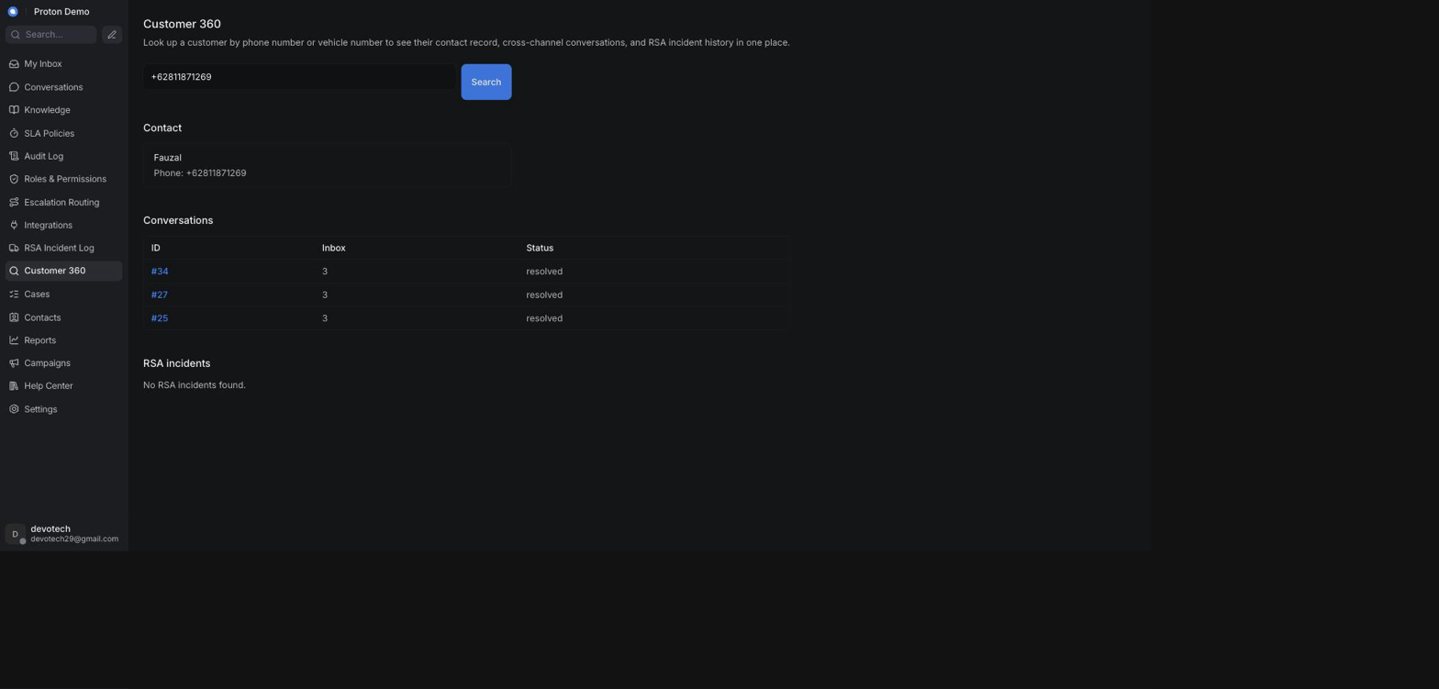
Customer 360 results showing vehicle and service history

Example scenario
A dealer calls asking whether a customer who bought a Proton e.MAS 7 has any open issues. The operator searches Customer 360 by the customer's phone number and sees, in one place, an open WhatsApp conversation about a charging fault, a closed RSA incident from the previous month for the same vehicle, and — since the dealership's DMS/TSP connection is configured — that vehicle's last two service visits, without switching between separate systems.

Integrations & automation
Customer 360 doesn't store anything of its own — it reads live from Chatwoot's contacts and conversations, from the RSA Incident Log (covered in the RSA Incident Log chapter), and, when enabled, from the DMS/TSP connection configured under the Administration chapter's Integrations section. If that connection isn't configured or isn't reachable, Customer 360 still works — it simply shows the CRM's own data without the vehicle/service-history block.

Knowledge
The Knowledge area is where administrators and agents manage everything that shapes how the AI assistant answers customers: the facts it can quote (FAQs, Documents), the personas it can speak as (Assistants), the playbooks and tools it can use (Scenarios, Tools), which inbox it is switched on for (Inboxes), and how it behaves (Settings). It sits in its own section of the left-hand navigation, separate from Conversations and Contacts, because it is configuration rather than day-to-day case work — most of it is used by administrators, though any agent with access can browse it to understand why the assistant answered the way it did.

FAQs

What it is
FAQs is the live, editable question-and-answer knowledge base the AI assistant is grounded on. Each entry pairs a customer question with the exact answer to give, plus optional keywords and tags to help matching. Unlike the Documents corpus (see the next section), FAQ entries are edited directly in the CRM and take effect immediately — there is no separate publishing step.

Where to find it
In the left-hand navigation, open Knowledge and select FAQs.

How to use it
1. Open Knowledge → FAQs. The page lists every entry with its question, answer, keywords, tags, and whether it is active.
2. To add an entry, click + New entry, fill in Question and Answer (both required), and optionally Keywords and Tags as comma-separated lists. Leave Active checked so the entry is usable for grounding, then save.
3. To change an entry, click Edit on its row, update the fields, and save.
4. To remove an entry, click Delete on its row and confirm.
5. Use the filter box at the top to search by question, keyword, or tag across all entries.
6. To add many entries at once, click Bulk upload (CSV), choose a .csv file, and wait for the confirmation message. It reports how many entries were created and, if any rows were skipped, which row numbers and why.
The CSV file must be UTF-8 text with a header row using exactly these column names:
Column | Required | Format | Notes
question | Yes | text | Row is skipped if empty.
answer | Yes | text | Row is skipped if empty.
keywords | No | multiple values separated by ; | Left blank for no keywords.
tags | No | multiple values separated by ; | Left blank for no tags.

Entries created through the bulk upload are always saved as active — if you need an imported entry to start out inactive, edit it afterwards and uncheck Active.
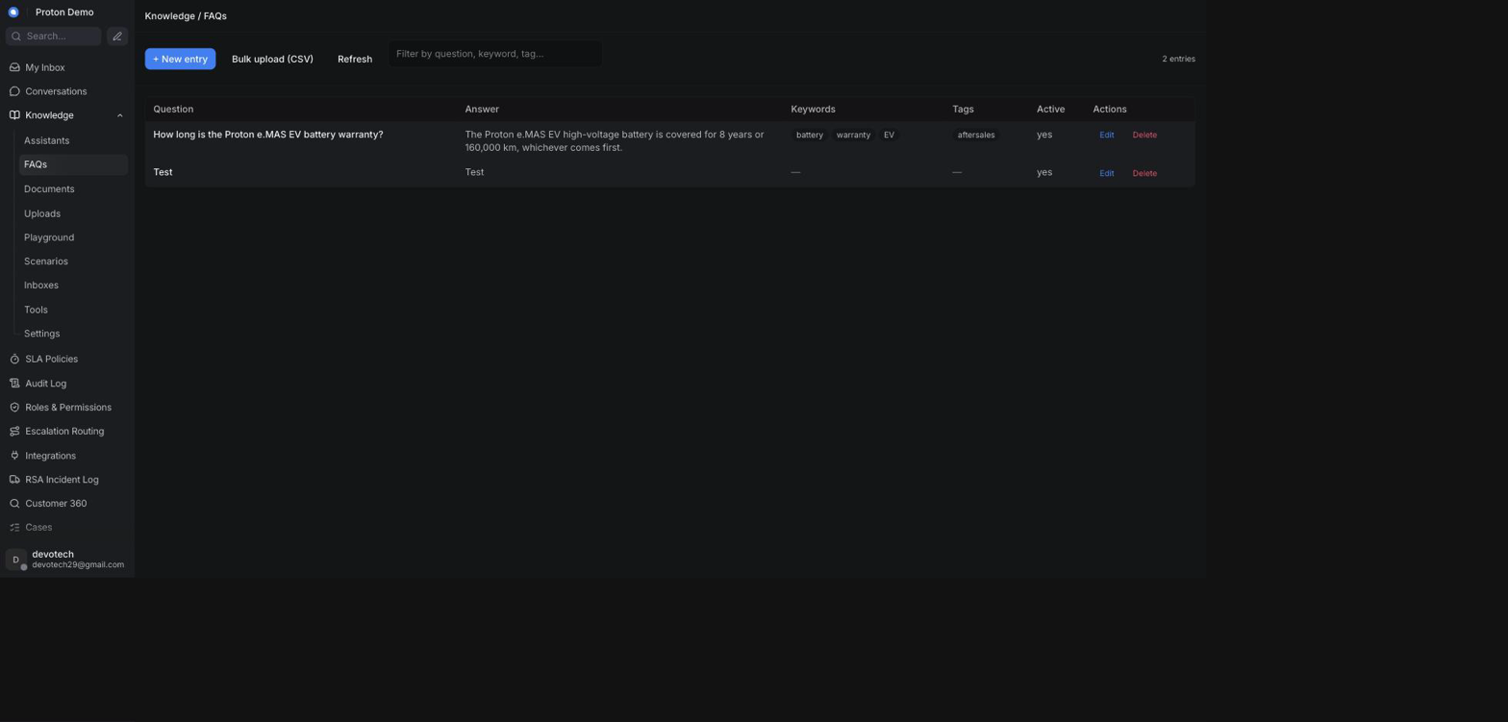
The FAQs list under Knowledge

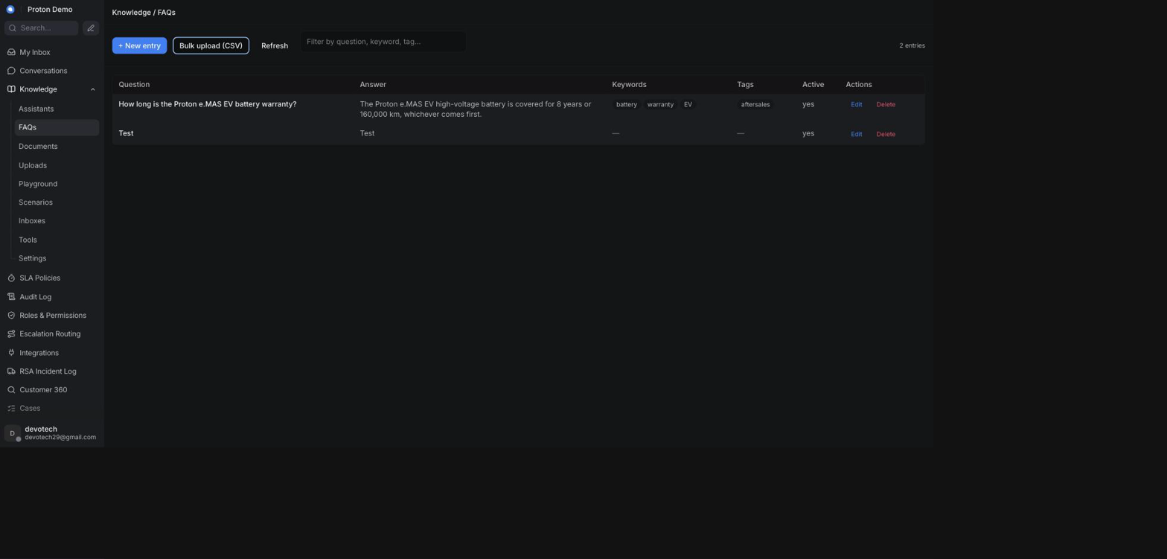
Bulk-uploading FAQs from a CSV file

Example scenario
Proton's service team compiles a spreadsheet of 40 frequently asked questions about the e.MAS 7 warranty ahead of a launch event. Instead of typing each one in by hand, the administrator exports the spreadsheet as a CSV with question/answer/keywords/tags columns and uses Bulk upload (CSV) to import all 40 entries in one go, then spot-checks a few of them in Playground before the launch.

Integrations & automation
FAQ entries are part of the knowledge base the assistant draws on for Suggest-a-reply, the Ask Copilot panel, and AI auto-drafted replies (see Conversations and AI Behaviour). Toggling an entry's Active flag off removes it from grounding immediately, without deleting it.

Documents

What it is
Documents covers the larger, bulk knowledge corpus that also grounds the assistant's answers, alongside FAQs. It has two related views in the left-hand navigation:
• Documents — a read-only listing of everything indexed in the tenant's bulk search corpus (product manuals, policies, and similar material loaded outside the CRM), so administrators and agents can see what the assistant can quote from.
• Uploads — where operators add their own text or files directly from the CRM; these are queued for indexing and become searchable once processing finishes.

Where to find it
In the left-hand navigation, open Knowledge and select Documents for the read-only corpus listing, or Uploads to add new material.

How to use it

Browsing the indexed corpus (Documents)
1. Open Knowledge → Documents. Each row shows a document's title, a link to its source (if available), and a short snippet.
2. Use the filter box to search by title, link, or snippet.
3. Click Refresh to reload the list after new material has finished indexing elsewhere.
This view is read-only from the CRM — there is no upload, edit, or delete here; use Uploads instead to add operator-authored material.

Adding operator-authored material (Uploads)
1. Open Knowledge → Uploads.
2. To paste text directly, click + Add text, give it a Title, paste the content into Body, and submit.
3. To upload a file instead, click Upload file and choose a .pdf, .docx, .md, .txt, or .markdown file.
4. Watch the Status column: new documents start as pending while they are processed, then move to indexed once searchable, or failed if something went wrong (hover the badge for the reason).
5. To remove a document you added, click Delete on its row and confirm.
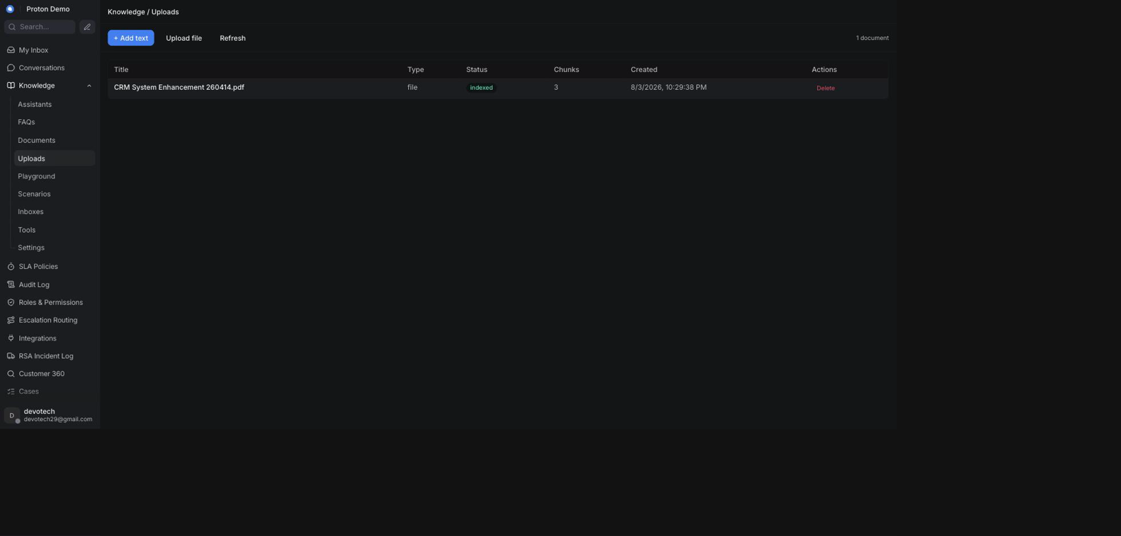
Uploading a document to the knowledge base

Example scenario
An administrator wants the assistant to be able to answer detailed questions about the Proton X50 owner's manual. Rather than writing FAQ entries for every possible question, they upload the manual as a PDF under Uploads and wait for it to reach indexed status, after which the assistant can draw on it directly.

Integrations & automation
Both the read-only corpus and the operator-authored uploads feed the same grounding the assistant uses for Suggest-a-reply, Ask Copilot, and Playground answers (see Conversations). Uploads that finish indexing become available to every assistant persona automatically — there is no separate step to attach a document to a specific assistant.

Assistants

What it is
An Assistant is a named AI persona: its own name, description, and product context, with its own instructions, temperature, guardrails, and tool access, configured on the Settings and Tools pages. Most tenants only need one, and a Default Assistant always exists so nothing has to be configured before the AI works. Larger tenants can create additional assistants — for example, one per product line or department — and pick which one answers on which inbox (see Inboxes).

Where to find it
In the left-hand navigation, open Knowledge and select Assistants.

How to use it
1. Open Knowledge → Assistants to see every assistant, with a default badge on the one used when no other assistant is assigned.
2. To create one, click + New assistant, enter a Name (required), optional Description and Product name, and save.
3. To change one, click Edit on its row, update the fields, and save.
4. To remove one, click Delete on its row and confirm — the default assistant cannot be deleted; make another assistant the default first if you need to retire it.
5. Once an assistant exists, pick it from the Assistant selector shown at the top of the Scenarios, Playground, Tools, and Settings pages to configure or test that specific persona.
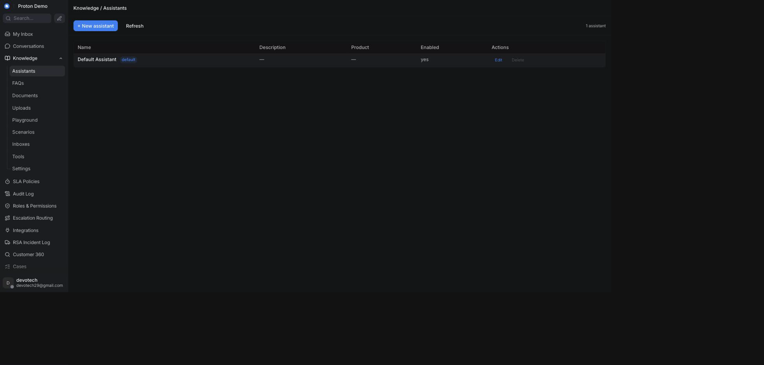
The Assistants list under Knowledge

Example scenario
Proton's dealership arm wants the same CRM tenant to answer both new-car sales questions and after-sales service questions with a different tone for each. An administrator creates a second assistant named "Proton Service Assistant" alongside the default sales-focused one, then assigns it to the after-sales WhatsApp inbox under Inboxes.

Integrations & automation
The assistant selected in the header of Scenarios, Playground, Tools, and Settings is shared across those pages during a session, so switching it in one place carries over to the others. Which assistant actually answers on a given conversation is controlled from Inboxes.

Scenarios

What it is
A Scenario is a named playbook — a block of instructions, scoped to one assistant, that gets added to that assistant's behaviour when the scenario is turned on. Use it to give the assistant extra guidance for a specific situation (for example, how to handle a recall notice or a warranty claim) without rewriting its whole persona. A scenario can also be tied to specific tools so the assistant knows which ones to reach for in that situation.

Where to find it
In the left-hand navigation, open Knowledge and select Scenarios.

How to use it
1. Open Knowledge → Scenarios and pick the assistant you want to manage scenarios for, using the Assistant selector at the top.
2. To create one, click + New scenario, enter a Title (required), an optional short Description, and the Instruction text the assistant should follow when this scenario applies.
3. Optionally tick which Tools the assistant should have available for this scenario, from the built-in and custom tools already registered under Tools.
4. Leave Enabled checked so the scenario is active, then save.
5. To turn a scenario on or off without editing it, use the toggle switch in its row.
6. To change or remove a scenario, click Edit or Delete on its row.
Each assistant can hold a limited number of scenarios, and the instruction text has a maximum length — the page shows a character counter and will not let you save past the limit.
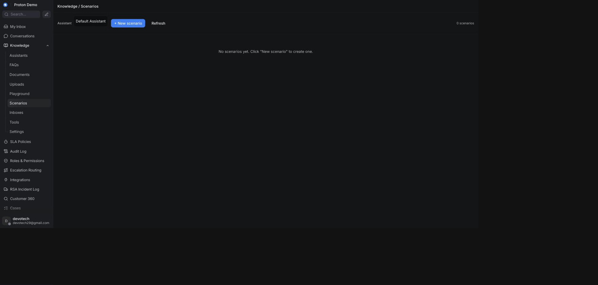
The Scenarios list under Knowledge

Example scenario
Proton issues a service campaign for a steering component on the X70. The administrator creates a "Steering component recall" scenario on the Service Assistant with instructions to ask for the vehicle number, check it against the recall list using the relevant tool, and direct affected customers to book a service appointment.

Integrations & automation
Enabled scenarios are folded into the assistant's behaviour wherever that assistant answers — in Playground testing and in real conversations alike. Disabling a scenario removes its instructions immediately without deleting it, so it can be re-enabled later.

Playground

What it is
Playground is a sandbox for trying out an assistant outside any real conversation. It behaves like the Ask Copilot panel in a conversation — you type a question, the assistant answers using its configured knowledge and tools, and the reply shows which tools it used and any sources it drew on — but nothing here reaches a customer.

Where to find it
In the left-hand navigation, open Knowledge and select Playground.

How to use it
1. Open Knowledge → Playground and pick the assistant to test with the Assistant selector at the top. Switching assistants starts a fresh conversation.
2. Type a question in the box at the bottom and press Enter (use Shift+Enter for a new line) or click Send.
3. Read the reply. If the assistant used a tool, a Looked at: line names it; if it cited sources, they appear as clickable links underneath.
4. Continue the back-and-forth as needed — each new message includes the full thread so far.
5. Click Reset to clear the conversation and start over.
6. Optionally expand Advanced to supply a real conversation ID, which lets you exercise tools that look up customer or ticket context as if you were inside that conversation.
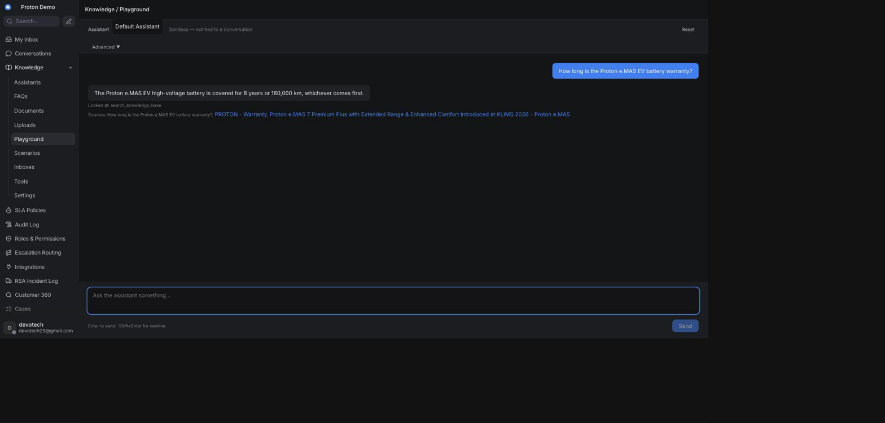
Testing a question in the Playground before it goes live

Example scenario
After bulk-importing new e.MAS 7 warranty FAQ entries, an administrator opens Playground, selects the Sales Assistant, and asks a few of the same questions a customer might ask (for example, "Berapa lama garansi baterai e.MAS 7?") to confirm the assistant answers correctly before customers start seeing it live.

Integrations & automation
Playground uses the same assistant configuration, knowledge base, and tools as real conversations, so a question that works in Playground will behave the same way when a customer asks it for real. Nothing typed in Playground is saved to a real conversation or visible to customers.

Tools

What it is
Tools are the actions an assistant is allowed to take beyond answering from text — looking things up or calling out to another system. There are two kinds:
• Built-in tools — capabilities that ship with the platform; you can only turn them on or off and adjust their description.
• Custom tools — webhook-based tools an administrator defines to call an external HTTPS endpoint (for example, a dealer's own booking or parts-lookup system).
Which of the registered tools an assistant may actually use is then set per-assistant, further down the same page.

Where to find it
In the left-hand navigation, open Knowledge and select Tools.

How to use it
1. Open Knowledge → Tools. The Built-in tools table lists every built-in tool with an editable description and an Enabled checkbox; click Save on a row after changing it.
2. To add a custom tool, click + New custom tool in the Custom tools section and fill in:
◦ Title and Description (shown to the assistant).
◦ Endpoint URL — must start with https://.
◦ HTTP method — GET or POST.
◦ Auth type — none, bearer token, basic (username/password), or an API key header; the corresponding secret fields appear once you pick one, and are never shown again after saving (leave them blank on an edit to keep the existing secret).
◦ Optionally a param_schema (a JSON description of the tool's inputs), a request template, and a response template.
◦ Enabled, so the tool is available to be assigned to an assistant.
3. Save. Custom tools are capped at a fixed number per tenant, shown as a count next to the section heading.
4. To change or remove a custom tool, click Edit or Delete on its row.
5. Scroll to Per-assistant enablement, pick an assistant with the Assistant selector, tick which built-in and custom tools that assistant may call, and click Save enablement.
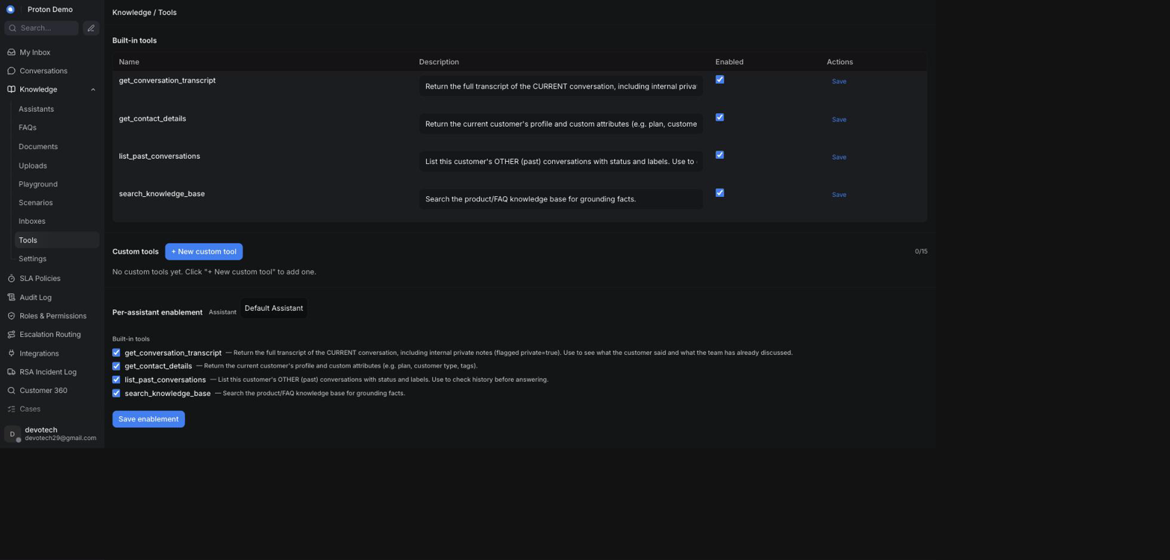
The Tools list under Knowledge

Example scenario
A dealer network wants its WhatsApp assistant to check real-time service-bay availability instead of just telling customers to call in. An administrator registers a custom tool pointing at the dealer's booking system endpoint, enables it for the after-sales assistant under Per-assistant enablement, and references it from a "Book a service" scenario.

Integrations & automation
Tools enabled for an assistant are available to it everywhere it answers — Playground, Ask Copilot, and live conversations — and can be scoped further by attaching them to specific Scenarios.

Inboxes (assignment)

What it is
The Inboxes page controls which assistant answers for each Chatwoot inbox, and in what mode. Every inbox that is not explicitly assigned here falls back to the tenant's default assistant and default mode, shown with a default badge; an inbox with its own assignment shows an override badge instead.

Where to find it
In the left-hand navigation, open Knowledge and select Inboxes.

How to use it
1. Open Knowledge → Inboxes to see every Chatwoot inbox with its channel type, currently assigned assistant, mode, and source badge.
2. To assign an assistant to an inbox, use the Assistant dropdown on its row and pick one — choosing — default — clears the override and goes back to inheriting the tenant default.
3. To change how the assistant behaves on that inbox, use the Mode dropdown: Off (the assistant does not answer on this inbox), Suggest (it drafts privately for a human to review and send), or Auto (it can reply directly).
4. Changes save automatically as soon as you pick a new value — there is no separate save button, and the row's badge switches to override once you have set anything explicitly.
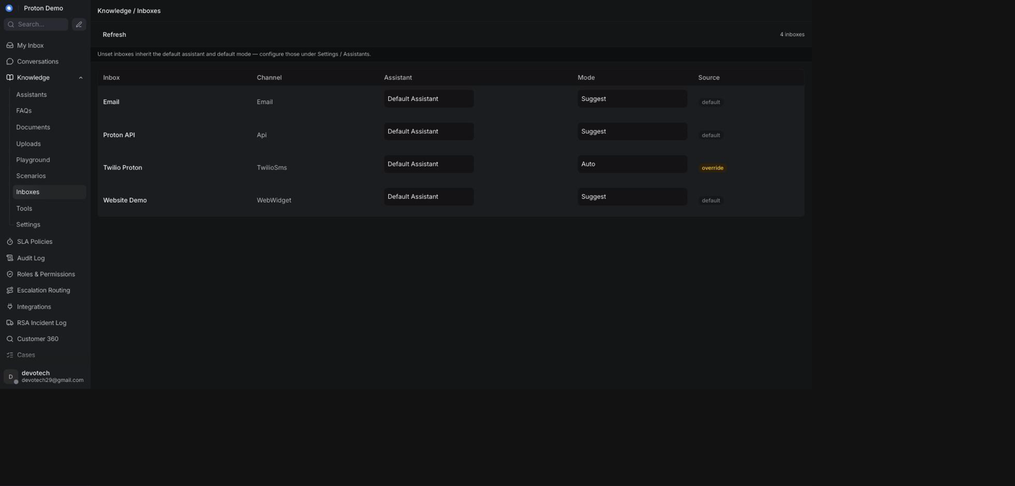
Assigning an assistant to an inbox

Example scenario
Proton adds a new WhatsApp inbox for e.MAS 7 pre-order enquiries and wants it handled by the sales-focused assistant in Auto mode, while the general support WhatsApp inbox stays on the default assistant in Suggest mode so agents can review replies first. The administrator opens Knowledge → Inboxes, finds the new inbox, sets its Assistant to the sales assistant and its Mode to Auto, and leaves the support inbox as-is.

Integrations & automation
The assistant and mode set here determine which persona and knowledge base answer a given inbox, including in the Ask Copilot panel (see Conversations) and in the AI's decision to reply, draft, or hand off (see AI Behaviour).

Settings (persona, language, lifecycle messages, guardrails)

What it is
Settings is where an assistant's persona and tone are configured, along with a smaller set of tenant-wide operational knobs. It has two parts: an Assistant persona panel, scoped to whichever assistant is selected at the top, and a Tenant settings panel that applies across the whole workspace. Leaving any field empty keeps today's default behaviour — nothing here needs to be filled in for the assistant to keep working as it already does.

Where to find it
In the left-hand navigation, open Knowledge and select Settings.

How to use it
1. Open Knowledge → Settings and pick an assistant with the Assistant selector at the top to edit its persona.
2. Under Basic, set the assistant's Name, Description, Product name, and Language. The assistant always mirrors the language the customer actually writes in — this field never overrides that. It only acts as a tie-breaker preference for when the customer's language is unclear; leave it empty to let the assistant fall back to whatever language it judges best in that case, or set it (for example, to Bahasa Melayu) to tell it which language to prefer as that fallback.
3. Under System, write System instructions describing who the assistant is and how it should behave — this is the core of its persona. Adjust Temperature from precise (0) to creative (1); leaving it as-is keeps the current balance.
4. Under Guardrails, add short rules the assistant must never break (for example, "never quote a price that is not in the price list"). These are enforced on top of the system instructions.
5. Under Response guidelines, add style and tone preferences (for example, "always reply in short paragraphs" or "always end with a follow-up question").
6. Under Messages, fill in the wording the assistant sends at key moments of a conversation: a Welcome message when it starts and a Handoff message when it hands off to a human agent — plus five more lifecycle messages: an Idle warning message (sent after a period of inactivity), an Idle close message (sent if the conversation is then closed for inactivity), a Resolution prompt message (asking whether the issue is resolved), and CSAT survey prompts split by who handled the chat — a Survey AI message and a Survey agent message — plus a Thanks message after a rating and an Assign agent message when a human is assigned. Leaving any of these blank keeps the platform's built-in default wording for that moment. A Resolution message field is also available on this page, but it is saved for future use only — nothing in the current build sends it to a customer.
7. Under Features, toggle whether this assistant uses knowledge-base/FAQ grounding, conversation memory context, source citations in its answers, and contact-attribute context.
8. Click Save assistant to apply the persona changes.
9. Below the persona panel, Tenant settings lets an administrator override a fixed set of workspace-wide values, each shown with whether it is currently on the platform's default (env) or has been overridden (override), and a Reset to return it to default individually:
◦ Assist Gemini model — which model Suggest-a-reply uses.
◦ Copilot Gemini model — which model the Ask Copilot panel uses.
◦ Copilot max tool iterations — how many tool calls Copilot may make while answering a single question.
◦ AI assist enabled, Copilot enabled, AI drafts enabled — tenant-wide toggles for Suggest-a-reply, the Ask Copilot panel, and AI auto-drafted replies respectively.
◦ Default mode — the fallback Suggest/Auto mode used for any inbox that does not have its own explicit mode set under Inboxes.
◦ Debounce seconds — how long the AI waits after a customer's message before answering, so a quick burst of messages is answered once instead of many times.
◦ Inbound auto-acknowledgement template — the message sent the first time a new email thread arrives, when the inbound auto-acknowledgement is turned on for the tenant.
◦ Escalation acknowledgement template — the message sent to the customer as part of the two-thread escalation email (see the AI Assistant Behaviour chapter's Escalation labels & the escalation email section).
Leaving either template blank keeps the platform's built-in default wording, exactly like the other fields on this panel. Editing one only changes the wording it sends — it doesn't turn the underlying feature on if it's currently off for your tenant.
Click Save settings to apply changes.
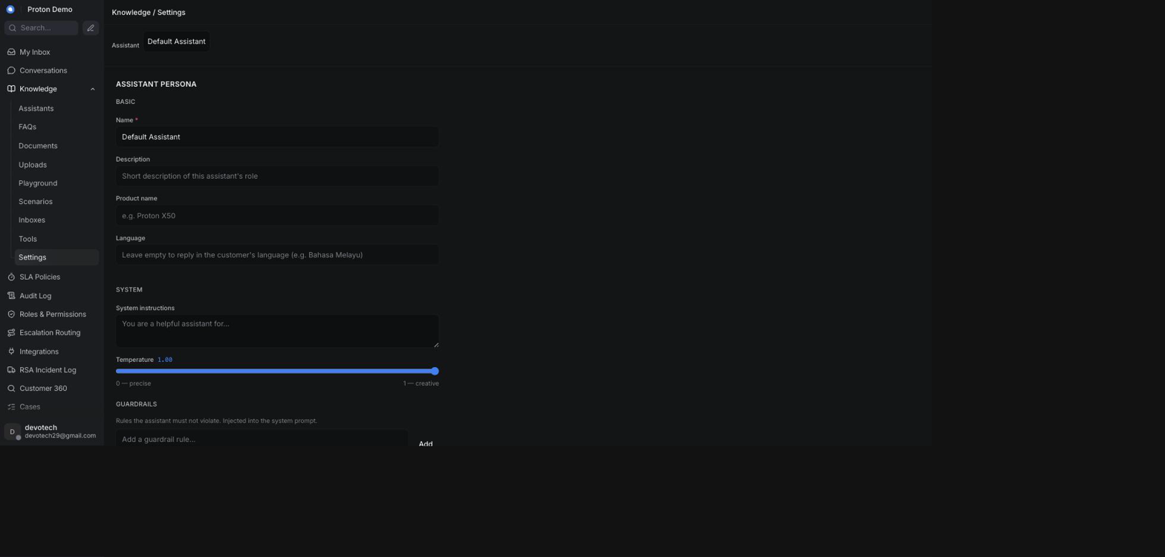
The assistant Settings page: persona, language, and lifecycle messages

Example scenario
Proton's brand team feels the sales assistant sounds too formal for WhatsApp. An administrator opens Knowledge → Settings, selects the Sales Assistant, adds a response guideline of "use a warm, casual tone and keep replies under three sentences," adds a guardrail of "never promise a delivery date," and saves — the next Playground test immediately reflects the new tone.

Integrations & automation
The persona, guardrails, response guidelines, and lifecycle messages configured here feed the assistant everywhere it operates: Playground testing, the Ask Copilot panel, Suggest-a-reply, AI auto-drafted replies, and the lifecycle messages sent during a conversation (see Conversations and AI Behaviour). An empty field anywhere on this page means the platform's built-in default is used instead — nothing has to be filled in for the assistant to work.

Cases

Case list

What it is
The Cases list is a single filterable table that shows every conversation as a "case" — Division, Concern, Purchased From, Escalated To, Agent, Car Plate, Aging (in days), and Status — so a supervisor can scan the whole book of work without opening conversations one at a time. It doesn't add a separate case record: it reads the same conversations shown in the Conversations chapter and displays their category, contact, assignment, and status information as table columns. Conversations that predate this vocabulary, or were never categorized, simply show a dash in the columns that don't apply — an unassigned case shows a dash in the Agent column the same way.

Where to find it
Cases in the main sidebar. This page requires the same permission as Customer 360 (see the Contacts chapter) — an administrator who hasn't been granted that permission won't see it.

How to use it
1. Open Cases from the sidebar.
2. Use the Division, Case type, Status, Channel, and Dealer filters at the top to narrow the list, or use Reset filters to clear them.
3. Read the table: Case ID, Division, Concern, Purchased From, Escalated To, Agent, Car Plate, Aging (days), and Status. Agent shows the name of whoever the underlying conversation is assigned to, or a dash if it's unassigned.
4. Click a Case ID to open the underlying conversation.
5. If a banner appears saying the list is showing only the first N of a larger total, the list has reached its display limit — the filters and totals shown no longer reflect every case in the account.
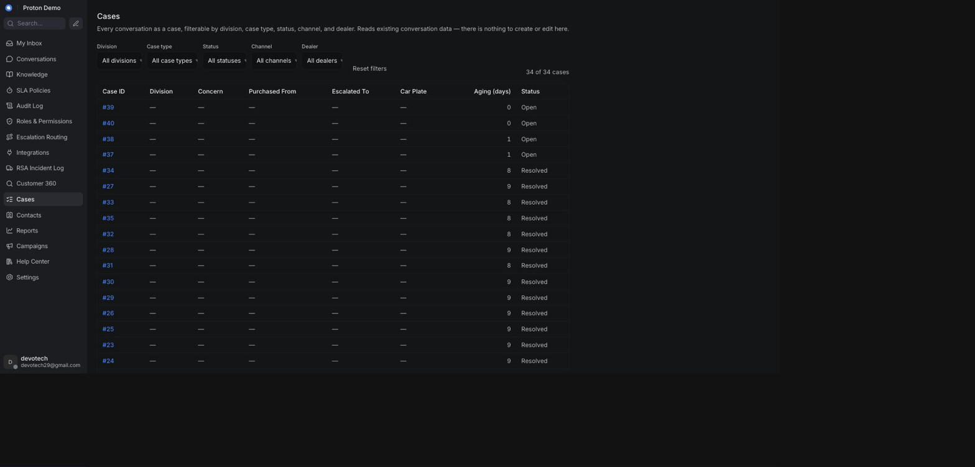
The Cases list page, including the Agent column

Example scenario
A supervisor filters the Cases list to the Aftersales division and the Complaint case type to see every open aftersales complaint across all dealers at a glance, then sorts by Aging to prioritize the oldest ones first — glancing at the Agent column to see, without opening a single conversation, which of the oldest cases don't have anyone assigned yet.

Integrations & automation
The Division, Concern, Case type, Channel, and Dealer values shown here come from the same conversation categorization covered in Case categories (below) — the AI assistant sets these automatically while handling a conversation (see the AI Assistant Behaviour chapter), and an agent can correct them the same way. Car Plate and Purchased From come from the customer's own contact record, and Agent simply mirrors the conversation's own assignee (see the Conversations chapter's Assignment & teams section). The Agent column is a Cases-list-only addition — it does not (yet) appear on the conversation card in the regular Conversations inbox view, so if you need to see who owns a case at a glance outside of Cases, open the conversation itself.

Case categories

What it is
Every conversation can carry a case category and a case subcategory — for example, category Aftersales with subcategory Aftersales: Service Operation. The subcategory list narrows to only the subcategories that belong to the category you've picked, so you can't accidentally pair a category with a subcategory from a different one; changing the category clears a subcategory that no longer matches.

Where to find it
The conversation's custom attributes panel, alongside the conversation (the same panel used for any other custom attribute).

How to use it
1. Open the conversation you want to categorize.
2. Open the custom attributes panel.
3. Choose a value for Case category (for example, Sales, Aftersales, Charging, Apps, Product, Marketing, or Others).
4. Choose a value for Case subcategory — only the subcategories that belong to the category you just chose are offered.
5. Save, or move on — most CRM attribute panels save automatically as soon as a value is picked.
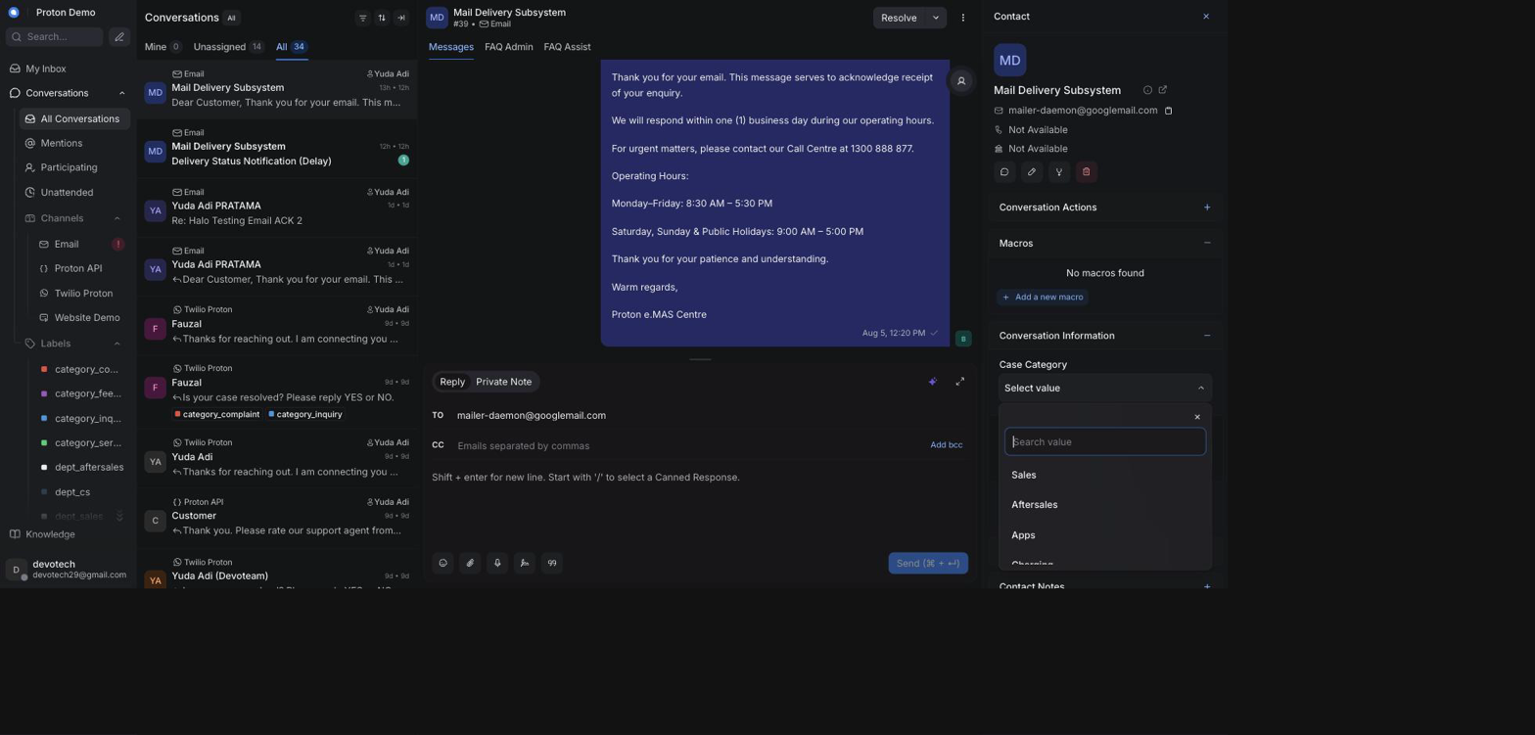
Choosing a case category and subcategory

Example scenario
A customer messages about a faulty home charger. The agent sets the conversation's case category to Charging and its subcategory to Charging: Home Charging, so the case shows up correctly filtered in the Cases list and counts toward the Charging division in reporting.

Integrations & automation
The list of available categories and subcategories is defined by an administrator under the Administration chapter's Custom Attributes section. Category/subcategory values are also set automatically by the AI assistant when it classifies an incoming conversation (see the AI Assistant Behaviour chapter) — an agent reviewing the case can always correct a misclassified category or subcategory here. These values feed the Cases list (above) and the Departments & PIC and Case Lifecycle reports (see the Reports chapter).

Case lifecycle & status

What it is
A case doesn't have a lifecycle of its own — its Status column simply shows the underlying conversation's status (for example Open, Pending, Snoozed, or Resolved). Resolving, reopening, or snoozing the conversation does the same thing to the case; there's no separate case state to keep in sync.

Where to find it
The Status column in the Cases list; the same status is also shown and changed on the conversation itself (see the Conversations chapter).

How to use it
1. In the Cases list, use the Status filter to see cases in a particular state (for example, only Open cases).
2. Open a case's conversation (click its Case ID) to change its status — resolve it, snooze it, or reopen it, exactly as covered in the Conversations chapter.
3. Return to the Cases list (or refresh it) to see the Status column reflect the change.
4. Watch the Aging (days) column alongside Status — it counts days since the conversation was created regardless of status, so a case can be both "old" and already resolved.
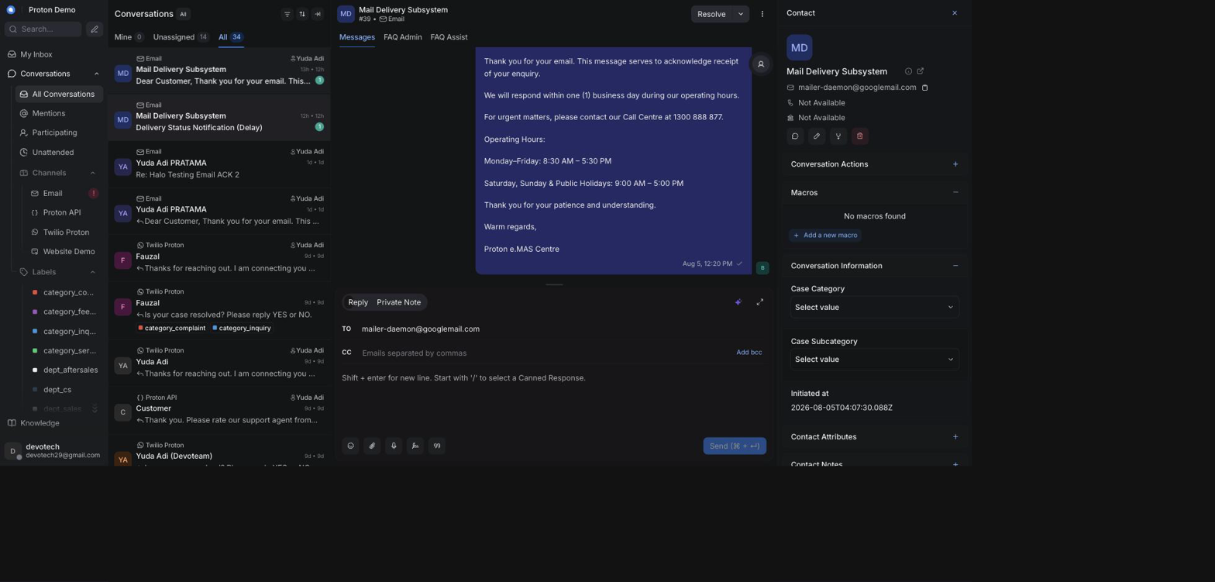
A case moving through its lifecycle statuses

Example scenario
A warranty complaint case sits with Status "Open" for several days while the dealer investigates. Once the dealer confirms the repair, the agent resolves the conversation from the conversation view; the next time anyone opens the Cases list, that same case now shows Status "Resolved".

Integrations & automation
Because a case's status is just its conversation's status, anything that changes conversation status elsewhere — an agent action, an automation rule, or the AI assistant resolving a conversation it handled — is reflected here automatically, with nothing to configure specifically for Cases.

How cases relate to conversations

What it is
There is no separate "case" record behind the scenes — every conversation is a case. The Cases list is simply a different view of the same conversations shown in the Conversations chapter, built from each conversation's category/subcategory, labels, status, and contact information.

Where to find it
Anywhere a conversation lives: the Conversations view, the conversation's custom attributes panel, and the contact's own record all feed what the Cases list displays.

How to use it
1. Treat categorizing a conversation (see Case categories, above) as the same action as categorizing its case — there's nothing extra to do.
2. Make sure the contact's vehicle number and dealer/purchase details are filled in on their profile (see the Contacts chapter), since the Cases list's Car Plate and Purchased From columns are read from there.
3. Once a conversation has these details, it appears correctly in the Cases list the next time the list loads — no separate publishing step.
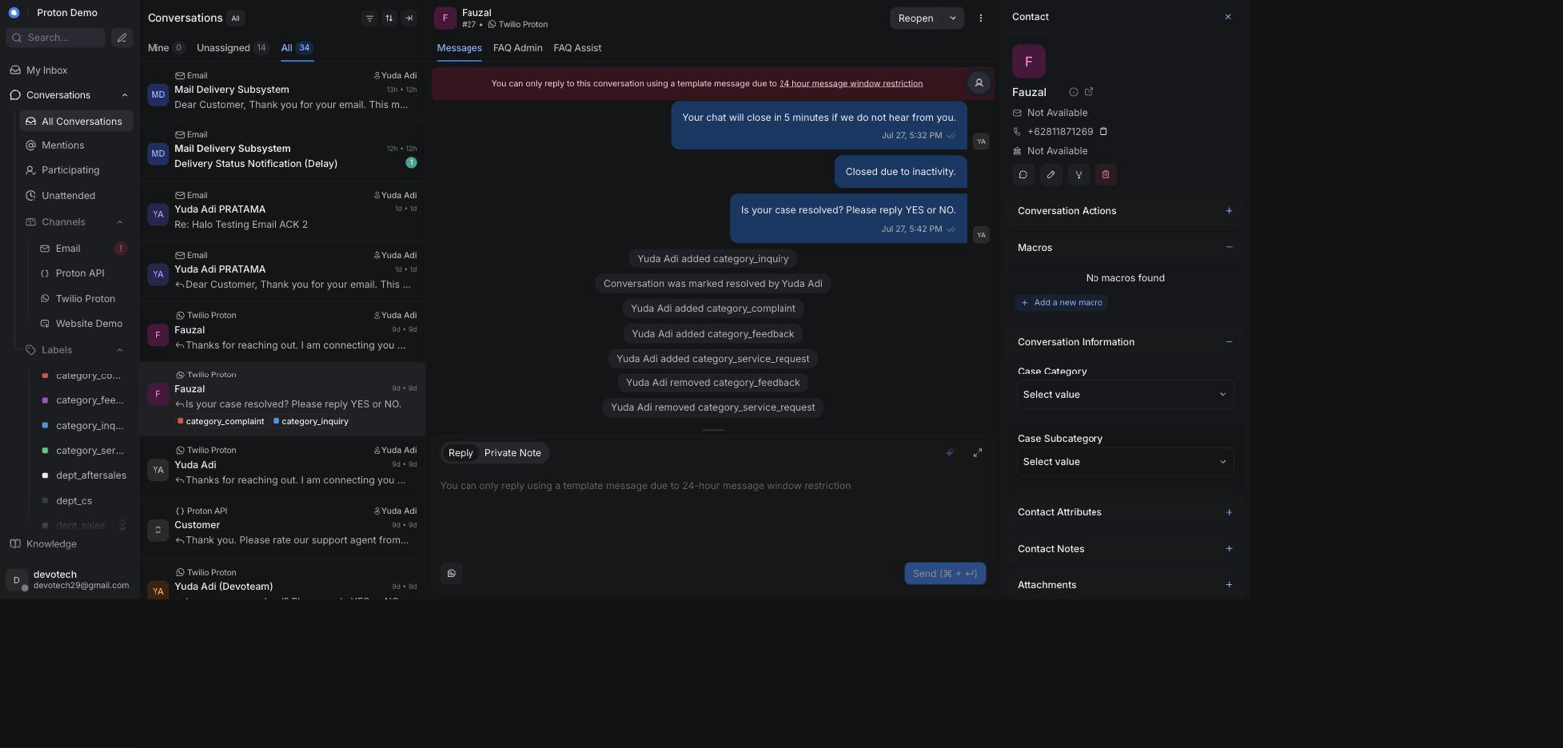
A case category set on a conversation

Example scenario
Several different customers each report the same software update problem in separate conversations, on separate days, through different channels. Because every agent categorizes their conversation under the same case category and subcategory, a supervisor filtering the Cases list by that category sees every affected customer's case together in one place, even though each one started as an unrelated conversation with a different contact.

Integrations & automation
Because a case is a conversation, everything that already applies to conversations — labels, escalation emails, AI auto-drafted replies (see the Conversations and AI Assistant Behaviour chapters) — applies to its case as well, with no separate synchronization step between the two.

Escalation status on a case

What it is
A case that's been escalated by email carries the same labels its underlying conversation does, so a supervisor scanning the Cases list can tell an escalation's state without opening it: whether it's simply been escalated (escalate), whether the dealer or PIC has since replied (escalation_replied), and which dealer it went to (the Escalated To column, and any dealer_<slug> label).

Where to find it
The Escalated To column in the Cases list, and the conversation's own labels once you open it — see the Conversations chapter's Labels and Escalation replies sections for the full mechanics.

How to use it
1. In the Cases list, look at Escalated To for cases that have already been forwarded somewhere.
2. Open a case whose escalation you want to check on. If the dealer or PIC has replied, the conversation carries the escalation_replied label and two private notes — the dealer's reply and an AI-drafted customer reply waiting for review (see the Conversations chapter's Escalation replies section for what those look like and how to act on them).
3. If a case shows escalate but no escalation_replied after a reasonable wait, that's your signal to follow up with the dealer/PIC directly rather than assume the CRM will surface a reply that hasn't arrived yet.
4. Use the Agent column (above) alongside this to see who's responsible for following up on a stalled escalation.

Escalation labels visible on rows in the Cases list

Example scenario
A supervisor reviewing the Cases list at the end of the week filters to cases carrying escalate and sorts by Aging, to spot any escalated case that's been open more than three days without an escalation_replied label — a sign worth chasing up with the dealer directly rather than waiting on the CRM.

Integrations & automation
This is the Cases-list view of the same escalation mechanics covered in the Conversations chapter (Labels, Escalation replies) and the AI Assistant Behaviour chapter (Escalation labels & the escalation email); nothing here needs separate configuration.

RSA Incident Log

Logging an RSA incident

What it is
The RSA Incident Log is a standalone page for recording roadside-assistance (RSA) incidents — breakdowns, accidents, and similar callouts — as they're reported. Each incident is its own record with the vehicle, the reported cause, and where and when it happened. It's manual data entry: logging an incident here doesn't dispatch a tow truck or notify anyone by itself.

Where to find it
RSA Incident Log in the main sidebar. In the current release this page shares its visibility with the SLA Policies page — an administrator needs the same permission that controls SLA Policies (see the Administration chapter) to see it.

How to use it
1. Open RSA Incident Log from the sidebar.
2. Review the Cases by cause and Cases by dealer summary at the top of the page for a running total of incidents logged so far.
3. Under Log an incident, fill in Incident date, Vehicle no., and Cause (all required).
4. Fill in whichever of the optional fields you already know: Vehicle model, Purchased from, Breakdown location, Arrived location, Customer called-in time, Towing assigned time, Time arrived breakdown area, Time arrived outlet, Total km, Late reason, and Remarks.
5. Click Log incident to save it. It appears in the incidents table below, and the cause/dealer summary at the top updates immediately.
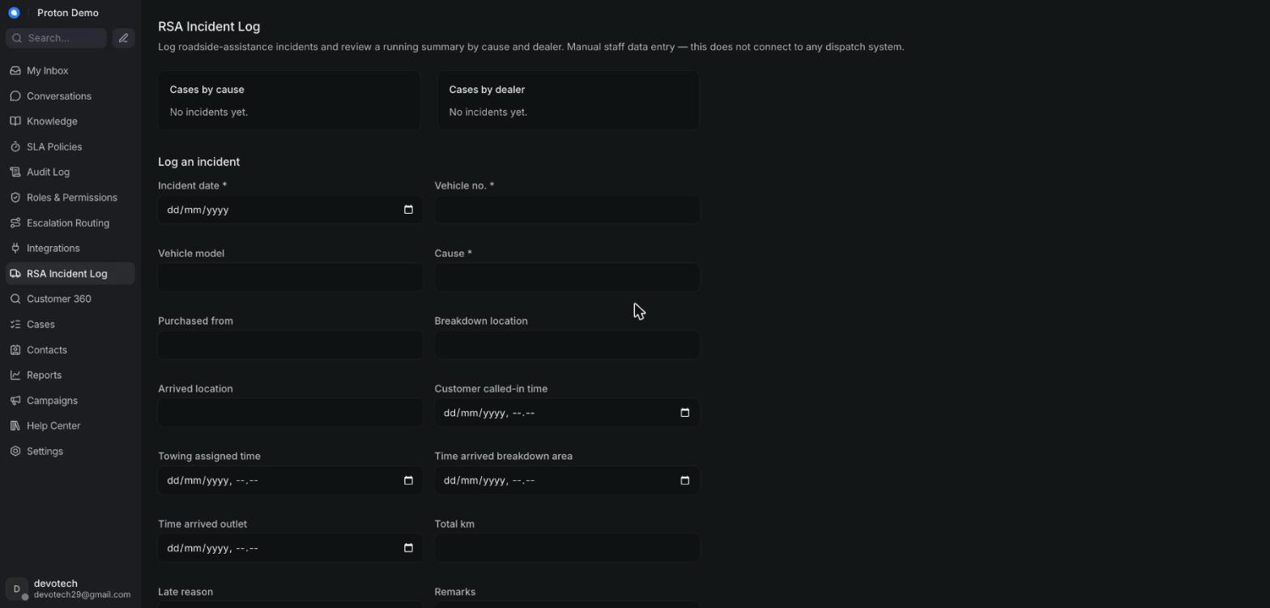
Creating a new RSA incident record

Example scenario
A customer calls the roadside-assistance line about a flat battery on the Jakarta–Cikampek toll road. Staff open the RSA Incident Log, log a new incident with today's date, the vehicle's plate number, cause "Flat battery / SOC 0%", and the breakdown location, leaving the still-unknown timing fields blank for now.

Integrations & automation
There's no dispatch-system integration behind this form — logging an incident is a record for tracking and reporting, not an automatic trigger to send a tow truck. What you log here is what later appears in Customer 360 and in reporting (see the sections below).

Incident statuses & updates

What it is
Rather than a single status label, an incident's progress is tracked through the timestamp fields captured when it was logged — when the customer called in, when towing was assigned, when the tow arrived at the breakdown location, and when the vehicle arrived at the outlet — plus free-text Late reason and Remarks fields for anything that needs explaining. As new information comes in, staff update the same incident record rather than creating a new one.

Where to find it
The incidents table at the bottom of the RSA Incident Log page; each row has Edit and Delete actions.

How to use it
1. Find the incident in the table and click Edit.
2. Fill in each stage's field as it happens — for example, Towing assigned time once a tow truck is dispatched, then Time arrived breakdown area and Time arrived outlet as the vehicle progresses.
3. Add Total km and a Late reason if relevant.
4. Click Save to update the record, or Cancel to discard the changes.
5. Use Delete to remove a record entered in error — this cannot be undone.
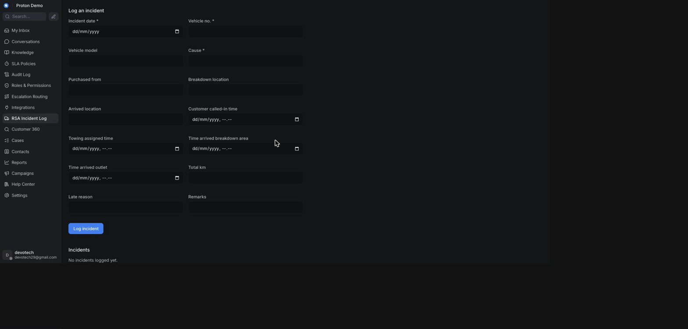
Updating the status of an RSA incident

Example scenario
After logging the initial callout, staff assign a tow truck and edit the incident to add the Towing assigned time. Once the vehicle reaches the dealer's service outlet, staff edit the same incident again to fill in Time arrived outlet and Total km, completing the record without creating a second one.

Integrations & automation
Every edit is reflected immediately in the Cases by cause and Cases by dealer summary at the top of this page, since that summary is calculated from the current incident records, not a separate log.

RSA in Customer 360 & reports

What it is
Incidents logged here also surface elsewhere: an operator searching Customer 360 by a vehicle number sees any matching incidents alongside that customer's contact and conversations, and the same incident data feeds Proton's wider reporting — the Cases by cause/Cases by dealer summary on this page is a lightweight version of that same reporting.

Where to find it
The RSA incidents table inside a Customer 360 lookup (see the Contacts chapter); the Cases by cause/Cases by dealer summary on this page; and the Departments & PIC and Case Lifecycle reports (see the Reports chapter).

How to use it
1. Go to Customer 360 and search by the vehicle's number.
2. Review the RSA incidents table in the results — it lists the same fields as this page's incident table.
3. Alternatively, stay on the RSA Incident Log page and use the Cases by cause/Cases by dealer summary for a running total without doing a per-vehicle lookup.

An RSA incident surfaced in a Customer 360 lookup

Example scenario
A breakdown call comes in for a customer's vehicle; staff log the incident, arrange towing, and update the record as the vehicle reaches the dealer outlet. Weeks later, that same dealer calls asking about the customer's vehicle history; staff open Customer 360, search the vehicle's plate number, and the completed incident — with its full timeline — appears alongside the customer's conversations.

Integrations & automation
Customer 360's vehicle-number search matches against each incident's Vehicle no. field, so entering that field accurately when logging an incident (see Logging an RSA incident, above) determines whether it will be found later from Customer 360.

Reports

Standard reports (Overview, Conversation, CSAT, Agent, Label, Inbox, Bot)

What it is
Chatwoot's built-in reporting pages — Overview, Conversation, CSAT, Agent, Label, Inbox, and Bot — give numbers on conversation volume, response and resolution times, customer satisfaction, and per-agent, per-label, and per-inbox performance. On top of a few of these native pages, Proton adds its own extra section that pulls cross-channel numbers (every channel combined, not just one inbox at a time) from the CRM's reporting warehouse:
• The Agent report gets a Tasks per Agent (Proton) table — cases, average first response, average resolution, and resolved count per agent/PIC.
• The Bot report gets a Proton AI & Channel Analytics section — bot-resolved percentage, volume by channel, bot-vs-agent resolution split, response speed, fallback and bounce rate, quality, first-response and resolution time by channel, and peak hours.
• The CSAT report gets a Cross-Channel CSAT & NPS section — blended CSAT and NPS scores, CSAT by channel, NPS respondent split, and NPS by agent.

Where to find it
Reports in the left sidebar. The Proton sections above appear at the bottom of their respective native report page — no extra navigation is needed to see them.

How to use it
1. Open Reports from the sidebar.
2. Pick the report tab you need (Overview, Conversation, CSAT, Agent, Label, Inbox, or Bot).
3. Set the date range and any filters the page offers (agent, inbox, label).
4. On the Agent, Bot, or CSAT report, scroll to the bottom to see the added Proton section — it loads independently of the filters above it.
5. Use the native download/export option, where the page offers one, to save the numbers for offline reporting.
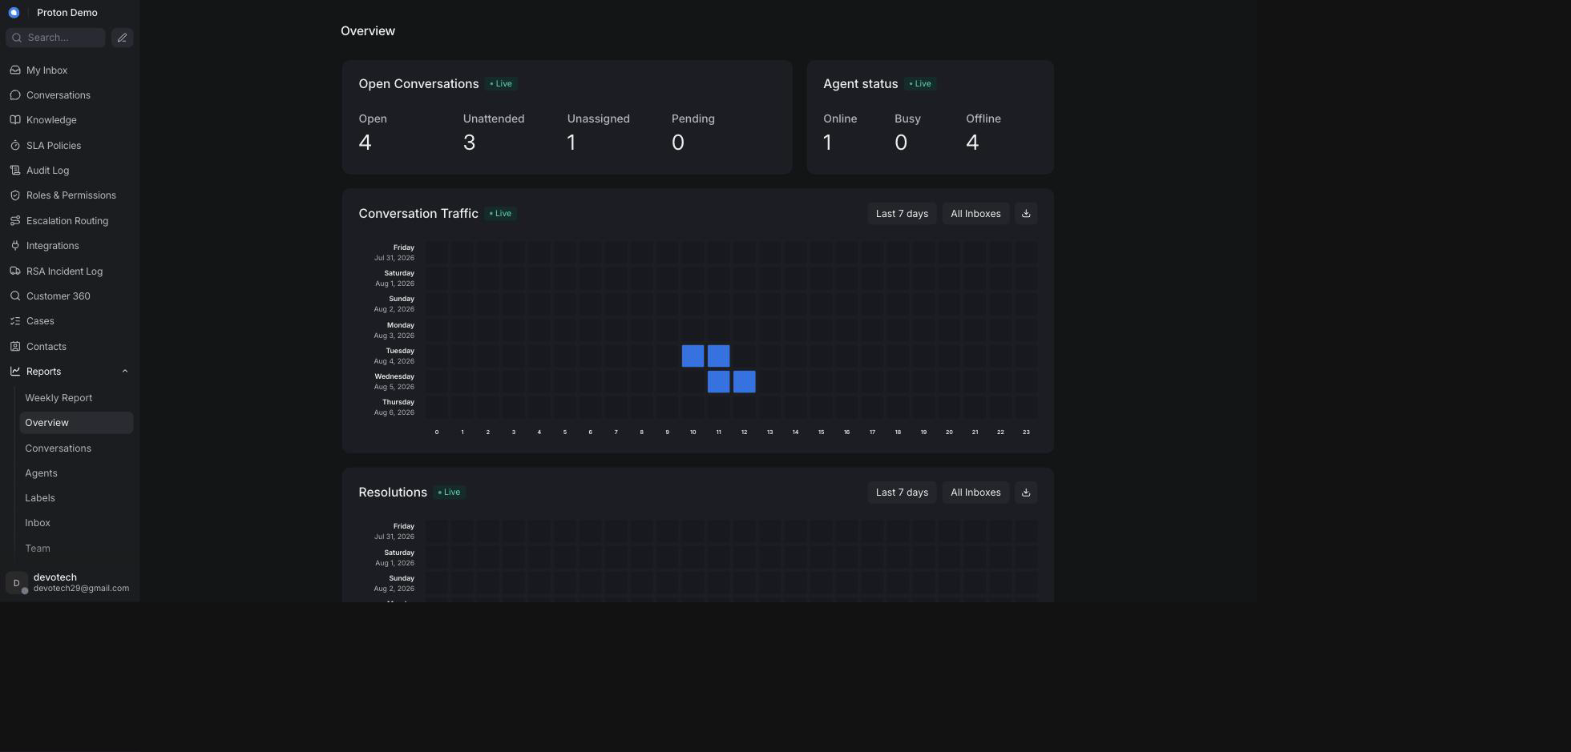
The standard reports overview page

Example scenario
Pak Andi, the Proton e.MAS operations lead, opens the Agent report every Monday morning to see which service advisors handled the most cases last week. He scrolls past the native chart to the Tasks per Agent (Proton) table, which stacks WhatsApp, email, and phone caseload for each PIC into one comparison instead of him checking each channel separately.

Integrations & automation
These pages read from Chatwoot conversation data and, for the Proton sections, from the CRM's reporting warehouse. There is nothing to turn on — the extra sections simply fail to load quietly (rather than break the page) if that warehouse is briefly unreachable.

Anomaly report

What it is
A page that flags channels whose recent conversation volume looks unusual — spiking or dropping well beyond that channel's own recent baseline — so an operator can catch a possible outage, campaign side-effect, or data problem early instead of noticing it days later in a monthly total.

Where to find it
Reports → Anomaly in the left sidebar.

How to use it
1. Open Reports → Anomaly.
2. Check the Flagged Channels count at the top — this is how many channels currently show anomalous volume.
3. Read the table below it: each row is a channel with its current volume, its normal baseline (mean and standard deviation), and a deviation score.
4. Treat a deviation badge in the yellow or red range as worth investigating — it means the channel's current volume sits well outside its usual pattern.
5. If a channel is flagged, cross-check the relevant Inbox report or ask the on-duty agents whether something changed (a broken integration, a marketing blast, a public holiday).
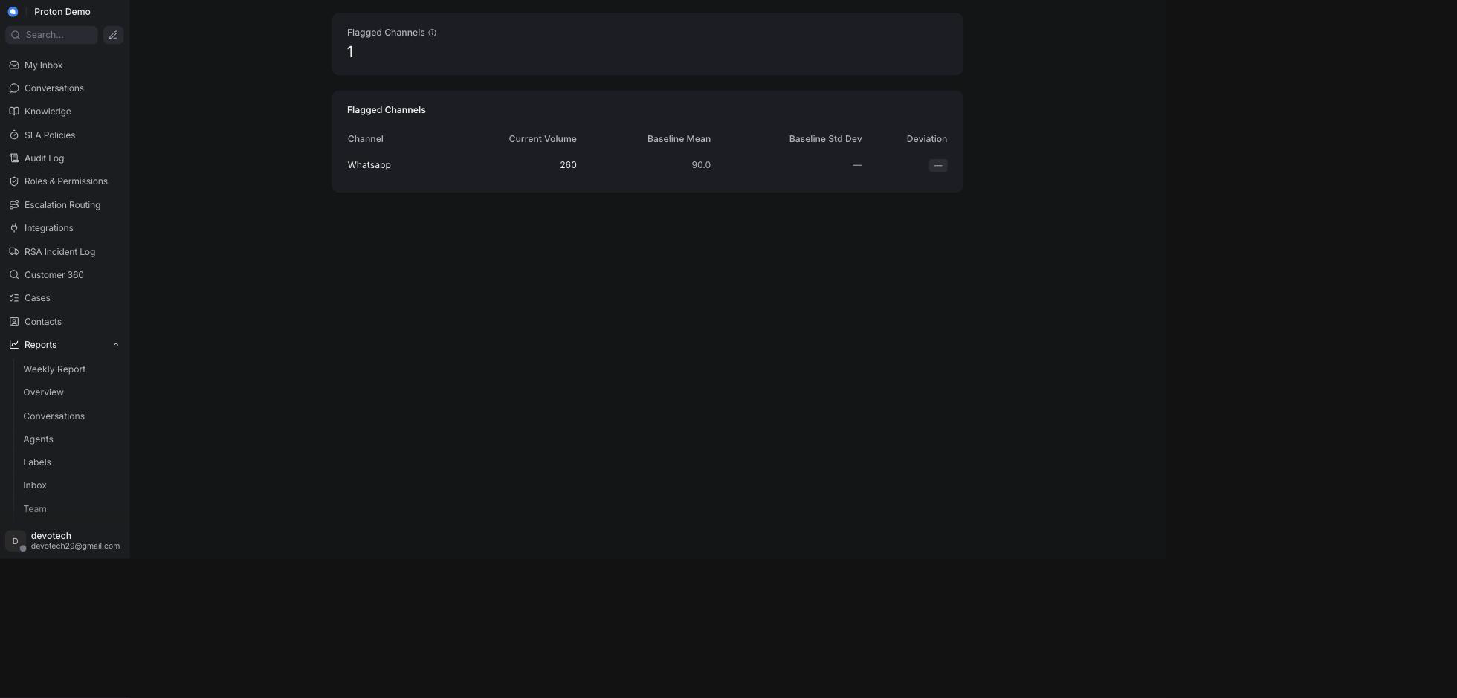
The Anomaly report page

Example scenario
On a Tuesday morning, Ibu Rina notices the WhatsApp channel flagged with a sharply higher deviation score. She finds that a service reminder blast went out overnight, driving an unusual spike in booking inquiries, and asks the on-shift team to add temporary coverage rather than assuming something is broken.

Integrations & automation
The Anomaly report is read-only reporting; it doesn't trigger any automated action on its own. Use it as an early-warning signal alongside the standard Inbox and Overview reports.

Departments & PIC report

What it is
A page that breaks conversation volume and performance down by department and by the person-in-charge (PIC) handling each case, plus how often resolved cases get reopened, and how case categories line up against vehicle models.

Where to find it
Reports → Departments & PIC in the left sidebar.

How to use it
1. Open Reports → Departments & PIC.
2. Review the Department / PIC Performance table — cases, average first response, average resolution, and resolution rate per department/PIC pair.
3. Check Top Departments by Cases for a quick visual of where volume concentrates.
4. Review Reopen / Case Reopen Rate (CRR) to see which dealer/department/PIC combinations have the most cases reopened after resolution — a high reopen rate can point to a quality problem, not just a busy team.
5. Use Category × Vehicle Model to see which complaint or inquiry categories cluster around specific vehicle models.
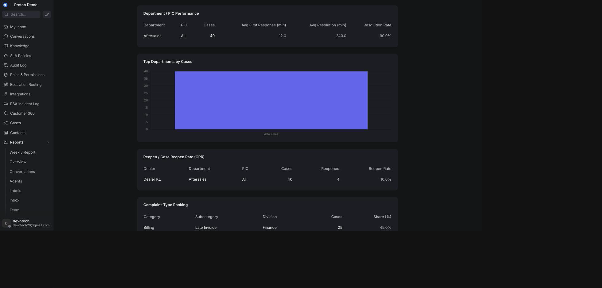
The Departments & PIC report page

Example scenario
During the weekly ops review, Pak Hendra pulls up Departments & PIC and sees the Service department's reopen rate at Dealer Bandung Timur is noticeably higher than other dealers, prompting a follow-up with that dealer's PIC about whether repairs are properly verified before a case is closed.

Integrations & automation
This report reflects case categories and dealer/department labels that agents apply during normal conversation handling — there is no separate configuration step; it fills in as agents work.

Case Lifecycle report

What it is
A page showing how long cases take to resolve and how cases move through their statuses over time, plus a running list of recent cases and, further down the same page, a work-in-progress / case-aging view of cases still open.

Where to find it
Reports → Case Lifecycle in the left sidebar.

How to use it
1. Open Reports → Case Lifecycle.
2. Review Resolution-Time Distribution to see how cases bucket across resolution-speed bands, from under 30 minutes up to more than 24 hours.
3. Review Case State Trend to see how the mix of case statuses has moved month over month.
4. Scroll to Recent Cases for a per-conversation table (channel, department, dealer, status, resolution time) for the most recently created cases.
5. Scroll further to Work-in-Progress / Case Aging for currently open or pending cases sorted by how many days old they are, bucketed so aging cases are easy to spot.
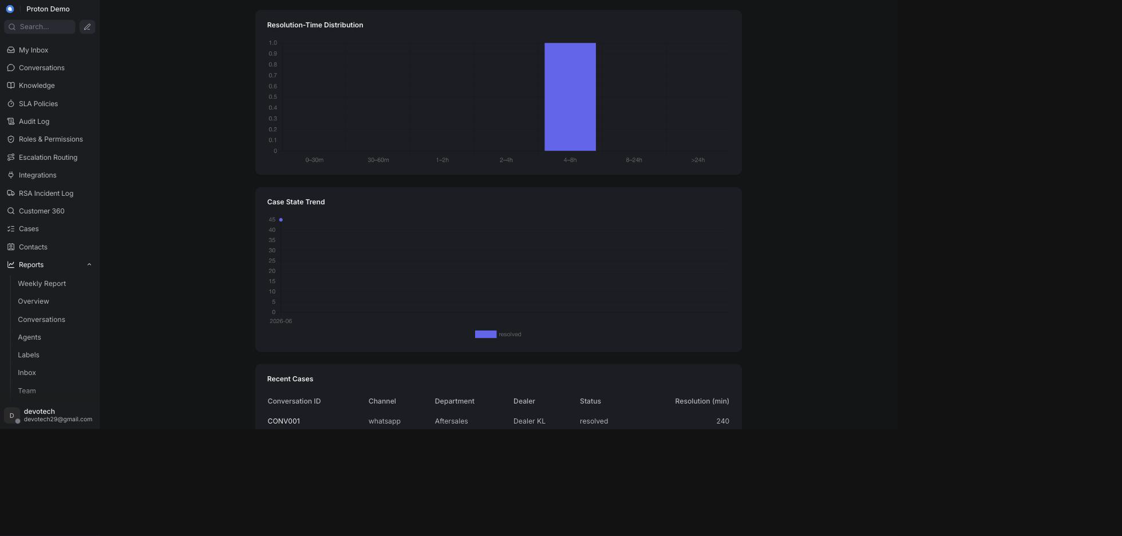
The Case Lifecycle report page

Example scenario
Ibu Sari, reviewing open RSA follow-ups, uses the Work-in-Progress / Case Aging table to find any case older than a week that's still open, and escalates those to the relevant PIC before they slip further.

Integrations & automation
Case status and category come from how agents and administrators manage conversations day to day (see Cases and RSA); this report has no separate setup of its own.

Weekly Report

What it is
A single page that reconciles the numbers in Proton's own weekly reporting routine — case volume, case status trend, department/PIC performance, call-centre and SLA performance, dealer escalation turnaround, SLA compliance, work-in-progress aging, and a per-case detail table — all against a chosen 7-day window, so a weekly reporting habit doesn't require collating several report pages by hand.

Where to find it
Reports → Weekly Report in the left sidebar.

How to use it
1. Open Reports → Weekly Report.
2. Use the week picker at the top to choose the window you're reporting on. It defaults to the current Monday–Sunday week, but its start date can be set to any day — useful if your own weekly routine runs on a different 7-day cycle (for example Friday-to-Thursday).
3. Read Case Volume for total cases in the window, the week-over-week change, and a breakdown by channel and by case type/division.
4. Read Case Status Trend for how cases split across statuses within the window.
5. Scroll through Inquiry / Complaint / Feedback Detail — Departments & PIC, Call Centre & SLA Performance, Work-in-Progress / Case Aging, and Dealer Escalation Turnaround — each section carries a small badge saying whether it's scoped to "This week" or "All time", so it's clear which numbers are windowed and which are running totals.
6. Check Per-Case Detail at the bottom for the individual conversations behind the week's numbers.
The page notes that Per-Case Detail (read live from current conversations) and the Case Volume total above (read from the reporting warehouse) can legitimately show slightly different counts, since they come from two different data sources — this is expected, not a bug.
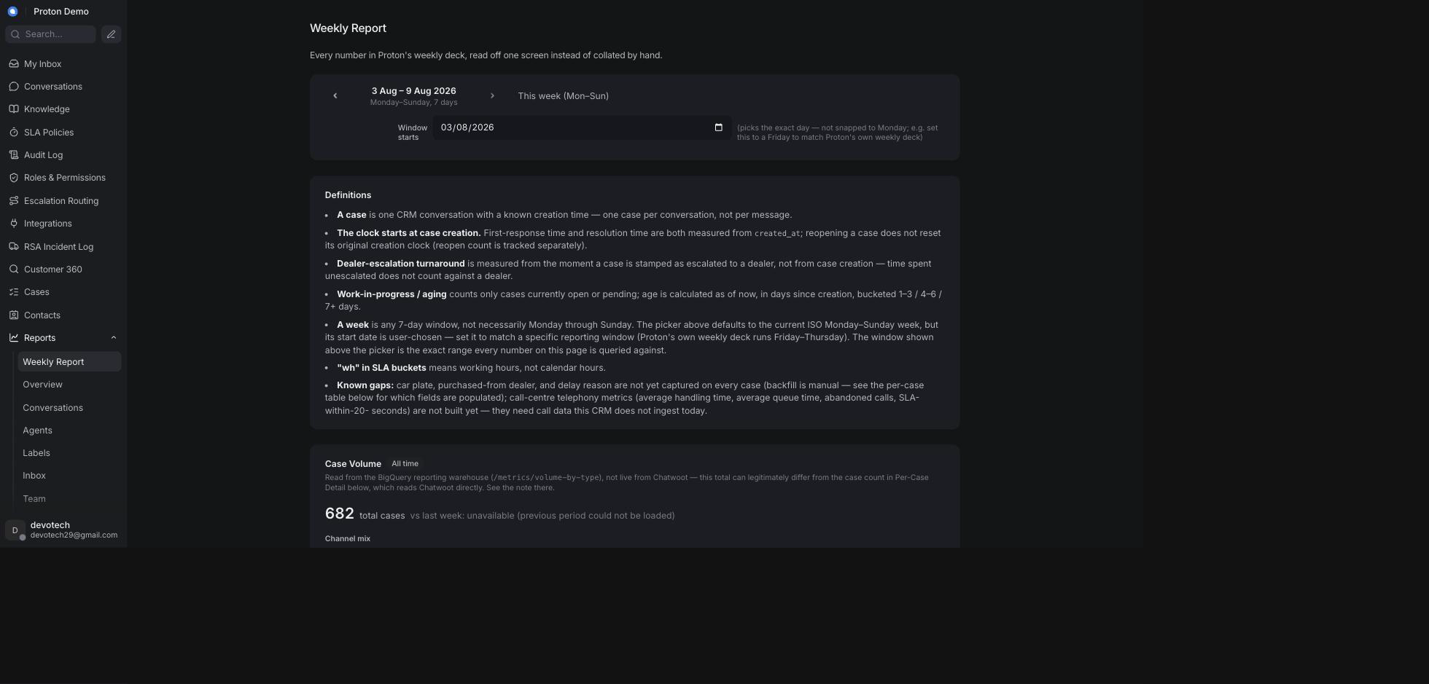
The Weekly Report page

Example scenario
Every Friday, Ibu Dewi sets the Weekly Report's window to the just-finished reporting period, notes the Case Volume and Departments & PIC numbers for the client's weekly update, and checks the Dealer Escalation Turnaround table before the call to flag any dealer whose average turnaround has crept up.

Integrations & automation
The Weekly Report reads from the same reporting warehouse and live case data as the other report pages; there is no export button on the page itself, so figures are typically copied by hand into a weekly deck, or pulled in bulk via BI/reporting exports for a larger dataset (see the Integrations chapter).

SLA reports

What it is
Chatwoot's native SLA report, showing which conversations met or missed their assigned SLA policy, plus a Proton section beneath it that rolls SLA achievement up across every channel and shows SLA compliance broken down into time buckets. This is a different page from SLA Policies under Administration, which is where SLA rules are configured rather than reported on.

Where to find it
Reports → SLA in the left sidebar.

How to use it
1. Open Reports → SLA.
2. Review the native SLA table for individual conversations that hit or missed their SLA.
3. Scroll down to Cross-Channel SLA Achievement for the overall met/missed percentage across every channel, plus a per-channel breakdown chart.
4. Continue to SLA Compliance by Bucket for a chart of how many cases fall into each SLA time bucket, split by case type.
Screenshot: The SLA reports page

Example scenario
Pak Yudi checks Cross-Channel SLA Achievement before a monthly client review to confirm the team is holding above its committed percentage, then drills into SLA Compliance by Bucket to see whether one particular case type is dragging the average down.

Integrations & automation
SLA achievement is measured against whichever SLA policy is applied to a conversation (configured on the SLA Policies admin page, see Administration); this report doesn't need separate setup of its own.

Dealer escalation turnaround

What it is
A measurement of how long a dealer takes to act on a case escalated to it. The clock starts the first time a case is marked as escalated to a specific dealer — not from when the case was originally created — and stops when the case is resolved. This keeps time spent before escalation from unfairly counting against the dealer.

Where to find it
The Dealer Escalation Turnaround table appears on the SLA reports page and again on the Weekly Report, both showing the same underlying numbers.

How to use it
1. Open the SLA reports page or the Weekly Report.
2. Find the Dealer Escalation Turnaround table: cases escalated, average turnaround, and P50/P90 turnaround in days, per dealer.
3. Check the Slowest cases sub-table for the specific conversations taking the longest to turn around — these are the ones worth following up individually.
4. Compare dealers to spot ones consistently slower than the group, and raise it with that dealer's PIC via Escalation Routing (see Administration).
Screenshot: A dealer escalation turnaround timestamp shown in a report

Example scenario
An agent applies a dealer label to a customer's complaint about a delayed repair, forwarding it to Dealer Kelapa Gading. The moment that label is applied, the case's escalation clock starts; once the case is later resolved, the elapsed time appears against Dealer Kelapa Gading in the turnaround table, letting Ibu Sari track that dealer's responsiveness over time.

Integrations & automation
The turnaround clock starts automatically, once, the first time a dealer label is applied to a conversation — an agent doesn't need to do anything extra beyond applying the label as part of normal escalation handling (see Labels, and Escalation labels & the escalation email in the AI Behaviour chapter).

Campaigns & Help Center

Campaigns

What it is
Chatwoot's native campaigns feature, used to proactively message contacts rather than only waiting for them to write in. Campaigns come in two kinds: one-off campaigns, sent once to a target audience over a channel such as WhatsApp or SMS, and ongoing campaigns, which trigger automatically for website-chat visitors who match a condition (for example, visiting a specific page).

Where to find it
Campaigns in the left sidebar.

How to use it
1. Open Campaigns from the sidebar.
2. Choose whether to create a one-off or an ongoing campaign.
3. For a one-off campaign, pick the inbox/channel, write the message, and select or upload the audience to send it to.
4. For an ongoing campaign, pick the website inbox, set the trigger condition (page URL, time on page, and similar), and write the message shown to matching visitors.
5. Save and activate the campaign, then monitor delivery and responses from the campaign's detail page.
Screenshot: Creating a one-off or ongoing campaign

Example scenario
Ahead of a service promotion, the marketing team sets up a one-off WhatsApp campaign reminding customers whose last service was six months ago that a check-up is due, giving the service department a head start on inbound bookings.

Integrations & automation
Campaigns send through whichever inbox/channel they're attached to (for example, a connected WhatsApp inbox); there's no separate setup beyond that channel already being connected (see the Integrations chapter).
Campaigns may not be enabled or visible for every Proton deployment — confirm on the live tenant whether this menu is present for your account before relying on it in training material.

Help Center portal

What it is
Chatwoot's native Help Center (knowledge-base portal) feature for publishing self-service articles that customers can read without contacting an agent, organized into categories.

Where to find it
Help Center in the left sidebar, or under account settings depending on the tenant.

How to use it
1. Open Help Center from the sidebar (or Settings).
2. Create or select a portal, then add categories to group related articles.
3. Create an article inside a category and write its content; it starts as a draft.
4. Preview the article, then publish it so it becomes visible on the public portal.
5. Keep articles up to date as procedures change, and unpublish or archive ones that are no longer accurate.
Screenshot: The Help Center portal with articles and categories

Example scenario
The knowledge team publishes a "How to book a service appointment" article in the Help Center's Service category, so customers who search for the answer online can self-serve instead of opening a new conversation, while agents draw on the same underlying information via Knowledge → FAQs when a customer asks directly instead.

Integrations & automation
Help Center content is separate from the Knowledge → FAQs, Documents, and Assistants features covered in the Knowledge chapter: the Help Center portal is a native, public-facing self-service site, while Knowledge feeds the AI assistant's answers inside conversations. The two typically need to be kept in sync manually, since they serve different audiences.
The Help Center menu may not be enabled for every Proton deployment — confirm on the live tenant whether this feature is active before relying on it in training material.

Administration (Settings)
This chapter covers the pages an administrator uses to configure the CRM itself, rather than to handle a customer conversation. Most of these pages require an administrator account; a handful of the Proton-specific pages (SLA Policies, Audit Log, Roles & Permissions, Escalation Routing, and Integrations) additionally require a specific permission to be granted to your role — if you don't see one of these items in the left-hand navigation, ask an administrator to grant you the matching permission from Roles & Permissions.

Agents

What it is
The list of everyone who can log in to this CRM as staff, together with their role (agent or administrator) and which teams/inboxes they belong to.

Where to find it
Open Settings (the gear icon) and select Agents.

How to use it
1. Open Settings → Agents to see everyone with access to this CRM.
2. To add someone, click Add Agent, enter their name and email, and pick a role (Agent or Administrator). An invitation is sent to that email address.
3. To change someone's role or the inboxes/teams they can see, click on their row and update the settings, then save.
4. To remove someone's access, open their row and choose the remove/deactivate option, then confirm.
Screenshot: The Agents settings page

Example scenario
Proton hires a new customer-service agent, Sari, to cover WhatsApp and email support. An administrator adds her under Settings → Agents with the Agent role, then assigns her to the After-Sales team and the relevant inboxes so conversations can be routed to her.

Integrations & automation
An agent's role here is what Roles & Permissions (below) grants extra permissions on top of, and which teams they can be part of under Teams.

Teams

What it is
A named group of agents (for example, one team per department) used to route and assign conversations as a group rather than to individuals one by one.

Where to find it
Open Settings (the gear icon) and select Teams.

How to use it
1. Open Settings → Teams to see the existing teams.
2. To add a team, click Add Team, give it a name and description, and choose whether conversations assigned to the team round-robin between its members automatically.
3. Add or remove agents from the team on its detail page.
4. To retire a team, open it and use the remove/delete option, then confirm.
Screenshot: The Teams settings page

Example scenario
Proton organizes its support desk into Sales, After-Sales, and RSA teams so that a complaint about a service appointment can be assigned to the After-Sales team as a whole, and picked up by whichever of its agents is free, instead of waiting for one named person.

Integrations & automation
Teams are used as assignment targets in Automation rules below, and as a grouping in reports (see the Reports chapter's Departments & PIC report).

Inboxes (incl. inactivity timing)

What it is
An inbox is one connected communication channel — a WhatsApp number, an email address, the website widget, and so on. Each inbox has its own settings: which agents can see it, its working hours, and (Proton addition) how long an idle conversation waits before the customer is warned and the conversation is auto-closed.

Where to find it
Open Settings (the gear icon) and select Inboxes, then choose the inbox you want to configure.

How to use it
1. Open Settings → Inboxes and select the inbox to configure.
2. Use the inbox's general settings to control its name, the agents/teams assigned to it, and greeting/away messages.
3. Open the tab that hosts business hours to set working hours for the inbox.
4. On the same tab, scroll to Inactivity & auto-close. Toggle Enable inactivity & auto-close for this inbox on or off.
5. Set Warn after idle (min), Close grace — in business hours (min), Close grace — out of hours (min), and Resolution-confirm grace (min). Leave any of these blank to inherit the tenant-wide default instead of setting a per-inbox value.
6. Optionally customize the wording of the Idle warning message, Chat closed message, Resolution prompt, Assign-to-agent message, AI rating survey, Agent rating survey, and Thank-you message sent to the customer at each stage. Leave a field blank to use the default wording.
7. Click Update to save — this single action saves both the business hours and the inactivity-timing settings together.
Screenshot: Inbox inactivity-timing settings

Example scenario
Proton's WhatsApp inbox is set to warn a customer after 10 minutes of no reply ("Warn after idle (min)"), then auto-close 5 minutes later during business hours, but wait longer overnight when no agent is on duty — set via a larger out-of-hours grace value on the same inbox.

Integrations & automation
The inactivity timers work together with the AI assistant's lifecycle messages (see the AI Behaviour chapter) to keep conversations moving without an agent having to manually chase or close every idle chat.

Labels

What it is
Labels are short, colour-coded tags administrators define for use across conversations — including the escalate label and the dealer labels that drive escalation notifications (see the Conversations and AI Behaviour chapters).

Where to find it
Open Settings (the gear icon) and select Labels.

How to use it
1. Open Settings → Labels to see every label defined for the account.
2. Click Add Label, give it a name, description, and colour, then save.
3. To change a label's name, description, or colour, click on it and update the fields.
4. To remove a label, use its delete option and confirm. This removes the label from any conversation it was applied to.
Screenshot: The Labels settings page

Example scenario
An administrator creates a dealer_jakarta-selatan label so that conversations escalated to that dealer can be tagged consistently by agents and picked up automatically by the escalation routing described later in this chapter.

Integrations & automation
Labels drive automation rules (below), the escalation email flow, and dealer-turnaround reporting (see the Reports chapter).

Custom Attributes

What it is
Custom Attributes let administrators define extra fields on conversations or contacts beyond what the CRM ships with by default — for example, the case category/subcategory fields used by Cases (see the Cases chapter).

Where to find it
Open Settings (the gear icon) and select Custom Attributes.

How to use it
1. Open Settings → Custom Attributes.
2. Click Add Custom Attribute, choose whether it applies to conversations or contacts, give it a name and a type (text, number, list, checkbox, etc.), and save.
3. To edit an attribute's options, click on it and update the fields.
4. To remove an attribute that is no longer needed, use its delete option and confirm.
Screenshot: The Custom Attributes settings page

Example scenario
Proton's case category and subcategory fields (used on the Cases page) are defined here as conversation-level custom attributes, so any conversation can be tagged with the same structured category values used in Case reporting.

Integrations & automation
Custom attributes back the Cases feature's category/subcategory fields (see the Cases chapter) and can also be used as conditions in Automation rules below.

Automation

What it is
Automation lets administrators define "when X happens, do Y" rules that run without an agent having to act — for example, applying a label automatically when a conversation matches certain conditions.

Where to find it
Open Settings (the gear icon) and select Automation.

How to use it
1. Open Settings → Automation to see the existing rules.
2. Click Add Automation Rule, choose an event to trigger on (for example, a conversation being created), add one or more conditions, and choose the action(s) to run (add a label, assign a team, send a message, etc.).
3. Save the rule. It applies to matching conversations going forward.
4. To adjust a rule, click on it and edit its conditions or actions.
5. To stop a rule from running, disable or delete it.
Screenshot: The Automation settings page

Example scenario
An administrator sets up a rule that automatically applies a "Priority: High" label whenever a new conversation arrives on the RSA (roadside assistance) inbox, so those conversations stand out in the inbox view without an agent tagging them by hand.

Integrations & automation
Automation rules can use labels and custom attributes (both covered above) as conditions, and can trigger the same kinds of actions an agent could take manually from a conversation.

Macros

What it is
Macros bundle a sequence of actions — such as adding a label, assigning a team, sending a reply, and resolving — into one saved, one-click action. This page is where those macro steps are created and edited; running a saved macro from an open conversation is covered in the Conversations chapter.

Where to find it
Open Settings (the gear icon) and select Macros.

How to use it
1. Open Settings → Macros to see the existing macros.
2. Click Add Macro, give it a name, and add the steps it should run in order (for example: apply a label, then send a reply, then resolve).
3. Save the macro. It becomes available to agents from the macro menu inside any open conversation.
4. To change a macro's steps, click on it, edit the step list, and save.
5. To retire a macro, delete it — this does not affect conversations it was already run on.
Screenshot: The Macros settings page

Example scenario
An administrator builds a "Test drive confirmed" macro that applies a test-drive label, sends a confirmation reply, and marks the conversation resolved, so agents handling this routine request can finish it in one click instead of three separate steps (see the Conversations chapter for the agent-side view of running this macro).

Integrations & automation
Macros created here are run by agents from the conversation view (see the Conversations chapter's Macros section) — this page is the admin-only counterpart to that agent-facing feature.

Canned Responses

What it is
Canned Responses are reusable message templates agents can insert into a reply instead of typing the same answer out each time.

Where to find it
Open Settings (the gear icon) and select Canned Responses.

How to use it
1. Open Settings → Canned Responses to see the existing templates.
2. Click Add Canned Response, give it a short code/shortcut and the full message text, then save.
3. To edit a template's text or shortcut, click on it and update the fields.
4. To remove a template that is no longer needed, use its delete option and confirm.
Screenshot: The Canned Responses settings page

Example scenario
An administrator creates a canned response for the standard warranty explanation on the e.MAS 7, so every agent can insert the same accurate wording instead of retyping it for each customer who asks.

Integrations & automation
Canned responses are inserted by agents from the reply box during a conversation (see the Conversations chapter); this page controls what is available to insert.

Integrations (incl. DMS / TSP connection)

What it is
This covers two related areas: the native Settings → Integrations page for connecting third-party apps and webhooks to the CRM, and a separate, permission-gated Integrations page in the main left-hand navigation where the Dealer Management System / Telematics Service Provider (DMS/TSP) connection is configured. The DMS/TSP connection is what lets the Customer 360 lookup (see the Contacts chapter) show a customer's vehicle and service history.

Where to find it
For general integrations/webhooks, open Settings (the gear icon) and select Integrations. For the DMS/TSP connection, look for Integrations in the main left-hand navigation (visible only if your role has been granted the "Manage DMS/TSP integration settings" permission — see Roles & Permissions below), then open the DMS / TSP card.

How to use it
1. From the main left-hand navigation, open Integrations, then click the DMS / TSP card. Its status badge shows Not connected, Enabled, or Status unavailable — it never claims to be actively connected, since that can only be confirmed with the Test connection button described below.
2. Check Enabled to turn the connection on.
3. Fill in a Provider label (a friendly name for your own reference), the Auth type (Bearer token, Basic auth, or API key header), and the Base URL of the DMS/TSP system (must start with https://).
4. Click Replace next to Credential to enter the API key/secret for this connection. Once saved, the credential always shows as masked (••••••••) and is never displayed again — click Replace again later to change it.
5. Optionally set an Extra header name and Extra header value if the DMS/TSP system requires an additional custom header. Unlike Credential, the extra header value is stored and shown in plain text, so avoid putting a second secret there.
6. Set the Timeout (seconds) the Customer 360 lookup should wait for a response before giving up and showing CRM data only (between 0.1 and 30 seconds).
7. Click Save, then click Test connection to confirm the saved configuration can actually reach the DMS/TSP system.
Screenshot: Configuring the DMS / TSP connection under Integrations

Example scenario
Proton's IT team receives API credentials from its DMS provider ahead of a pilot. An administrator with the integration-management permission opens Integrations → DMS / TSP, enables the connection, enters the base URL and credential, saves, and clicks Test connection to confirm it returns Reachable before telling the After-Sales team that vehicle history will now appear in Customer 360.

Integrations & automation
Once enabled and reachable, this connection feeds the DMS/TSP vehicle and service-history section of the Customer 360 lookup (see the Contacts chapter). It has no effect anywhere else in the CRM until it is enabled.

SLA Policies

What it is
SLA Policies define the response and resolution time targets the CRM tracks per conversation — either a single tenant-wide default, or an override for a specific inbox — plus two related timing settings: how long an unresolved breach waits before re-alerting a second time (Tier-2), and how much advance warning a case gets before it actually breaches. These targets are also what the always-on SLA breach engine checks a conversation against: when a case on the Email inbox goes past its target, the CRM posts a private note on it and emails the department's PIC group — see the Conversations chapter's SLA breach alerts section for what that looks like from an agent's side.

Where to find it
In the main left-hand navigation, select SLA Policies (visible only if your role has been granted the "Manage SLA policies" permission — see Roles & Permissions below).

How to use it
1. Open SLA Policies. Use the Scope dropdown to choose Tenant default or a specific inbox.
2. Set the Response window (hours) — how quickly a first reply is expected — and the Resolution window (hours) — how quickly the conversation is expected to be resolved.
3. Set Tier-2 re-alert after (hours) if you want a second, level-2 alert to fire when a case is still unresolved that many hours after its first breach — leave it blank to inherit the deployed default.
4. Set Warn before breach (minutes) to have the CRM raise an early warning that many minutes before a case is about to breach its resolution target, rather than waiting for the breach itself — leave it blank to inherit the deployed default.
5. Optionally set Per-channel ACK minutes (JSON) for a channel-specific acknowledgement target, for example {"whatsapp": 15}, and a PIC WhatsApp number to notify.
6. Leave any field empty on an inbox's policy to inherit the tenant default (or the deployed default, for Tier-2/warning) instead of setting an inbox-specific value.
7. Click Save. The policy applies to conversations on that scope going forward; it does not re-evaluate already-closed conversations.
Screenshot: Editing an SLA policy's response, resolution, Tier-2, and warning thresholds

Example scenario
Proton sets a tenant-wide default of a 1-hour response window and an 8-hour resolution window, then overrides the Email inbox specifically with a 30-minute response window and a Warn before breach of 30 minutes, so the team gets a heads-up while there's still time to respond before an Email case actually breaches and triggers the PIC-group alert.

Integrations & automation
SLA policy targets are what the SLA reports in the Reports chapter measure performance against; a policy breach is what those reports flag as missed, and what the SLA breach alert engine (Conversations chapter) actively notifies the PIC group and posts a private note about, on the Email inbox today.

Audit Log

What it is
A read-only, filterable log of case/ticket status changes — who changed a case from one status to another, and when — used to review what happened on a case after the fact.

Where to find it
In the main left-hand navigation, select Audit Log (visible only if your role has been granted the "View the audit log" permission — see Roles & Permissions below).

How to use it
1. Open Audit Log to see every recorded status change, newest first. Each row shows the timestamp, the ticket/case, the actor who made the change, the transition (from status to status), and any remark left with it.
2. To narrow the list, enter an Actor to filter by who made the change, and/or a From/To date range.
3. Click Filter to apply the filters.
Screenshot: Filtering the audit log

Example scenario
A customer disputes when their RSA case was marked resolved. An administrator opens Audit Log, filters by the case's date range, and finds the exact transition from "In progress" to "Resolved," who made it, and the remark left at the time.

Integrations & automation
The audit log records the same case status transitions surfaced in the Cases and RSA chapters — it is the historical trail behind those features, not a separate data source.

Roles & Permissions

What it is
This page controls which capabilities each role grants: both Chatwoot's own native access controls (which conversations a role can see, and whether it can manage contacts, reports, or the knowledge base) and the Proton-specific administrative permissions (SLA Policies, Audit Log, Roles & Permissions itself, Escalation Routing, Customer 360, and DMS/TSP integration management). It replaces the need to edit any configuration file to change what a role can do.

Where to find it
In the main left-hand navigation, select Roles & Permissions (visible only if your role has been granted the "Manage roles and permission assignments" permission).

How to use it
1. Open Roles & Permissions. Pick an existing role from the Role dropdown, or create a new one by entering a role id and name under New role id / Name and clicking Create role.
2. Under Chatwoot access, choose one conversation-visibility option for the role — Manage all conversations, Unassigned conversations only, or My conversations only — and toggle whether the role can manage Contacts, Reports, and/or Knowledge base.
3. Under Permissions, check or uncheck any of the Proton administrative permissions to grant or remove them for this role (for example, "Manage SLA policies" or "View the Customer 360 lookup").
4. Under Assigned users, enter a Chatwoot user id and click Assign to give a specific person this role, or click Remove next to a listed user id to take it away.
Screenshot: Creating a role and assigning permissions

Example scenario
Proton onboards a new agent, Budi, who should only handle his own assigned conversations and never see administrative pages. An administrator either assigns him the existing Agent role, or creates a limited Front-desk role with conversation visibility set to My conversations only and none of the Proton administrative permissions checked, then assigns Budi's user id to it under Assigned users.

Integrations & automation
Every Proton administrative page in this chapter — SLA Policies, Audit Log, Roles & Permissions, Escalation Routing, and the DMS/TSP integration page — only appears in the navigation for a user whose role has been granted the matching permission here.

Escalation Routing

What it is
Escalation Routing maintains two directories used to route notifications: which person-in-charge (PIC) to notify for each department, and which dealer group — a named group with one or more member email addresses — represents each dealer, for SLA breaches and escalated conversations. Every member of a dealer group receives the escalation forward, not just one address.

Where to find it
In the main left-hand navigation, select Escalation Routing (visible only if your role has been granted the "Manage PIC/dealer escalation routing" permission).

How to use it
1. Open Escalation Routing. It has two sections: Department PICs and Dealer groups.
2. To add a department's PIC, fill in Department, PIC name, PIC email, optionally PIC WhatsApp, and optionally Members (CC) (comma-separated email addresses to CC on that department's escalation email), then click Add PIC.
3. To change an existing PIC, click Edit on its row, update the fields — including adding or removing addresses from Members (CC) — and click Save; or click Delete and confirm to remove it.
4. To add a dealer group, fill in Group name and Members (one or more email addresses, comma-separated — everyone listed is forwarded the case) under the Dealer groups section, then click Add dealer.
5. To change a dealer group's membership — adding a new staff member or removing someone who's left — click Edit on its row, update the comma-separated Members list, and click Save; or click Delete and confirm to remove the whole group.
6. Changes take effect immediately for new escalations — there is no redeploy or waiting period. Any department or dealer not yet edited here falls back to the defaults configured when the tenant was set up.
Screenshot: Editing the PIC contact for a department and a dealer group's members

Example scenario
The After-Sales PIC at Proton changes when a new department head, Ibu Ratna, takes over. An administrator opens Escalation Routing, clicks Edit on the After-Sales row, updates the PIC name and PIC email to hers, and clicks Save — the next escalation email for After-Sales goes to her immediately, without needing IT to change anything outside the CRM. Separately, when a dealer outlet adds a second service advisor who should also see escalated cases, an administrator opens the matching dealer group, adds the new advisor's address to Members alongside the existing one, and saves — both now receive every future forward to that dealer.

Integrations & automation
This directory is what the escalation email (see the AI Behaviour chapter's escalation-labels section) and dealer-labeled conversations use to decide who gets notified, and what the dealer-turnaround report (see the Reports chapter) uses to attribute a handoff to a specific dealer. It is also the allowlist that the escalation reply loop (see the Conversations chapter's Escalation replies section) checks against — a reply that lands from an address not listed here as a PIC or a dealer-group member is not linked back onto the case.

Account settings

What it is
Account-wide settings that are not specific to any one inbox, team, or agent — for example the account name, default timezone, and other platform-level preferences.

Where to find it
Open Settings (the gear icon) and select Account Settings.

How to use it
1. Open Settings → Account Settings.
2. Update the account name, timezone, or other available preferences as needed.
3. Save your changes.
Screenshot: The account settings page

Example scenario
When Proton's support desk switches its reporting to WIB (Indonesia Western time), an administrator updates the account timezone under Account Settings so timestamps shown across the CRM match local business hours.

Integrations & automation
Account-level settings such as timezone affect how timestamps are displayed across reports and the audit log elsewhere in this chapter.

AI Assistant Behaviour

When the AI replies vs. hands off to a human

What it is
The AI assistant only acts on a conversation while it is genuinely waiting for a first response — a Pending conversation with a new incoming customer message. It ignores its own earlier replies and never touches a conversation that's already Open, Snoozed, or Resolved; that territory belongs to a human. When a burst of messages arrives quickly (a customer typing several lines in a row), the assistant waits a brief moment after the last one before deciding, so the whole burst gets one answer instead of several.
Each time it decides, it settles on one of two outcomes from your side: it either replies (see Suggest mode vs. Auto mode, below), or it hands the conversation off to a human — reopening it so an agent can take over. Internally the assistant can flag two different reasons for handing off (for example, "this needs a specialist" versus simply "I'm not sure"), but since this CRM keeps every escalation inside Chatwoot rather than a separate ticketing system, both reasons produce exactly the same thing you see: a reopened conversation, ready for an agent.

Where to find it
Not something an agent switches on or off. Whether the assistant is active at all on a given inbox, and in what mode, is set by an administrator under Knowledge → Inboxes (see the Knowledge chapter).

How to use it
1. Watch the conversation list: a conversation the assistant is still working on stays Pending; once it hands off, the conversation reopens (moves out of Pending) so a human can see it needs attention.
2. If the assistant hands off, it may first post a short acknowledgement message to the customer (an administrator-configured handoff message) before reopening the conversation — don't be surprised to see that message already sent when you open the conversation.
3. When a handoff conversation is reopened, it's often assigned to an agent automatically as part of the handoff, rather than staying unassigned.
4. Treat a conversation the assistant handed off the same way you would any other reopened conversation — read the thread, and reply or take whatever action the customer needs.
Screenshot: A conversation handed off to a human agent

Example scenario
A customer messages the after-sales WhatsApp inbox asking for a refund on a cancelled service package. The assistant recognizes this needs a human decision, posts a brief "we'll connect you with an agent" message, and reopens the conversation, which is then automatically assigned to the on-duty agent.

Integrations & automation
This behaviour works together with the AI auto-draft feature covered in the Conversations chapter, and its persona, guardrails, and messages are configured under Knowledge → Settings (see the Knowledge chapter). Which inbox the assistant is active on, and in what mode, is set under Knowledge → Inboxes.

Suggest mode vs. Auto mode

What it is
Every inbox where the assistant is active runs in one of two modes, chosen by an administrator: Suggest mode, where the assistant drafts a reply as a private note and reopens the conversation for a human to review and send; or Auto mode, where the assistant sends its reply straight to the customer and the conversation stays Pending while it continues handling the conversation on its own.

Where to find it
Set per inbox under Knowledge → Inboxes, with a tenant-wide default mode under Knowledge → Settings that applies to any inbox without its own override (see the Knowledge chapter for both).

How to use it
1. An administrator decides which inboxes should run in Suggest mode (every reply reviewed by a human first) and which can run in Auto mode (the assistant replies directly, useful for high-volume, low-risk questions).
2. Set or change the mode for a specific inbox under Knowledge → Inboxes; leave an inbox unset to inherit the tenant-wide default mode from Knowledge → Settings.
3. As an agent, you can tell which mode an inbox is running by what you see: a suggested draft arriving as a private note (Suggest mode) versus a reply already sent to the customer with the conversation still Pending (Auto mode).
4. In either mode, if the assistant can't confidently answer, it hands off to a human instead (see the section above) rather than guessing.
Screenshot: The difference between a suggested private note and an auto-sent reply

Example scenario
Proton runs its general WhatsApp support inbox in Suggest mode, so every AI-drafted reply is reviewed by an agent before it reaches a customer, but runs a simpler pre-order inquiry inbox in Auto mode, since those questions are lower-risk and higher-volume, and the team wants customers to get an instant answer.

Integrations & automation
The mode set here is what the Conversations chapter's "AI auto-draft and suggest-vs-auto mode" section describes from an agent's point of view. Whichever mode is active, replies are grounded in the same knowledge base covered in the Knowledge chapter.

Escalation labels & the escalation email

What it is
Applying the escalate label to a conversation on an Email inbox triggers an automatic two-part escalation email: a short acknowledgement sent to the customer, and a separate forward containing the case details sent to the responsible department PIC and/or dealer group. This only applies to Email-channel conversations — applying the label on a WhatsApp or phone conversation doesn't send an email, since there's no email thread for it to join. Label order matters: the handler reads whatever department/dealer labels are already present the moment escalate is applied, so applying escalate before the department label means that leg silently doesn't fire for that trigger — apply the department label, then the dealer label if there is one, then escalate, in that order.
This is no longer a one-way notification. The escalation email carries a hidden reference back to its conversation, so when the dealer or PIC replies, the CRM links that reply back onto the original case automatically — as a private note, with an AI-drafted customer-facing reply beside it for an agent to review and send. A customer who instead replies to their own acknowledgement email rejoins their case too, as a normal incoming message that reopens it. See the Conversations chapter's Escalation replies section for the full walkthrough of what an agent sees and does with it.
Separately, the first time a dealer label is applied to any conversation (on any channel, with or without the escalate label), the CRM stamps a one-time timestamp used to measure how long that dealer takes to act on the case — this is what feeds the dealer turnaround figures in the Reports chapter. And separately again, an always-on SLA breach engine watches the Email inbox for cases that miss their response or resolution target and alerts the department's PIC group by email plus a private note on the case — see the Administration chapter's SLA Policies section and the Conversations chapter's SLA breach alerts section.

Where to find it
Applied like any other label, from an open conversation's label control (see the Conversations chapter's Labels section).

How to use it
1. Open the Email conversation you need to escalate.
2. Apply a department label first (for example dept_sales), then the relevant dealer label if one is involved — see Escalation Routing in the Administration chapter for how these map to a specific PIC or dealer group.
3. Apply the escalate label last.
4. The acknowledgement email to the customer and the internal forward to the PIC/dealer group are sent automatically; there's nothing further to click.
5. If you only need the case attributed to a dealer for turnaround reporting (no escalation email needed, or the conversation isn't on an Email inbox), apply just the dealer label — the turnaround clock still starts.
6. Watch the conversation afterward for a dealer/PIC reply — it arrives as a private note, not a new task you have to go find (see the Conversations chapter's Escalation replies section).
Screenshot: Applying the department, dealer, and escalate labels to a conversation in order

Example scenario
A customer emails about a recurring charging fault that the support team can't resolve directly. The agent applies the department label, then the relevant dealer's label, then escalate; the customer receives an acknowledgement email while every member of the dealer group receives the case details by email, and the dealer's turnaround clock starts running from that moment. Two days later, the dealer replies confirming the fix — the agent finds that reply waiting as a private note on the same conversation, along with a drafted customer update ready to review and send.

Integrations & automation
This ties directly into the Escalation Routing directory (Administration chapter), which determines who actually receives the PIC/dealer email and doubles as the allowlist for the reply loop, and into the Dealer Escalation Turnaround figures shown in the Reports chapter. See also the Integration Overview chapter's Email section, and the Conversations chapter's Escalation replies and SLA breach alerts sections for the agent-facing side of both flows.

Lifecycle messages

What it is
The assistant sends a set sequence of automatic, customer-facing messages across a conversation's life, separate from anything it says while answering a question: an opening welcome/disclaimer message when a conversation starts (or, on an Email inbox, a simple acknowledgement of receipt instead), an idle-warning message if the customer goes quiet, a closing message if the conversation is then auto-closed for inactivity, a prompt asking whether the case is resolved, a satisfaction survey (worded differently depending on whether the AI or a human agent handled the conversation), a thank-you after the customer rates it, and a message letting the customer know a human agent is being assigned if the case isn't resolved yet.

Where to find it
The wording of each message is set per assistant under Knowledge → Settings (see the Knowledge chapter's Messages section), and the timing — how long to wait before warning or closing an idle conversation — is set per inbox under Administration → Inboxes (see the Administration chapter), which can also override the wording for that inbox specifically.

How to use it
1. Expect a new conversation to open with a welcome/disclaimer message (or an acknowledgement, on email) — this happens automatically, before an agent even looks at it.
2. If a customer stops replying mid-conversation, expect an idle-warning message once the configured wait time passes, followed by an automatic close if they still don't respond within the grace period.
3. When the assistant or an agent resolves the customer's issue, expect a "is your case resolved?" prompt; a "yes" answer leads to a satisfaction rating request, then a thank-you; a "no" (or an unclear) answer reopens the conversation for a human instead.
4. When a human agent resolves a conversation directly (without going through that prompt), the customer instead receives the agent-specific satisfaction survey afterward.
5. Treat all of these messages as normal, expected parts of the flow — they don't need an agent to trigger them.
Screenshot: The set of customer lifecycle messages in the assistant settings

Example scenario
A customer messages the WhatsApp support line late at night. The assistant answers the initial question, then the customer goes quiet; after the configured idle period they receive a warning message, and since they never reply again, the conversation auto-closes without ever needing an agent to step in.

Integrations & automation
These messages work together with the inactivity/auto-close timers covered in the Administration chapter's Inboxes section, and their wording is configured alongside the rest of an assistant's persona in the Knowledge chapter's Settings section. A conversation resolved through this flow shows up the same way as any other resolved conversation in the Conversations chapter.

Phone / IVR touchpoint

What it is
Inbound phone calls to Proton's support line are answered by the same AI assistant, using a voice conversation rather than text: it can hold a natural back-and-forth, answer vehicle questions from the same knowledge base used on WhatsApp, and ask the caller to rate the call 1–5 at the end. There is no traditional press-1-for-sales phone menu — callers speak naturally and the assistant works out what they need.

Where to find it
There is no separate phone/IVR configuration screen inside the CRM. What you see is the result each call leaves behind: a conversation in the Conversations view with the call's transcript as its messages, updating close to real time during the call.

How to use it
1. When a customer calls in, the assistant answers and the call appears as a new conversation in the Conversations view, with the spoken exchange logged as a transcript.
2. Read that transcript conversation the same way you would a WhatsApp or web conversation, including after the call has ended.
3. At the end of the call, the caller is asked to rate the interaction 1–5; that rating feeds the CSAT report (see the Reports chapter) the same way a text-channel rating does.
4. If a caller reports an accident or breakdown outside business hours, the assistant is designed to route them straight to the 24/7 roadside assistance line rather than the normal queue — log the incident in the RSA Incident Log chapter once it reaches an agent.
5. If a caller asks to speak to a person, confirm with your administrator what currently happens on your tenant — live transfer to an agent may not be fully connected yet on every deployment.
Screenshot: An inbound phone/IVR conversation in the inbox

Example scenario
A customer calls outside business hours asking about the battery warranty on an e.MAS X70; the assistant answers from the knowledge base, and the call's transcript appears in the Conversations view for an agent to review the next morning. Had the same caller instead reported an accident, the assistant would route the call directly to the 24/7 roadside-assistance line.

Integrations & automation
Phone/IVR conversations join the same single inbox front door described in the Introduction chapter, are answered from the same knowledge base described in the Knowledge chapter, and feed the CSAT report and, for roadside-assistance calls, the RSA Incident Log chapter — the same way any other channel does. See also the Integration Overview chapter's Phone/IVR section.

End-to-End Scenarios

Scenario 1: WhatsApp inquiry to resolution
1. A customer messages Proton's WhatsApp number asking about the price and availability of a test drive for the e.MAS 7. Chatwoot creates a new conversation on the WhatsApp inbox, which is running in Suggest mode (see the AI Assistant Behaviour chapter's Suggest mode vs. Auto mode section).
2. The AI assistant drafts an answer grounded in the knowledge base and posts it as a private note, then reopens the conversation for a human (see the Conversations chapter's AI auto-draft section and the AI Assistant Behaviour chapter).
3. The on-duty agent opens the conversation, reads the suggested draft and its source citations, tweaks the wording slightly, and sends it as their own reply (see the Conversations chapter's Private notes and Suggest-a-reply sections).
4. The customer confirms they'd like to book the test drive; the agent arranges it and, once everything is confirmed, marks the conversation Resolved (see the Conversations chapter's Resolving, snoozing & transcripts section).
5. The customer receives the standard resolution prompt and satisfaction survey, and their 1–5 rating shows up later in the CSAT report (see the AI Assistant Behaviour chapter's Lifecycle messages section and the Reports chapter).
Screenshot: A WhatsApp inquiry resolved with an AI-suggested reply

Scenario 2: Complaint escalation, the dealer's reply, and the turnaround report
1. A customer emails in about a recurring charging fault that wasn't fixed at their last service visit. The conversation lands on the Email inbox (see the Conversations chapter's Conversation inbox & views section).
2. The agent handling it decides the case needs the dealer's attention and applies the `dept_aftersales` label first, then the relevant dealer's label, then escalate last — in that order, since the handler only picks up whichever department/dealer labels are already on the conversation at the moment escalate is applied (see the Conversations chapter's Labels section).
3. The CRM automatically sends the customer a short acknowledgement email and forwards the case details to the dealer group's members by email, using the contacts set up in Escalation Routing; the dealer's turnaround clock starts at the same moment (see the AI Assistant Behaviour chapter's Escalation labels & the escalation email section and the Administration chapter's Escalation Routing section).
4. Two days later, the dealer emails back confirming the fault has been repaired. Within a couple of minutes, the agent sees a new private note on the same conversation starting Reply from with the dealer's update, and directly beneath it a second note — Suggested customer reply (draft — review before sending): — with an AI-drafted update already written (see the Conversations chapter's Escalation replies section).
5. The agent reads the draft, adjusts a couple of words, sends it as their own reply to the customer, and marks the conversation Resolved.
6. During the weekly ops review, a supervisor opens the Weekly Report page and checks the Dealer Escalation Turnaround table to see how long that dealer took to close the case, alongside every other escalation from the same week (see the Reports chapter's Weekly Report and Dealer escalation turnaround sections).
Screenshot: A complaint tracked from escalation label, through the dealer's reply, to the turnaround report

Scenario 3: RSA call to Customer 360 follow-up
1. A customer calls Proton's support line reporting a breakdown on the toll road. The call is answered by the AI assistant, and the conversation appears in the Conversations view with the call transcript (see the AI Assistant Behaviour chapter's Phone/IVR touchpoint section).
2. Because it's a roadside situation, an administrator with access to the RSA Incident Log page logs a new entry with the vehicle number, cause, and breakdown location (see the RSA Incident Log chapter's Logging an RSA incident section).
3. As towing is arranged and the vehicle reaches the dealer's outlet, the same administrator updates the incident record with the relevant timestamps (see the RSA Incident Log chapter's Incident statuses & updates section).
4. A few weeks later, the same dealer calls asking about that customer's vehicle history. An administrator with Customer 360 access opens Customer 360, searches by the vehicle number, and sees the completed RSA incident together with the customer's conversations in one place (see the Contacts chapter's Customer 360 section and the RSA Incident Log chapter's RSA in Customer 360 & reports section).
5. Where the DMS/TSP connection is configured, the same Customer 360 result also shows that vehicle's service history alongside the RSA incident (see the Contacts chapter's Customer 360 section and the Administration chapter's Integrations section).
Screenshot: An RSA incident followed up through Customer 360

Scenario 4: FAQ batch import to live bot answer
1. Ahead of an e.MAS 7 launch event, Proton's service team compiles a spreadsheet of 40 frequently asked warranty questions.
2. An administrator exports the spreadsheet as a CSV file and uses Bulk upload (CSV) under Knowledge → FAQs to import all 40 entries in one go (see the Knowledge chapter's FAQs section).
3. Before the launch, the administrator opens Knowledge → Playground and asks a few of the same questions a customer might ask, to confirm the assistant answers correctly using the newly imported entries (see the Knowledge chapter's Playground section).
4. Satisfied with the answers, the administrator leaves the entries active. When the launch event starts and a real customer asks one of those questions on WhatsApp, the AI assistant answers it live, grounded in the newly imported FAQ (see the Conversations chapter's Suggest-a-reply and AI auto-draft sections, and the AI Assistant Behaviour chapter).
5. Any question the imported FAQs don't cover still falls back to a normal handoff to a human agent, the same as any other unanswerable question (see the AI Assistant Behaviour chapter's When the AI replies vs. hands off to a human section).
Screenshot: A newly imported FAQ answered live by the bot after Playground testing

Scenario 5: Weekly reporting routine
1. Every Friday afternoon, Proton's operations lead opens Reports → Weekly Report and sets the week picker to the period just finishing (see the Reports chapter's Weekly Report section).
2. They read Case Volume for the week's total and its channel/division breakdown, then Case Status Trend for how cases split across statuses during the window.
3. They scroll through Inquiry / Complaint / Feedback Detail — Departments & PIC, Call Centre & SLA Performance, and Work-in-Progress / Case Aging to note anything that needs follow-up before the client call.
4. They check Dealer Escalation Turnaround for any dealer whose average turnaround has crept up, ready to raise it on the call (see the AI Assistant Behaviour chapter's Escalation labels & the escalation email section for how that clock starts).
5. Figures from the page are copied into the weekly client deck; if the client asks for a deeper cut of the data than the page shows, the operations lead asks their CRM administrator to arrange a bulk export (see the Integration Overview chapter's BI/reporting exports section).
Screenshot: Using the Weekly Report page for the weekly client meeting

Scenario 6: New agent onboarding
1. Proton hires a new customer-service agent, Dian, to cover the After-Sales WhatsApp and email inboxes.
2. An administrator opens Settings → Agents, adds Dian with the Agent role, and an invitation is sent to her email address (see the Administration chapter's Agents section).
3. The administrator assigns her to the After-Sales team under Settings → Teams, so conversations can be routed to the team as a whole rather than to her individually at first (see the Administration chapter's Teams section).
4. The administrator makes sure she has access to the relevant WhatsApp and email inboxes under Settings → Inboxes (see the Administration chapter's Inboxes section).
5. Dian signs in for the first time using the credentials from her invitation, lands on the Conversations view, and — since her role is Agent — sees Conversations, Contacts, and Knowledge, but none of the administrator-only pages (see the Introduction chapter's Logging in and Roles: agent vs administrator sections).
Screenshot: Onboarding a new agent with a role, team, and inbox assignment

Scenario 7: A customer replies to their own acknowledgement email
1. A customer emails in about a delayed part; the agent escalates it with a department label, a dealer label, and escalate, and the customer receives the short acknowledgement email (see Scenario 2, above).
2. Two days later, still waiting, the customer hits Reply on that same acknowledgement email and asks for an update, without changing the subject line.
3. Chatwoot has no way to thread that reply onto the original case on its own, so it briefly appears as a brand-new conversation on the Email inbox — the agent doesn't need to do anything with this one; the CRM resolves it automatically in the background.
4. On the original conversation, the customer's message appears as a normal incoming message — not a private note — and the conversation reopens by itself (see the Conversations chapter's Escalation replies section).
5. The agent sees the reopened conversation in their queue like any other, replies with an honest status update, and the case continues as normal — nothing about the escalation itself (the ack, the PIC email, the dealer forward) fires again just because the customer replied.
Screenshot: A customer's reply to their acknowledgement email rejoining their case

Scenario 8: Maintaining a dealer group
1. Dealer Kelapa Gading adds a second service advisor, Pak Rudi, who should also see escalated cases forwarded to that dealer, alongside the existing contact.
2. An administrator with the escalation-routing permission opens Escalation Routing and finds the Dealer groups section (see the Administration chapter's Escalation Routing section).
3. They click Edit on the Kelapa Gading dealer group's row, add Pak Rudi's email address to the comma-separated Members field alongside the existing address, and click Save.
4. From that point on, every escalation forwarded to Kelapa Gading — including one already mid-conversation — goes to both addresses, with no redeploy or waiting period.
5. Months later, the original contact leaves the dealership. The same administrator edits the group again, removes that address from Members, and saves — future escalations stop reaching the old address immediately.
Screenshot: Editing a dealer group's member list under Escalation Routing

Scenario 9: An SLA breach reaches the PIC group and the case
1. An email case sits open overnight with no first agent reply, past the Email inbox's configured Response window (see the Administration chapter's SLA Policies section).
2. Once the next SLA scan runs, the CRM posts a private note on the conversation starting ⚠️ SLA breach, naming which target was missed (see the Conversations chapter's SLA breach alerts section).
3. At the same moment, the department's PIC group (resolved from the conversation's own department label) receives an email with the breach details and a link back to the case.
4. The next morning, the on-duty agent opens Conversations, spots the breach note on a case in their queue, and replies immediately — already aware the PIC group has been notified too, so a follow-up from that side may already be in motion.
5. A supervisor checks later in the day and confirms no second alert fired for the same breach — the CRM only alerts once per breach per case.
Screenshot: An SLA breach private note and the matching PIC-group email

Scenario 10: Adjusting SLA thresholds ahead of a launch event
1. Ahead of an e.MAS 7 launch event, Proton expects a spike in email inquiries and wants a tighter response target on the Email inbox for the week, plus more advance warning before anything breaches.
2. An administrator with the SLA-management permission opens SLA Policies, sets Scope to the Email inbox, and lowers the Response window (hours) from 1 to 0.5 (see the Administration chapter's SLA Policies section).
3. They also set Warn before breach (minutes) to 30, so the team gets an early nudge with half an hour of runway rather than finding out only once a case has already breached.
4. They leave Tier-2 re-alert after (hours) blank, since the deployed default re-alert timing is fine for this event.
5. They click Save — the tighter thresholds apply to Email-inbox cases from that moment on. The following week, once the event traffic has settled, the administrator returns to the same page and clears the Response window and warning fields back to blank, restoring the tenant default.
Screenshot: Tightening the Email inbox's SLA response window and warning threshold

Scenario 11: Editing a customer-facing email template
1. Proton's brand team wants the escalation acknowledgement email to sound warmer than the built-in default wording.
2. An administrator opens Knowledge → Settings, scrolls to Tenant settings, and finds the Escalation acknowledgement template field (see the Knowledge chapter's Settings section).
3. They rewrite the wording, leave every other field on the panel untouched, and click Save settings.
4. The next time an agent escalates an Email case, the customer receives the new wording instead of the platform default — nothing else about the escalation flow changes.
5. The administrator also looks at the Inbound auto-acknowledgement template field just above it and edits that wording too, for consistency — but is careful to check with their CRM contact first, since on this tenant the inbound auto-acknowledgement is currently switched off. Editing the template alone doesn't turn the feature on; nothing will actually send until an administrator enables it.
Screenshot: Editing the escalation acknowledgement email wording under Knowledge Settings

Integration Overview
This chapter is a quick-reference map of every outside system the CRM connects to, what each one is for, and what you see inside the CRM as a result. Each section below has its own full write-up; use this table to find the right one.
Integration | What it connects | What you see in the CRM
WhatsApp | Proton's WhatsApp Business number | A WhatsApp inbox in Conversations
Email (incl. escalation emails) | Proton's support email address(es) | An Email inbox in Conversations, plus automatic two-thread escalation emails when the escalate label is applied
Phone / IVR | Proton's support phone line, answered by an AI voice assistant | A conversation with a call transcript, alongside your other channels
Gemini AI | Google's Gemini AI model | AI-drafted replies, Ask Copilot answers, summaries, and Playground test answers
DMS / TSP | A dealer's Dealer Management System / Telematics Service Provider | Vehicle and service-history results inside a Customer 360 lookup
Knowledge base | Proton's FAQ and document corpus | The content AI-assist features and Ask Copilot draw their answers and source citations from
BI / reporting exports | External BI/reporting tools | Report figures made available for use outside the CRM

WhatsApp

What it is
Proton's WhatsApp Business number connected to the CRM as a channel, so customer WhatsApp messages arrive and are answered from inside the same platform as every other conversation.

Where to find it
Appears as a WhatsApp inbox in the Conversations view (see the Conversations chapter's Conversation inbox & views section).

How to use it
1. A customer messages Proton's WhatsApp number; the message arrives as a new (or continuing) conversation in the WhatsApp inbox.
2. Handle it like any other conversation — read, reply, and use AI-assist features exactly as covered in the Conversations chapter.
3. If WhatsApp messages stop arriving, or replies aren't reaching customers, report it to your CRM administrator or Devoteam support — this is usually a problem with the WhatsApp Business connection itself, not something fixable from inside the CRM.
Screenshot: A WhatsApp inbox conversation

Example scenario
A customer messages Proton's WhatsApp number asking about e.MAS 7 test drive availability; the conversation arrives in the WhatsApp inbox, where the AI assistant drafts a reply for an agent to review and send (see the End-to-End Scenarios chapter's Scenario 1).

Integrations & automation
WhatsApp conversations feed the AI Assistant Behaviour chapter's decisions, create or update the customer's record in the Contacts chapter, and are counted in the channel breakdowns shown throughout the Reports chapter.

Email (incl. escalation emails)

What it is
Proton's support email address(es) connected as an Email channel, plus the two-thread escalation email flow that fires when an agent applies the escalate label to an Email-channel conversation, and the reply loop that links a dealer's, PIC's, or customer's reply back onto the case that sent it.

Where to find it
Appears as an Email inbox in the Conversations view. The escalation email flow itself has no separate settings screen — it's triggered by applying a label (see the AI Assistant Behaviour chapter's Escalation labels & the escalation email section).

How to use it
1. A customer emails Proton's support address; a new conversation is created on the Email inbox. If your tenant has the inbound auto-acknowledgement turned on, the customer also receives an automatic acknowledgement of receipt — check with your administrator whether it's on for you, since it's an editable, opt-in setting rather than something every tenant has running (see the Knowledge chapter's Settings section).
2. Handle the conversation like any other email conversation.
3. If the case needs escalating, apply a department label, then a dealer label if one applies, then the escalate label, in that order — the customer acknowledgement and the internal PIC/dealer-group forward emails are sent automatically (see the AI Assistant Behaviour chapter).
4. Watch the conversation for the dealer or PIC's reply — it's linked back onto this same conversation as a private note, with an AI-drafted customer reply beside it, rather than arriving as a separate email you have to go find (see the Conversations chapter's Escalation replies section). A customer who replies to their own acknowledgement rejoins the conversation the same way, as a normal incoming message.
5. If an expected escalation email, acknowledgement, or reply doesn't arrive, first check the recipients set up in Escalation Routing (see the Administration chapter); if it's still not working, report it to your CRM administrator or Devoteam support.
Screenshot: An escalation email thread sent from an Email-channel conversation

Example scenario
A customer emails about a recurring charging fault; the agent escalates it with a department label, a dealer label, and escalate, the customer receives an acknowledgement email, and every member of the dealer group receives the case details by email at the same time (see the End-to-End Scenarios chapter's Scenario 2). A few days later the dealer's reply shows up as a private note on the same conversation, with a draft reply ready for the agent to send on to the customer.

Integrations & automation
Escalation emails rely on the Escalation Routing directory (Administration chapter) to know who to notify — and to check a reply against before linking it back onto a case — and feed the Dealer Escalation Turnaround figures in the Reports chapter.

Phone / IVR

What it is
Proton's support phone line, answered by the same AI assistant used on other channels rather than a traditional keypad menu, using a live voice conversation.

Where to find it
There is no phone/IVR settings screen inside the CRM. What you see is each call's artifact: a conversation with the call transcript, appearing alongside your other channels in the Conversations view.

How to use it
1. A customer calls Proton's support line; the AI assistant answers and the call appears as a conversation with a live-updating transcript.
2. Review the transcript conversation the same way you would any other, once the call has ended.
3. A 1–5 rating captured at the end of the call feeds the CSAT report (see the Reports chapter).
4. Since there's no configuration screen for this integration inside the CRM, report any issue with call handling (calls not answering, no transcript appearing, or similar) to your CRM administrator or Devoteam support.
Screenshot: An inbound phone/IVR call reaching the inbox

Example scenario
A customer calls reporting a breakdown; the call is answered by the AI assistant and logged as a conversation, and staff follow up by logging an RSA incident once they pick up the case (see the End-to-End Scenarios chapter's Scenario 3).

Integrations & automation
Phone/IVR conversations join the same single-inbox front door described in the Introduction chapter, are answered from the same knowledge base as other channels (see the Knowledge chapter), and feed the CSAT report and, for roadside-assistance calls, the RSA Incident Log chapter.

Gemini AI

What it is
Google's Gemini AI model, which powers every AI-assist feature in the CRM: AI auto-drafted or auto-sent replies, Suggest-a-reply, the Ask Copilot panel, Summarize, and Playground testing.

Where to find it
Not a page of its own — it's the engine behind the AI-assist buttons and automatic behaviour covered in the Conversations, Knowledge, and AI Assistant Behaviour chapters.

How to use it
1. Use it indirectly through the Conversations chapter's Suggest reply, Ask Copilot, and Summarize actions, or let it act automatically through AI auto-draft (see the AI Assistant Behaviour chapter).
2. Administrators tune how it behaves — its persona, guardrails, and response style — under Knowledge → Settings (see the Knowledge chapter).
3. Test how it will answer before customers see it, using Knowledge → Playground.
4. If AI-assist features stop responding, answer in the wrong language, or seem to ignore a guardrail, first check the assistant's configuration under Knowledge → Settings; if the problem continues, report it to your CRM administrator or Devoteam support.
Screenshot: The Gemini AI assistant drafting a reply

Example scenario
An agent handling a charging-error question clicks Suggest reply; Gemini AI drafts an answer grounded in the knowledge base with a Sources line underneath, which the agent reviews before sending (see the Conversations chapter's Suggest-a-reply section).

Integrations & automation
Gemini AI is the shared engine behind every AI-assist feature described in the Conversations, Knowledge, and AI Assistant Behaviour chapters — nothing in this section works independently of those.

DMS / TSP

What it is
An optional connection to a dealer's own Dealer Management System or Telematics Service Provider, which lets the Customer 360 lookup show a customer's vehicle and service history alongside their CRM conversations.

Where to find it
Configured under Administration → Integrations, on the DMS / TSP card (visible only to administrators with the matching permission — see the Administration chapter's Integrations and Roles & Permissions sections). Its results appear inside a Customer 360 lookup (see the Contacts chapter).

How to use it
1. An administrator with the right permission configures the connection under Administration → Integrations → DMS / TSP — provider label, authentication, base URL, and credential — and clicks Test connection to confirm it's reachable (see the Administration chapter).
2. Once enabled, any Customer 360 search that matches a vehicle shows a DMS / TSP section with that vehicle's service history.
3. A Not connected notice means the connection isn't configured or isn't reachable; a Mock data notice means the results shown are demo data rather than a live system. Either way, Customer 360 still shows the CRM's own contact, conversation, and RSA data.
4. If the connection reports an error or shows unexpected data, first check its status and Test connection result under Administration → Integrations; if it still doesn't work, report it to your CRM administrator or Devoteam support, since the fault may be on the dealer's own system.
Screenshot: The DMS / TSP connection status in Integrations

Example scenario
A dealer calls asking about a customer's vehicle history; because the dealership's DMS/TSP connection is configured and reachable, the operator's Customer 360 search shows that vehicle's last two service visits alongside its CRM conversations (see the Contacts chapter's Customer 360 section).

Integrations & automation
This connection only affects the Customer 360 lookup covered in the Contacts chapter — it has no effect anywhere else in the CRM until it is enabled and reachable.

Knowledge base (Vertex corpus)

What it is
The combined FAQ and document corpus the AI assistant is grounded on: editable FAQ entries, an indexed document corpus, and operator-uploaded material, all covered in full in the Knowledge chapter.

Where to find it
Knowledge → FAQs, Knowledge → Documents, and Knowledge → Uploads (see the Knowledge chapter).

How to use it
1. Maintain question-and-answer entries under Knowledge → FAQs, including bulk CSV import for adding many at once (see the Knowledge chapter's FAQs section).
2. Browse the larger indexed document corpus under Knowledge → Documents, and add operator-authored material under Knowledge → Uploads (see the Knowledge chapter's Documents section).
3. Test how the assistant answers using this material before customers see it, in Knowledge → Playground.
4. If an AI answer looks wrong, outdated, or missing a source, check whether the relevant FAQ entry or document is active/indexed first; if material that should be indexed is stuck as failed or missing, report it to your CRM administrator or Devoteam support.
Screenshot: The knowledge base sources cited in a suggested reply

Example scenario
Ahead of a launch event, an administrator bulk-uploads 40 warranty FAQ entries and spot-checks a few in Playground; once confirmed, real customer questions on WhatsApp are answered live using those same entries (see the End-to-End Scenarios chapter's Scenario 4).

Integrations & automation
The knowledge base is what grounds AI auto-drafted replies, Suggest-a-reply, and the Ask Copilot panel described in the Conversations and AI Assistant Behaviour chapters — a change here takes effect the next time the assistant answers, with no separate publishing step for FAQs.

BI / reporting exports

What it is
A way to get reporting figures out of the CRM for use in external BI/analysis tools, beyond what a given report page shows on screen.

Where to find it
Some report pages offer their own download/export option directly on the page (see the Reports chapter); a larger, tenant-wide export is arranged through your CRM administrator rather than a self-service button on every report.

How to use it
1. First check whether the report you need already offers a download or export option on its own page (see the Reports chapter).
2. If you need more data than that page shows — for example, a full dataset behind the Weekly Report for a client business review — ask your CRM administrator to arrange a bulk export.
3. Use the exported figures in your external BI/reporting tool as needed.
Screenshot: Exporting report data for BI use

Example scenario
Ahead of a quarterly business review, Proton's operations lead needs dealer-level detail beyond what the Weekly Report page shows on screen, so they ask their CRM administrator to arrange a bulk export of the underlying reporting data (see the Reports chapter's Weekly Report section).

Integrations & automation
Exports draw on the same reporting warehouse behind every page in the Reports chapter, so exported figures should match what those pages show for the same period.

Glossary

Terms
Term | Definition
Handoff | When the AI assistant stops handling a conversation and reopens it for a human agent, either because it can't confidently help or because the customer needs a person. See the AI Assistant Behaviour chapter.
Escalation | Applying the escalate label to an Email-channel conversation, which automatically sends the customer an acknowledgement email and forwards the case details to the responsible PIC and/or dealer group. A dealer or PIC's reply is linked back onto the same case as a private note, with an AI-drafted customer reply beside it. See the AI Assistant Behaviour chapter and the Conversations chapter's Escalation replies section.
Escalation reply | A dealer, PIC, or customer's emailed reply to an escalation, linked back onto its original case automatically — as a private note for a dealer/PIC reply, or as a normal incoming message for a customer replying to their own acknowledgement. See the Conversations chapter's Escalation replies section.
PIC (Person In Charge) | The named contact responsible for a department, who receives escalation notifications for that department. Managed under Escalation Routing in the Administration chapter.
Dealer group | A named group of one or more member email addresses that represents a dealer outlet for escalation purposes — every member receives the forward. Managed under Escalation Routing in the Administration chapter.
Dealer slug | The short, consistent identifier used in a dealer label (for example, one per dealer outlet) so a conversation can be attributed to a specific dealer group for escalation and turnaround reporting. See the Conversations chapter's Labels section.
SLA (Service Level Agreement) | The response- and resolution-time targets the CRM tracks per conversation, configured under SLA Policies in the Administration chapter and measured on the SLA reports page in the Reports chapter. A breach on the Email inbox posts a private note on the case and emails the department's PIC group — see the Conversations chapter's SLA breach alerts section.
CSAT (Customer Satisfaction) | The 1–5 satisfaction rating a customer gives after a conversation, whether it was handled by the AI assistant or a human agent, shown in the CSAT report. See the Reports chapter.
RSA (Roadside Assistance) | Breakdown, accident, and similar roadside callout support, recorded in the RSA Incident Log chapter.
DMS / TSP (Dealer Management System / Telematics Service Provider) | A dealer's own vehicle and service-history system, optionally connected to the CRM so that data can be surfaced inside Customer 360. See the Contacts and Administration chapters.
IVR (Interactive Voice Response) | The phone system that answers incoming calls; in this CRM, calls are answered by the AI assistant using natural conversation rather than a traditional press-1 menu. See the AI Assistant Behaviour chapter's Phone/IVR touchpoint section.
Persona | An assistant's configured name, instructions, tone, and language preference, set on the Assistants and Settings pages. See the Knowledge chapter.
Guardrails | Short rules an administrator adds to an assistant's persona that it must never break, enforced on top of its general instructions. See the Knowledge chapter's Settings section.
Lifecycle message | One of the automatic customer-facing messages sent at a specific point in a conversation — for example a welcome message, an idle warning, or a satisfaction survey prompt. See the AI Assistant Behaviour chapter's Lifecycle messages section.
Segment | A saved, reusable contact filter, so a frequently used search doesn't need to be rebuilt each time. See the Contacts chapter's Notes & segments section.
Macro | A saved sequence of actions (for example, apply a label, send a reply, resolve) that an agent can run in one click from an open conversation. See the Conversations chapter's Macros section and the Administration chapter.
Canned response | A pre-written reply snippet an agent can insert into a conversation instead of retyping a common answer. See the Conversations chapter's Canned responses section and the Administration chapter.
Agent-bot | The AI assistant's automatic handling of a conversation — deciding, on its own, whether to reply or hand off to a human. See the AI Assistant Behaviour chapter.
Private note | An internal message on a conversation, visible only to agents and administrators, never the customer — also how an AI-suggested reply arrives for review. See the Conversations chapter's Private notes section.
Customer 360 | A single search that looks a customer up by phone number or vehicle number and brings together their contact record, conversations, RSA incidents, and (where connected) DMS/TSP vehicle history. See the Contacts chapter.
Case category | The main category and subcategory assigned to a conversation (for example, Aftersales / Service Operation) used to organize the Cases list and reporting. See the Cases chapter.
Audit log | A read-only, filterable record of case/ticket status changes — who changed what, and when. See the Administration chapter.
Role & permission | The base access level (Agent or Administrator) an account has, plus any specific administrative capabilities granted on top of it, such as managing escalation routing or viewing the audit log. See the Introduction and Administration chapters.
Weekly Report | A single report page that reconciles a week's case volume, department/PIC performance, SLA, and dealer-turnaround figures into one view for a recurring reporting routine. See the Reports chapter.

